# C:\Users\Patrick\SafeSync\Metuant client work\Melbourne Metro Rail Authority\Templates\MM Brand Decal1.jpgProject Rationale and Benefits

## Introduction

Melbourne is now Australia’s fastest growing capital city, with a current population of approximately four million.

Melbourne’s population is projected to reach 7.8 million by 2051 (DTPLI, *Victoria in Future 2015*), with much of this population growth concentrated in greenfield residential developments in Melbourne’s northern, western and south-eastern growth corridors. Significant residential intensification is also anticipated in inner Melbourne.

At the same time, Melbourne’s economy will continue to shift away from a traditional reliance on manufacturing to one based around knowledge-based services. The distribution of employment across the metropolitan area will change, with growth in service-based jobs concentrated in the CBD and manufacturing-based industries shifting to the outer growth areas.

These changes in the rate and pattern of population and jobs growth will place increasing strain on Melbourne’s infrastructure and services, with a growing demand for travel putting the city’s transport networks under particular pressure. These pressures must be addressed if Melbourne’s liveability, productivity and competitiveness are to be sustained into the future.

With accessibility and connectivity the hallmarks of a successful city, there is a clear need to upgrade Melbourne’s metropolitan rail network to provide the capacity needed to meet the demand generated by the city’s growing population and changing economy.

Melbourne Metro would support the delivery of a substantial uplift in capacity across the rail network, allowing more people to travel by train in the morning and evening peak periods. It would also improve the connectivity and accessibility of Melbourne’s main growth areas, catalyse urban renewal and open up opportunities for new housing, commercial development and jobs close to the city centre. Importantly, Melbourne Metro would facilitate the transition of Melbourne’s rail network into an international-style metro system and provide the foundation for further improvements to the capacity and reliability of the rail network in the future, ensuring that the network keeps pace with a growing and changing Melbourne.

## Previous Studies

### The Eddington Report: *Investing in Transport*

In 2006, the Victorian Government appointed Sir Rod Eddington to lead an independent investigation into the best transport solutions for connecting Melbourne’s eastern and western suburbs. The report of the Eddington study, *Investing in Transport*, documented the investigation of east-west transport volumes and patterns, the existing capacity of transport infrastructure, options to address capacity constraints and future demand and funding issues.

Key findings of the study included:

* Melbourne’s strong economic and population growth means that there will be a very substantial increase in demand for travel
* Melbourne’s economic success is increasingly less dependent upon traditional industries such as manufacturing and more dependent upon ‘knowledge’ and ‘business’ services. This shift is generating different patterns of travel
* In the future, Melbourne will need a flexible, fully connected transport network to reduce road and rail congestion and would support a modern economy
* Many high income, highly sought after jobs will continue to be located in the CBD and inner urban region. This would place further pressure on peak period transport connections to the central city
* Melbourne’s long-term prosperity would require the city to find new ways to succeed and grow in a carbon-constrained world. Higher levels of investment in public transport are vital, as is the development of urban areas that are conducive to walking and cycling
* Transport issues are more pressing in the west: Strong population growth is outstripping local employment growth in the city’s west, creating significant travel pressures as more people travel to the city and to the inner- and middle-eastern suburbs for work or business.

To address these and other issues, the *Investing in Transport* report recommended construction of a new 17 km rail tunnel linking Melbourne’s fast-growing western and south-eastern suburbs to deliver a ‘generational step-up’ in the city’s rail capacity and Melbourne’s first ‘metro’ style passenger line.

### Previous Project Development

Following the *Investing in Transport* report, further work was undertaken to develop the rail tunnel concept. A summary of these studies and investigations is provided below:

* 2009 – Infrastructure Australia released its first assessment of the Melbourne Metro Stage One project and classified it as ‘Ready to Proceed’
* 2010 to 2011 – Business cases for Melbourne Metro Stage One to Domain (2010) and subsequently (following value engineering) Melbourne Metro Stage 2 to South Yarra (2011) were completed
* 2012 to 2013 – Following further value engineering of the 2011 alignment and variations in scope and initial operations from the former Melbourne Metro Stage One to Domain business case, Infrastructure Australia classed Melbourne Metro as a new ‘Threshold’ project on its National Priority List. This list sets out a pipeline of infrastructure projects across four categories: Early Stage, Real Potential, Threshold and Ready to Proceed. ‘Threshold’ projects have strong economic merit, but are not ready to proceed due to a small number of outstanding issues
* 2015 – Following further investigation of a number of capital investment options, an update of the earlier Melbourne Metro business cases assessed the preferred option of linking Melbourne Metro from Kensington to South Yarra via two nine-kilometre tunnels in a single stage. MMRA has developed this updated Melbourne Metro business case to inform consideration of the project by the Australian and Victorian Governments. The Melbourne Metro Business Case was released in February 2016 and can be viewed on the MMRA website.

## Policy Context

Melbourne Metro has been developed within the context of existing legislation, policies and plans at the national and state levels. Melbourne Metro is supported by all relevant transport and land use planning strategies that have been published or adopted by the Australian and Victorian governments, and has been designed with regard to the transport system objectives and decision-making principles of Victoria’s *Transport Integration Act 2010*.

### National Context

#### Australian Infrastructure Plan

Infrastructure Australia released the *Australian Infrastructure Plan* in February 2016. This 15-year rolling infrastructure plan identifies four headline aspirations:

* Productive cities, productive regions
* Efficient infrastructure markets
* Sustainable and equitable infrastructure
* Better decisions and better delivery.

The Plan was accompanied by an Infrastructure Priority List, which highlights Melbourne Metro as a high priority initiative that responds to the problem of urban congestion.

Melbourne Metro would support the headline aspirations of the *Australian Infrastructure Plan*. In particular, Melbourne Metro would be the centrepiece of the Victorian Government’s response to address capacity constraints on the Melbourne metropolitan rail network and better connect Melbourne’s growth areas in the west and south east to the expanding CBD.

#### Strategic Planning for Capital Cities

The *National Objective and Criteria for Future Strategic Planning for Capital Cities* developed by the Council of Australian Governments (COAG) aims ‘to ensure Australian cities are globally competitive, productive, sustainable, liveable and socially inclusive and are well placed to meet future challenges and growth’. This objective is supported by criteria against which the appropriateness of strategic planning systems for cities can be measured. The criteria includes consideration of:

* Levels of integration
* A consistent hierarchy of future oriented and publicly available plans
* Provision of nationally significant infrastructure
* Ability to address nationally significant policy issues
* Ability for planned, sequenced and evidence-based land release
* Appropriate balance of infill and greenfield development.

Melbourne Metro is consistent with this framework as it would be a key project in Victoria’s infrastructure program that addresses nationally significant issues, including the need to lift productivity levels. Planning for Melbourne Metro also adopts a strong focus on integrated transport and land use planning.

#### Infrastructure Australia National Urban Transport Strategy

The *National Urban Transport Strategy* covers roads, railways and interchanges that support passenger and freight transport in Australia's cities. The strategy seeks to direct investment towards improved city planning, better infrastructure use and management, and selective investment in new infrastructure that enhances productivity. Key issues identified include:

* Integrating transport systems
* Integrating long-term infrastructure planning and land use planning
* Impact of urban transport systems on productivity
* Importance of urban access and equity
* Achieving the right balance between private car use and public transport use
* Coherent and consistent funding and financing
* Consistent measurement and reporting of results.

The objectives of Melbourne Metro align with the strategy. In particular, Melbourne Metro aims to deliver strong productivity and accessibility benefits, better integrate public transport infrastructure investment with land use planning, and attract more people to use public transport.

### Victorian Context

#### Transport Integration Act 2010

The Transport Integration Act 2010 requires that particular decisions affecting the transport system be made within an integrated decision-making framework that supports the following transport system objectives:

* Social and economic inclusion
* Economic prosperity
* Environmental sustainability
* Integration of transport and land use
* Efficiency, coordination and reliability
* Safety and health and wellbeing.

Under the Act, decisions under transport legislation, or interface legislation, which are likely to have a significant impact on the transport system must also consider a range of decision-making principles including the transport system user perspective, equity, the precautionary principle and the 'triple bottom line' that take into account costs and benefits and value for money, as well as sustainability.

MMRA has had regard to these principles in developing the Melbourne Metro Concept Design.

Melbourne Metro would deliver a range of benefits that align with the Act’s objectives, including:

* Social and economic inclusion as more people are able to use the public transport system to access jobs and services
* Greater accessibility to jobs, improved freight efficiency and employment growth in the CBD, leading to economic prosperity
* Promotion of environmental sustainability by accommodating growing public transport use and alleviating vehicle traffic
* Integrated transport and land use, particularly at stations where there are station oversite and other development opportunities
* Improved transport efficiency and reliability.

#### Plan Melbourne

Plan Melbourne is the Victorian Government's metropolitan planning strategy that will guide the city's growth to 2050. It seeks to integrate long-term land use, infrastructure and transport planning to meet Melbourne’s future population, housing and employment needs – and to identify the infrastructure, services and major projects needed to meet these needs.

The plan envisages an integrated transport system connecting people to jobs and services, and goods to markets. The key transport challenges nominated in the plan are to ensure sufficient commuter capacity on the city’s public transport and road networks, and to ensure Victoria maintains a competitive advantage in freight and logistics. The objective ‘A more connected Melbourne’ identifies that better transport connections are required to support Melbourne’s population growth and the continuing expansion of Central Melbourne.

The CBD is a critical component of the plan, supported by a number of employment clusters. The plan envisages a significant expansion of the CBD through a staged release of land for urban renewal.

The Plan notes that Melbourne’s liveability and competitiveness over the coming decades could be undermined if a number of issues are not addressed, including congestion on road and public transport networks during peak periods and accessibility to employment, services and recreational opportunities.

Plan Melbourne is being refreshed to reflect community and expert priorities. The Plan Melbourne Refresh discussion paper (released in October 2015) acknowledges the ‘big challenges’ facing Melbourne as a result of projected population growth and the need to upgrade the city’s transport system to respond to growth pressures. The discussion paper notes that ‘as the city grows, Melbourne’s transport network will be under increasing pressure which will impact on productivity and the city’s liveability. Building new transport infrastructure will be a key part of responding to increased demand, particularly in the fast growing parts of the city’. Melbourne Metro is clearly aligned with the directions outlined in the discussion paper.

#### State Planning Policy Framework

The State Planning Policy Framework provides overarching policy guidance across all Victorian planning schemes. It ensures the objectives of planning in Victoria, as set out in Section 4 of the Planning and Environment Act 1987, are applied through appropriate policies and decision-making.

The framework provides a context for spatial planning and decision making by planning authorities. It informs these authorities of those aspects of State planning policy they are to take into account and give effect to in planning and administering their respective areas.

The project supports and implements key parts of Clause 18 (Transport) of the State Planning Policy Framework including:

* Coordinating improvements to public transport, walking and cycling networks with the ongoing development and redevelopment of the urban area
* Reserving land for strategic transport infrastructure
* Locating transport routes to achieve the greatest overall benefit to the community and with regard to making the best use of existing social, cultural and economic infrastructure, minimising impacts on the environment and optimising accessibility, safety, emergency access, service and amenity
* Locating and designing new transport routes and adjoining land uses to minimise disruption of residential communities and their amenity
* Ensuring transport practices, including design, construction and management, reduce environmental impacts.

#### Network Development Plan – Metropolitan Rail

The *Network Development Plan – Metropolitan Rail* (December 2012), developed by Public Transport Victoria (PTV), identifies how the metropolitan rail network would be developed over the long term to address congestion and growing patronage and improve the network’s reliability and accessibility.

The plan sets out four sequential stages of the network’s development, with the second stage being the introduction of a metro-style train system for Melbourne. This system, enabled by construction of a major cross-city rail tunnel, is identified as the best way to overcome the network’s capacity constraints and enable later expansion of the network.

The plan identifies Melbourne Metro as the most significant means of overcoming the capacity constraints in Melbourne’s rail system. Melbourne Metro would allow longer trains to operate, enable service plans and timetables to be further simplified, remove Sunbury and Cranbourne/Pakenham trains from the City Loop allowing for more services on other lines and support the operation of the network with genuine metro-style characteristics (having dedicated lines for services). While the project included in the plan was the predecessor to Melbourne Metro, the project objectives and the proposed metro-style rail line were essentially the same.

## Project Rationale

### Critical Drivers of Change

The critical ‘background’ drivers for the development of Melbourne Metro and other proposed improvements to Melbourne’s transport networks include:

* Melbourne’s population is growing at an unprecedented rate and is expected to reach almost 6 million by 2031 and 7.8 million by 2051 (DTPLI, *Victoria in Future 2015*) – from a current population of approximately 4 million. Melbourne is home to some of the fastest growing suburbs in the nation, with 40 per cent of the city’s population growth over the next 30 years expected to occur across outer metropolitan Local Government Areas such as Hume, Melton, Wyndham, Cardinia and Whittlesea in the northern, western and south-eastern growth corridors. The city’s west is undergoing regeneration and transformation, and parts of inner Melbourne are experiencing strong growth in line with the increasing demand for centrally located housing.
* Melbourne’s industry and employment base is changing as Victoria’s economy shifts away from its traditional strong dependence on manufacturing towards knowledge-based services located in central Melbourne – with these services now accounting for more than one fifth of Gross State Product (DTPLI, *Victoria in Future 2015*: Population and Household Projections to 2051).[1]
* These changes are influencing the built form and layout of the broader metropolitan area. Manufacturing, transport, warehousing and wholesale trade businesses are increasingly clustered in Melbourne’s outer north, west and south east (taking advantage of large and relatively inexpensive parcels of land with good access to the major road network). Reflecting these changes, the concentration of jobs has shifted towards central Melbourne, where the majority of professional services firms, other service-based businesses and knowledge-based jobs are now located.
* As Melbourne’s population grows and the city’s economy changes, the demand for personal and business travel is increasing and there is an escalating demand for moving more goods to, from and around the city. This growing travel demand is leading to more cars, trucks and commercial vehicles on Melbourne’s roads and more people using public transport, especially to commute to jobs in or near the central city.
* Mirroring the rise of employment in Central Melbourne, suburban rail patronage is growing rapidly, from a low point of 89 million trips in 1980–81 to 227.5 million trips in 2013–14. Public transport patronage is at historical highs and Melbourne’s rail network is currently carrying the highest number of passengers in its history. PTV demand forecasts predict that rail network patronage across Melbourne will continue to rise over the next two decades, with weekday patronage on the city’s rail network forecast to double from 750,000 in 2011 to 1.5 million in 2031. By 2021, patronage demand will be exceeded on the Craigieburn and Sunbury Lines, and Werribee trains would also be experiencing significant capacity constraints. By 2031, demand would exceed capacity by 20 to 30 per cent on these lines and also exceed capacity on the Upfield, Cranbourne and Pakenham Lines.
* Melbourne’s rail network was designed for a much smaller population and built to serve patterns of travel and demand that are very different from current and anticipated future trends. Without action, the existing rail network would struggle to cope with this increasing demand and changing travel needs. This result would be reduced connectivity and accessibility across the city – limiting personal and business travel choices and options, undermining the city’s attractiveness and liveability, and restricting the competitiveness of industries and businesses. In turn, these outcomes would constrain economic development and jobs growth not only in Melbourne, but also across Victoria.

### An Expanding Central Melbourne

The expansion of central Melbourne – both in geographic size and in its importance as an economic and employment powerhouse – is a strong driver for improving the city’s transport networks.

Plan Melbourne reports that since 2010, Central Melbourne has been responsible for around one third of the growth in Victoria’s Gross State Product. By 2051, over 1.7 million new jobs are expected to be created in Melbourne, with a large share in the CBD and adjacent inner suburbs. The City of Melbourne is set to become Australia’s largest business centre, with jobs projected to grow from 435,000 in 2011 to almost 900,000 jobs by 2051.

A challenge confronting the expanding central Melbourne area is that existing supplies of office space are unsuitable to accommodate diverse businesses and employment. Investing in new, accessible urban renewal sites adjacent to the existing CBD, such as the Arden-Macaulay precinct, would provide an opportunity to create new, fit-for-purpose office space that can cater to changing market demands in close proximity to the CBD. A central working environment offers significant benefits to knowledge-based industries. It provides the opportunity to take advantage of proximity to clients and other professionals, links to interstate and international markets and access to a deep and highly skilled labour market – and allows the development and exploitation of economies of agglomeration.

As central Melbourne grows and economic activity intensifies into the future, there would be considerable growth in travel demand for access to central Melbourne. Not only would access to central Melbourne continue to grow based on economic drivers; it would also be driven by tourist (overseas and local) movements, overseas demand for Australian education institutions and the need for cross-city travel in general.

With limited road access into central Melbourne, and land constraints inhibiting the ability to expand roads, the use of private vehicles in the inner suburbs has steadied and the mode share of public transport has increased. There is also limited scope to increase parking in inner Melbourne, mainly because parking often competes with other uses such as tram, cycling and pedestrian routes and more productive land uses (particularly in the case of off-street parking).

To maintain the city’s liveability and accessibility, the demand for access to central Melbourne would need to be met largely by walking, cycling and public transport, putting these networks under increasing pressure.

Over the last decade, train loads in the morning peak period rose significantly when compared to the vehicle kilometres travelled in inner Melbourne. Since 2005, morning peak period train loads have increased by over 50 per cent, whereas the level of private vehicle kilometres in inner Melbourne has remained largely steady. With these trends expected to continue, travel to inner Melbourne for work in the peak period by private vehicle is forecast to drop substantially by mid-century.

Good connectivity between the expanded central city precincts (such as St Kilda Road, Southbank, the Parkville education and health precinct, Docklands, Fishermans Bend and Arden-Macaulay) – and across the inner city more broadly – is essential for maintaining and boosting central Melbourne’s job-generating attributes: a key driver of Melbourne’s and Victoria’s productive capacity.

Melbourne Metro would support the creation of rail network capacity to serve the ongoing expansion of Central Melbourne, as well as providing direct access to the Arden-Macaulay, Parkville health, research and education precinct, the CBD (including major civic facilities), Southbank and St Kilda Road precincts. Indirectly, Melbourne Metro would support increased central city rail capacity on other lines, assisting employment and residential growth in the Hoddle Grid, Southbank and Docklands. Finally, Melbourne Metro would improve links between the expanding central Melbourne and major employment nodes and growth corridors in Melbourne’s west, north and south-east.

Figure ‎2–1 Melbourne’s expanded central city

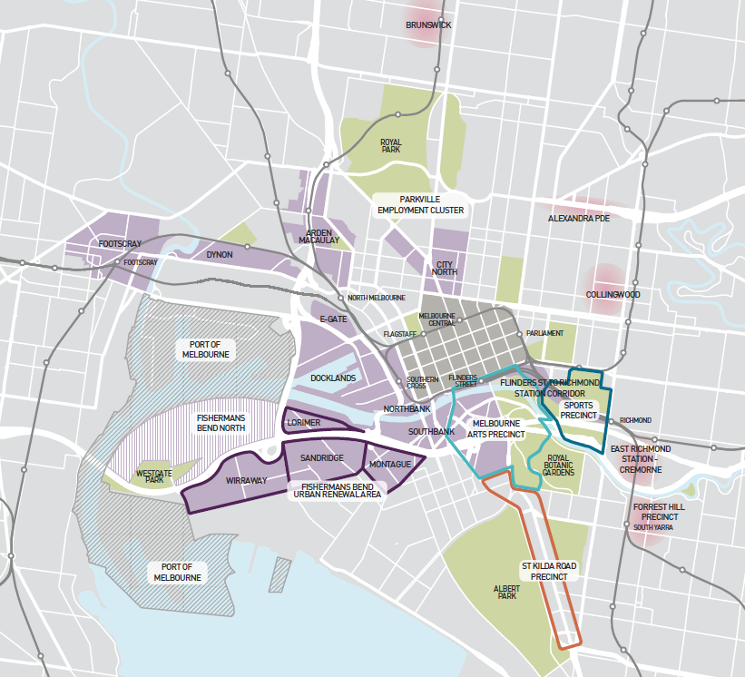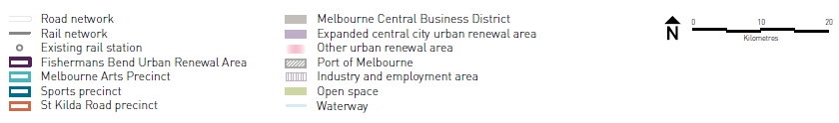

Source: *Plan Melbourne* (2014)

### Public Transport Constraints

The drivers outlined in Section ‎2.4.1 define the broad context for the conception and development of Melbourne Metro to address public transport constraints. The three specific public transport constraints that Melbourne Metro has been designed to address are described below.

#### Overcrowded and unreliable rail services are reducing Melbourne’s liveability and accessibility

Patronage growth continues to exert considerable pressure across Melbourne’s rail network. As noted above, the metropolitan rail network has experienced unprecedented patronage demand in recent years, which is outstripping the capacity of services during peak times.

A range of projects are being delivered to increase the number of services that can operate on the rail network, including the Cranbourne/Pakenham Line Upgrade, Regional Rail Link, Level Crossing Removal Program, High Capacity Signalling technology trials and deployment, and procurement and deployment of HCMTs. However, even following the delivery of these projects, the shortfall of rail capacity compared to demand is still projected to grow.

The shortfalls are projected to be greatest on the Dandenong Group between 2021 and 2031 and, in the longer term, the lines operating through North Melbourne (particularly the Sunbury Line), the Clifton Hill Group and the Werribee Line. These capacity shortfalls would result in:

* More overcrowding on trains, increasing the number of 'load breaches' on the network[2] and causing passengers greater discomfort
* More overcrowding at central Melbourne train stations, which are already experiencing significant crowding, especially at peak times
* An increase in embarking and disembarking times, affecting the reliability and punctuality of services
* Regional services between Victoria's major regional cities and Melbourne's employment precincts being increasingly compromised on those parts of the network that still share metropolitan and regional services.

If these issues are not addressed, public transport users would face increasingly unpleasant travel experiences and longer and less reliable journey times. This would reduce the time commuters have available for other activities (such as spending time with family and friends) and constrain accessibility to jobs, education and services. This ongoing decline in accessibility would have a detrimental impact on Melbourne’s liveability – a key characteristic of the city and a critical feature in attracting workers, visitors, businesses and capital.

#### Physical transport network constraints are reducing Melbourne’s economic prosperity and productivity

As Melbourne continues to grow, the existing transport network would be unable to meet demand, particularly during peak periods when patronage is highest. This would impose a number of costs on the Melbourne and Victorian labour forces. Some of these costs accrue to existing transport users who would be affected by declining service quality. Other costs arise as commuters are deterred from using public transport and instead choose to travel by motor vehicle, generating a number of external costs to the broader community.

Ongoing congestion on the Melbourne public transport network would significantly impede labour productivity and other drivers of economic prosperity, particularly in knowledge-intensive industries. The impacts of this congestion are likely to include:

* Increased journey times, reducing access to jobs and other economic opportunities located in central Melbourne, particularly for people living in the outer suburbs
* Increased inability to board services, which increases effective waiting and travel times
* Detrimental effects on the utility of on-board time, with rail users precluded from being able to read or complete work when they are forced to stand
* Reduced accessibility limiting the pool of employees available to employers (and vice-versa), making it more difficult to match skills with demand and reducing labour productivity. As people switch from public transport to car travel, road congestion worsens and travel time increases. This exacerbates journey time and labour productivity issues for both public transport users and road users.

These constraints would contribute to declining productivity, which is expected to be the cornerstone of future economic growth. As central Melbourne contributes around 27 per cent of Victoria’s Gross State Product (and six per cent of Australian Gross Domestic Product), constraints on access to the central city would have substantial flow-on impacts to the overall Victorian and national economies.

#### Insufficient public transport services are impacting access into and around central Melbourne and limiting the potential for urban renewal

As noted earlier in this chapter, central Melbourne is experiencing strong jobs and business growth and would continue to be a major services-based employment hub. While public transport connectivity has historically been very good within the CBD, Melbourne’s central core is now expanding into areas that have insufficient public transport coverage such as Arden-Macaulay, Parkville, Fishermans Bend and E-Gate.

In addition, the centre of growth in the CBD is moving towards the west, with employment growth projected to be strongest along the east-west axis of Collins Street and the north-west axis of William Street. This part of the city remains relatively under-serviced by the existing CBD tram network, which is heavily reliant on the congested Swanston Street north-south corridor.

Without a significant boost in public transport services to these and other locations in an expanded central Melbourne, their ability to contribute to an effective expanded CBD would be compromised because:

* The additional travel time needed to access the northern and western expansion areas of the CBD from the broader metropolitan area reduces the labour catchment available to businesses in those locations
* Without catalysing infrastructure, investment would be more likely to be fragmented across a number of inner city locations, making it difficult to overcome the existing constraints that prevented redevelopment of these precincts in the past (such as contamination, flooding and site consolidation)
* Development that requires or assumes a heavy reliance on cars for transportation would prevent high density clustering, reducing the ways in which businesses can interact with one another, requiring greater land take and eroding the productive value that can be extracted from these central city locations.

Melbourne’s rail network

Melbourne’s rail network was built to serve patterns of travel that vary markedly from current and anticipated future requirements.

The city’s metropolitan rail infrastructure is a significant legacy asset, dating back to the mid-1800s. Over the decades, the rail network has undergone significant modernisation and expansions. These included the network electrification in the 1920s; construction of the City Loop between 1971 and 1985; and the extension of suburban services from Dandenong to Cranbourne (1995), Broadmeadows to Craigieburn (2007), Epping to South Morang (2011) and Watergardens to Sunbury (2012). More recently, extra capacity has been delivered by the Regional Rail Link, which was designed to remove major rail bottlenecks by untangling metropolitan and regional trains as they travel through Melbourne's west into the heart of the city.

Currently, Melbourne’s metropolitan rail lines are organised into five groups (shown in Figure ‎2–2):

* The Northern Group (incorporating the Craigieburn, Sunbury and Upfield Lines in Melbourne’s north and north-west)
* Cross-City Group (incorporating the Werribee, Williamstown, Frankston and Sandringham Lines in Melbourne’s west and south-east)
* Dandenong Group (incorporating the Cranbourne/Pakenham line in Melbourne’s south-east)
* Clifton Hill Group (incorporating the South Morang and Hurstbridge Lines in Melbourne’s north and north-east)
* Burnley Group (incorporating the Glen Waverley, Alamein, Belgrave and Lilydale Lines in Melbourne’s east).

In recent years, significant effort has been made to reduce interdependence between and within groups (subject to infrastructure constraints) to move towards a more ‘metro-style’ network. Despite this, there is still a degree of interaction between groups and delays or disruptions on one line may cascade quickly onto other lines.

Figure ‎2–2 Melbourne’s current rail network

The illustration shows the current Melbourne's metropolitan rail lines that are organised into five groups:
- The Northern Group (incorporating the Craigieburn, Sunbury and Upfield Lines in Melbourne’s north and north-west)
- Cross-City Group (incorporating the Werribee, Williamstown, Frankston and Sandringham Lines in Melbourne’s west and south-east)
- Dandenong Group (incorporating the Cranbourne/Pakenham line in Melbourne’s south-east)
- Clifton Hill Group (incorporating the South Morang and Hurstbridge Lines in Melbourne’s north and north-east)
- Burnley Group (incorporating the Glen Waverley, Alamein, Belgrave and Lilydale Lines in Melbourne’s east).

Source: PTV

## Project Benefits

As the first major upgrade of the Melbourne metropolitan rail network in 30 years, Melbourne Metro would support the delivery of significant benefits to Melbourne and Victoria. These benefits are summarised below.

### Increased Capacity on Melbourne's Rail Network

Melbourne Metro would deliver a major capacity uplift across the rail network by providing the inner core infrastructure needed to reconfigure the Northern and Caulfield Groups into four independent groups:

* *Sunshine – Dandenong Line via Melbourne Metro* – removes the Sunbury and Cranbourne/Pakenham Lines from the inner core network and connects them to operate a through service via Arden, Parkville, CBD North, CBD South and Domain
* *Northern Loop Line* – removes Sunbury services from the Northern Loop, freeing up capacity on the Northern Loop to operate additional services on the Upfield and Craigieburn Lines
* *Frankston Loop Line* – enables the Caulfield Loop to be dedicated for Frankston services, providing additional capacity for growth on the Frankston Line. All Frankston trains would operate through the City Loop independently
* *Cross-City Line* – enables the Cross-City Line to be reconfigured to operate additional services from Werribee, Laverton and Williamstown would operate through to Sandringham and vice versa via North Melbourne, Southern Cross, Flinders Street, Richmond and South Yarra.

This reconfiguration would allow for the independent operation of all lines and support the transformation of the metropolitan rail network into a metro-style service with the capacity to move more people in peak periods and deliver more reliable, more frequent and less crowded services. It would create a through-running suburban corridor from Sunbury in the west to Cranbourne and Pakenham in the east that would bypass the existing City Loop. This would not only increase capacity on the Sunbury and Cranbourne/Pakenham Lines, but also create capacity in the existing inner core of the rail system. This increased capacity would provide the opportunity to improve service frequencies and reliability on the Cross-City, Northern and Frankston Lines – enabling the capacity uplift generated by Melbourne Metro to be exploited fully.

Importantly, the reconfiguration would also provide the ‘spine’ for potential future expansions of the network to keep pace with Melbourne’s growth, including the extension of the metropolitan rail network to Melbourne Airport, Melton, Rowville and Wallan. These extensions are not confirmed and would be subject to Victorian Government approval. The implications of this reconfiguration are discussed in more detail in Chapter 6 Project Description.

Figure ‎2–3 Network configuration in 2026 with Melbourne Metro

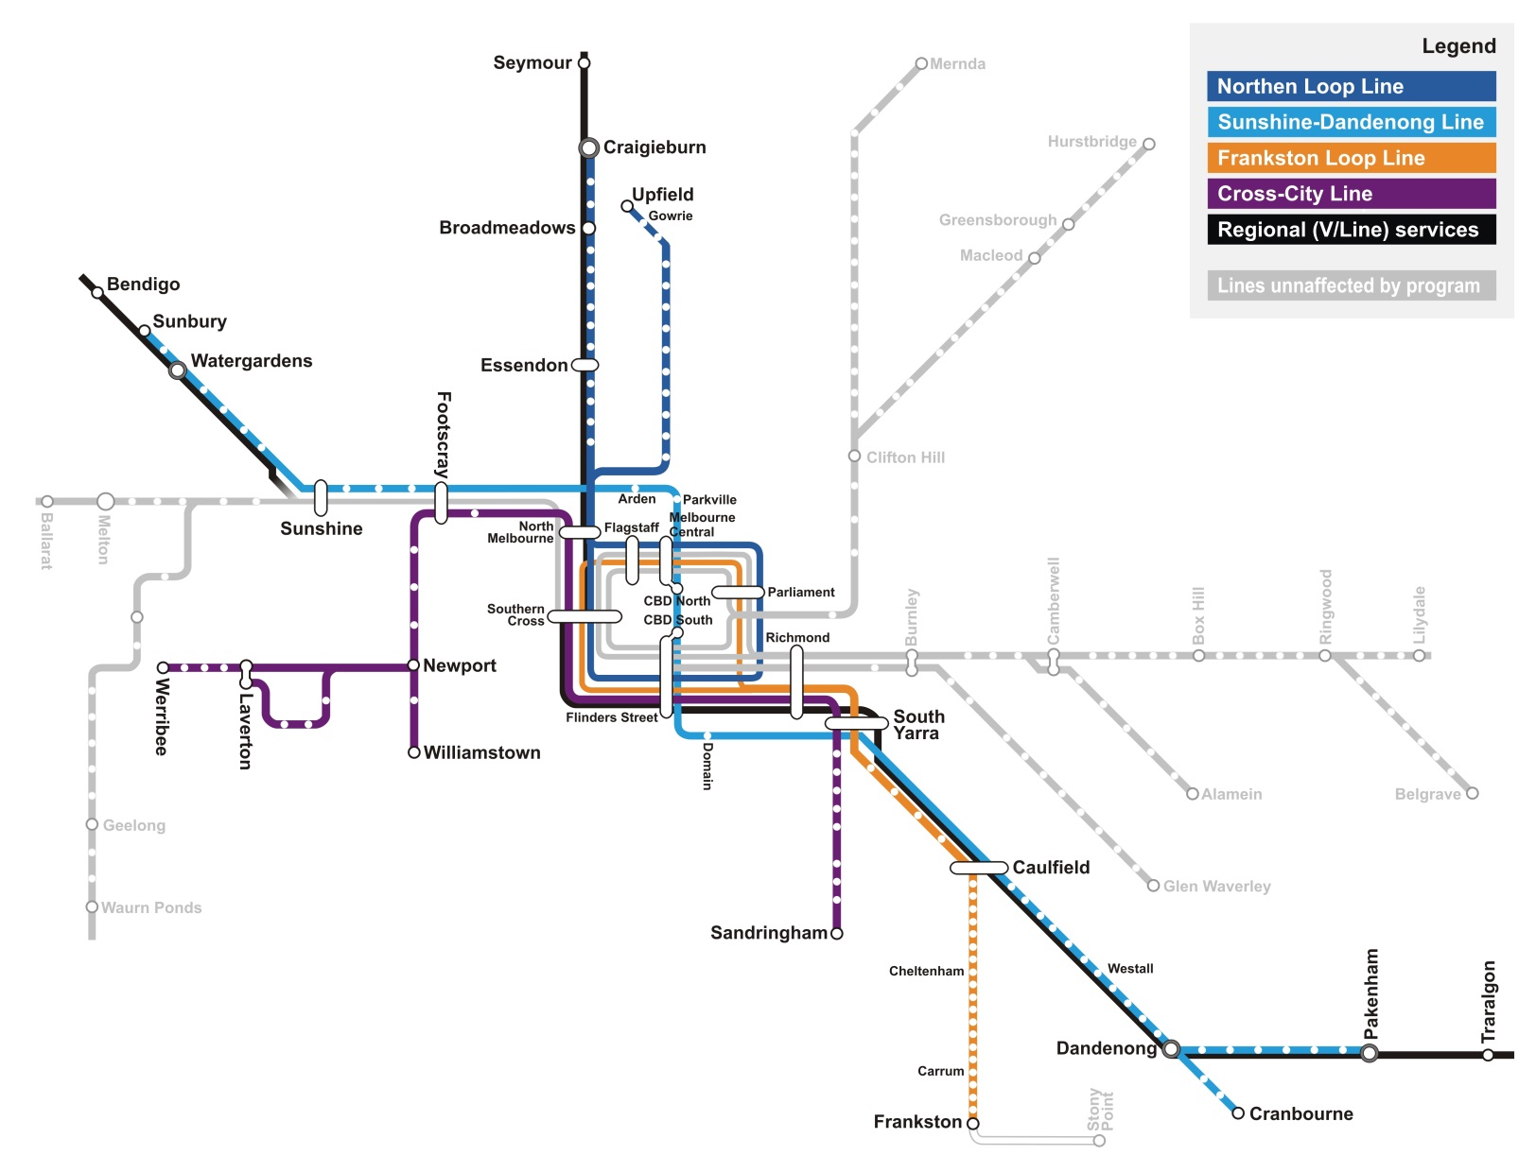

Source: PTV

### Moving More People in Peak Periods

On its first day of operations, Melbourne Metro would expand the capacity of the network by over 39,000 additional passengers in each of the morning and afternoon peak periods. Approximately one third of this increased peak period capacity would be delivered on the new Sunshine – Dandenong Line. The remaining capacity uplift would benefit lines operating via the existing network, using capacity released by the move of Sunshine – Dandenong Line services into the new Melbourne Metro tunnels.

Figure ‎2–4 shows the anticipated initial increases in capacity for the two-hour AM peak delivered by Melbourne Metro on the first day of operations.

As this figure shows, a large proportion of the initial capacity increases would benefit groups other than the new Sunshine/Dandenong Group, as these groups would take advantage of existing inner core capacity freed by diverting the Sunshine and Dandenong Lines into Melbourne Metro.

Melbourne Metro provides the backbone for further improving the network in the future by incorporating features, such as long platforms and high capacity signalling that allows a staged approach to expanding the metropolitan rail network. If further investments are made in the medium term including extended HCMTs, longer platforms, Melton quad track, Melton electrification, and power and signalling upgrades, this would enable further capacity for 41,000 passengers per peak period to be introduced on the Sunshine – Dandenong Line progressively from 2031 as required.

Figure ‎2–4 Capacity uplift delivered by Melbourne Metro (passengers in two-hour AM peak)

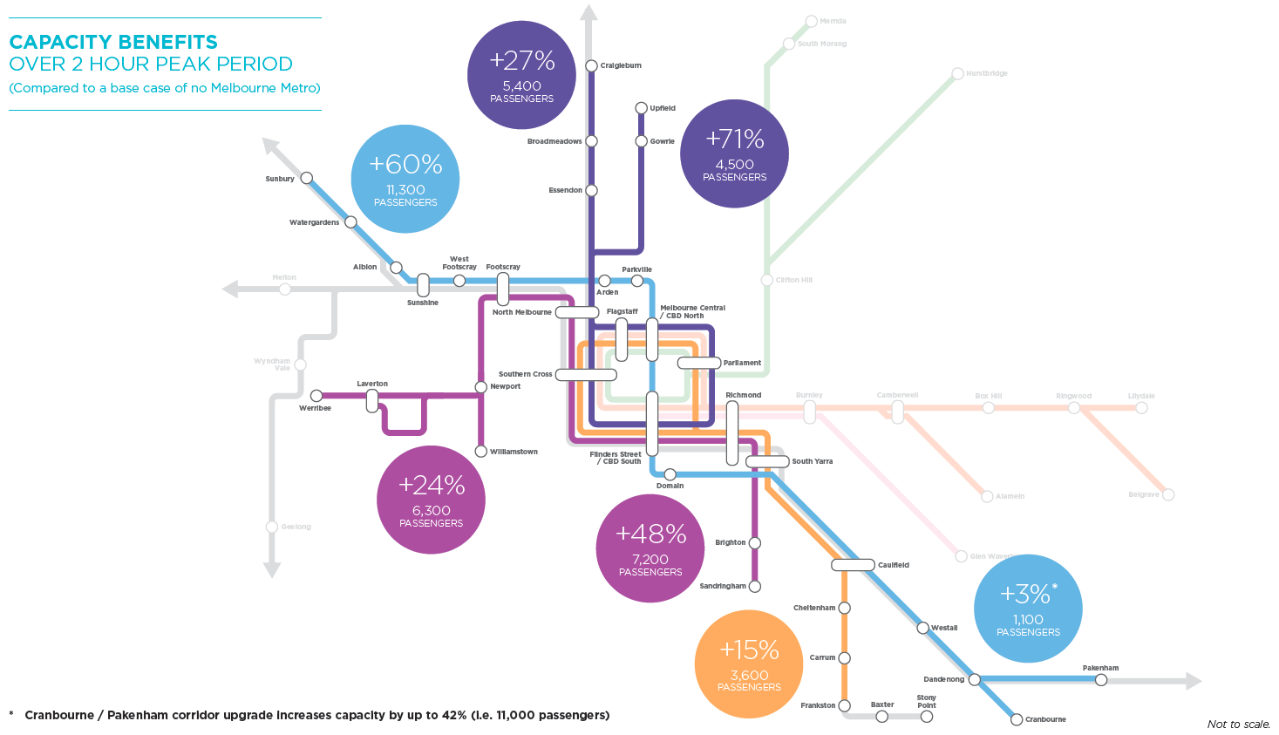

Source: PTV

### More Reliable and Less Crowded Services

By creating the ability for independent line operation across the network, Melbourne Metro would enable improvements to the reliability of the network. In particular, the project enables the following lines to benefit from improved service reliability: Werribee and Williamstown, Sunbury, Melton, Craigieburn and Upfield, Frankston and Sandringham.

The capacity uplift facilitated by Melbourne Metro would also relieve crowding pressures on trains that currently travel through North Melbourne, as well as on the Cranbourne/Pakenham, Sandringham and Frankston Lines.

By adding new CBD stations to some of Melbourne’s busiest lines, Melbourne Metro would take pressure off existing CBD and inner city stations, especially Flinders Street and Melbourne Central. Melbourne Metro would also change the distribution of interchanges in the inner Melbourne rail network, relieving North Melbourne and Richmond stations, and increasing the level of interchange at Footscray. The recent upgrade to Footscray by the Regional Rail Link project was designed to accommodate an increased level of passenger interchange.

### Greater Productivity, Economic Development and Jobs Growth

The improvements in connectivity and accessibility supported by Melbourne Metro would help to drive economic development and jobs growth and lift levels of productivity by:

* Improving access to and within the CBD for businesses, workers and students – expanding the footprint of the rail network in central Melbourne beyond the limits of the existing five CBD stations and allowing more people to travel to and from the CBD during the busiest travel periods
* Improving access to education and research opportunities, particularly in the Parkville education and biomedical precinct – supporting Australia’s trajectory as a knowledge-based employment economy
* Improving tram network operational efficiency by restructuring the tram network to better serve emerging employment patterns and facilitate new connections across and within the expanding CBD (including to and from Parkville, Domain, western parts of the CBD and South Melbourne)
* Catalysing urban renewal and development by providing high quality transport connections to support planned urban renewal precincts and building new stations at Arden (see box on page 2-24), Parkville and Domain – opening up opportunities for significant commercial and residential uplift and creating opportunities to strengthen and expand Melbourne’s knowledge economy
* Reshaping accessibility across the metropolitan area, particularly in the west and north of the city – enabling businesses to achieve higher productivity through economies of scale and scope
* Providing improved access to growing central city employment precincts, with all five new stations expected to be used heavily for access to the precincts they serve, especially during the morning peak period
* Improving the accessibility of four out of Melbourne’s six national employment clusters: Parkville, Monash, Dandenong South and Sunshine
* Reducing road congestion and freight costs by encouraging some travellers to switch to public transport, especially during peak periods
* Improving efficiencies longer term throughout Melbourne and Victoria’s regions by linking the labour force and employment growth areas to increase business profitability and draw new business investment into Melbourne and Victoria, further boosting employment and incomes.

### A More Liveable Melbourne

In addition to the economic and employment benefits outlined above, Melburnians and Victorians are expected to benefit more broadly from Melbourne Metro in ways that are not captured in standard economic measures. In particular, Melbourne Metro would contribute to maintaining and enhancing Melbourne’s reputation for liveability by:

* Providing a modern, reliable and efficient rail system that offers a positive experience for users, reinforces positive perceptions of central Melbourne and helps to attract new residents and visitors to Melbourne
* Relieving crowding on the inner city tram network
* Increasing the potential number and range of social services and economic opportunities available to people within a given travel time from their homes (including services that are critical to people's wellbeing and level of opportunity, such as health and education)
* Providing more housing options within the walking or cycling catchments of train stations, increasing opportunities for people to use active transport for part of their journeys to work and other destinations
* Contributing to lower levels of car use as travel demand increases, leading in turn to a more sustainable urban form with reduced air and noise pollution
* Improving personal wellbeing and societal welfare through better access to goods and services, sport, cultural and recreational activities
* Improving social inclusion by increasing the availability and reach of the public transport network, reducing the barriers for accessing social and economic opportunities and supporting greater individual and community wellbeing
* Improving health outcomes by increasing accessibility to a wider range of health services (including hospitals, diagnostic centres and allied health services), community centres and public amenities.

These outcomes are important factors in the enjoyment Melburnians derive from the places they live and the opportunities they can access to improve their lives. They play a key role in ensuring Melbourne remains a highly liveable city – something that is not only important to Melburnians’ quality of life, but is also an important measure that influences the decision of businesses to invest in Melbourne and Victoria, rather than competing locations.

Catalysing development in the Arden-Macaulay Urban Renewal Precinct

The Victorian Government and the City of Melbourne have identified the Arden-Macaulay precinct as a major urban renewal site with the potential to accommodate 25,000 residents and more than 43,000 jobs. *Plan Melbourne* has identified the area as a ‘future emerging’ precinct.

While a range of actions and interventions are required to facilitate urban renewal in the area, a new train station located at the heart of the precinct would present a significant opportunity to stimulate residential and commercial development.

Currently, a coordinated approach is underway to facilitate more intensive development in Arden-Macaulay, including preparation of a structure plan and Planning Scheme Amendment, development of an integrated flooding and development scheme, and finalisation of the Arden-Macaulay Partnership Blueprint between the Victorian Government, City of Melbourne, Department of Education and Training, Office of Housing, VicTrack and other major land owners and stakeholders in the precinct.

Located in the centre of the urban renewal precinct, the new station would support these efforts and strengthen Arden-Macaulay’s potential to become Australia’s premier transit-oriented development. Additional rail access, combined with integration with other transport modes, would result in Arden-Macaulay having ‘CBD like’ levels of accessibility to the broader Melbourne labour market, increasing the attractiveness of the area to investors. With Melbourne Metro connecting Arden-Macaulay directly to major health and education institutions in Parkville and the CBD, the precinct would also offer opportunities for business and jobs growth focused around high value knowledge sectors.

The Victorian Government and the City of Melbourne are working together on a draft Arden Framework Plan to guide the renewal of the area around Arden station for the next three decades. The draft plan is being prepared for community consultation during 2016.

## Satisfying the Project Objectives

As noted in Section 1.1.3 in Chapter 1, the broad strategic direction of the development of Melbourne Metro is being guided by a number of high-level Project Objectives. Table ‎2–1 summarises how Melbourne Metro would meet these objectives.

Table ‎2–1 Meeting Melbourne Metro Project Objectives

|  |  |
| --- | --- |
| 1. Objective | 1. Melbourne Metro benefits |
| * + - 1. Provide additional capacity on Melbourne's rail system to meet customer needs that, as part of a program of investment, meets medium-term demands and supports long-term patronage growth | 1. On opening, Melbourne Metro delivers capacity to accommodate over 39,000 passengers in each two-hour peak period each morning and afternoon. 2. Redirecting Dandenong and Sunbury rail services through Melbourne Metro tunnels would alleviate capacity constraints and provide the ability to increase capacity further over time, supporting long-term patronage growth. 3. A range of other investments, subsequent to Melbourne Metro, in the medium term (including extended trains, longer platforms, Melton quadruplicated track, Melton electrification, and power and signalling upgrades) would enable capacity for an additional 41,000 passengers per peak period to be introduced on the Sunshine – Dandenong Line progressively from 2031 as required. 4. Further details are provided in Section ‎2.5.1. |
| * + - 1. Optimise the efficiency and reliability of operations and improve the customer experience by moving towards a metro-style rail system | 1. Melbourne Metro would enable the reconfiguration of the network into separate groups with independent operations, rolling stock, stabling and maintenance facilities. This would improve the resilience, punctuality and reliability of the network by quarantining the flow-on impact of delays and cancellations. These independent groups would be supported by improved signalling and rolling stock to maximise service provision, leading to ‘turn up and go’ timetables and frequencies. 2. Further details are provided in Section ‎2.5.2. |
| * + - 1. Support the long-term plan and vision to develop and operate Victoria's rail network | 1. The capacity unlocked by Melbourne Metro would provide the foundation for longer-term expansion of the network. Note using this capacity would require further investments outside the inner core of the network and can be provided by projects such as Regional Rail Link, Melbourne Airport Rail Link or track amplification to separate remaining regional and suburban train interactions in the suburban area. 2. Further details are provided in Sections ‎2.5.2 and ‎2.5.3. |
| * + - 1. Improve access and reduce congestion of the tram system in central Melbourne and the road network in the north, west and south east by diverting travel to the rail network | 1. Melbourne Metro would help relieve the busy Swanston Street tram corridor serving St Kilda Road and Parkville, encouraging tram travellers to shift to the rail network and relieving tram congestion and overcrowding. It would support plans by PTV to re-organise the tram network to better serve the western end of the CBD where the current supply of tram services does not match employment catchments. |
| * + - 1. Improve accessibility to jobs, education and other social and economic opportunities by enabling the growth and more effective use of land in Melbourne | 1. Upon completion, Melbourne Metro would enable more job opportunities to be accessible to workers within a reduced travel time. Employers would also be able to access a greater pool of potential employees. This would improve 'job matching,' a critical element in increasing labour productivity and Victoria’s economic performance. By improving the accessibility of employment hubs such as Parkville and Domain, Melbourne Metro would support commercial and residential development in these areas. It would also support development of the Arden-Macaulay precinct as a major urban renewal site and employment destination on the fringe of the CBD. 2. Further details are provided in Section ‎2.5.4. |
| * + - 1. Deliver strong productivity, sustainability and liveability benefits by providing a value for money transport solution | 1. Melbourne Metro would provide a number of interrelated productivity, sustainability and liveability benefits to Melbourne and Victoria. Stronger productivity would be created through increased access to the Central Melbourne region, while improved sustainability would be delivered through increased public transport usage. Liveability would be enhanced through improvements resulting from increased accessibility, reduced overcrowding on public transport and improvements to the public realm, including support for urban renewal. 2. Further details are provided in Section ‎2.5.5. |
| * + - 1. Contribute to a safe, accessible rail network that supports the health and wellbeing of users | 1. Melbourne Metro would be designed and constructed in a way that supports the continuing safe operation of the railway network. The project design would use Safety in Design (SiD) and Crime Prevention through Environmental Design (CPTED) principles that ensure the safety and wellbeing of the users of trains, trams, stations and interchanges. Melbourne Metro would also allow more people to live within the walking catchment of train stations, increasing opportunities for walking and cycling part of their journeys. |

1. Gross State Product is a monetary measure of the economic output of a state, province or region. It is the sum of all goods and services produced by industries within the state in a year. While Gross State Product is not a complete measure of economic activity, it assists in determining Victoria’s overall economic performance from year to year and allows comparisons to be made with other states and regions.
2. A ‘load breach’ is defined as more than a rolling average of 798 people on board.