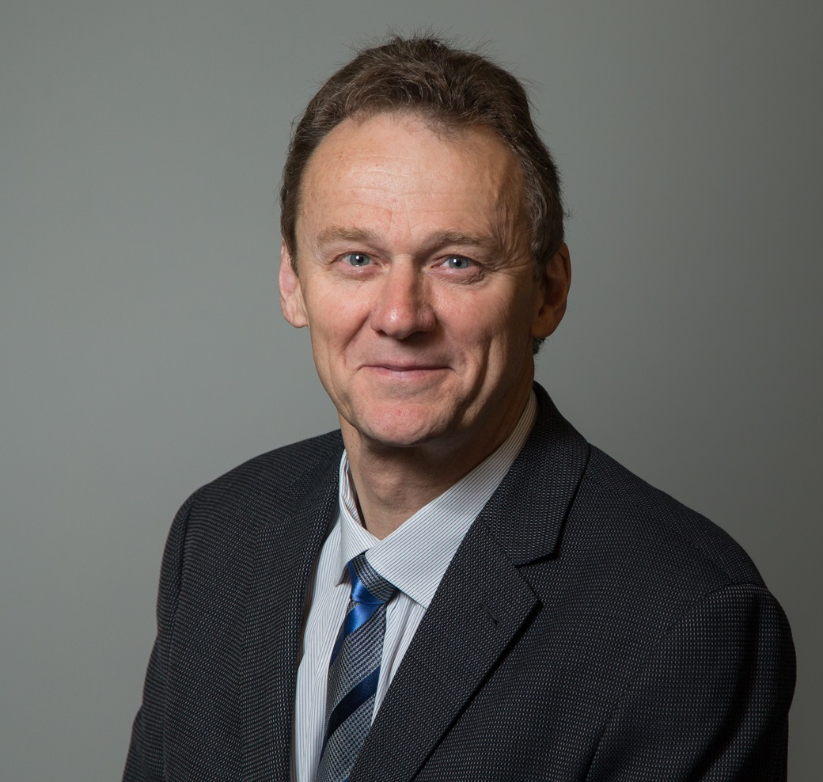

Foreword

From the CEO

Melbourne Metro would create a new dedicated underground rail path through the heart of the city for two of Melbourne’s busiest train lines, thereby freeing up the City Loop for more trains on other lines to run more often in and out of the city. It would significantly boost our network capacity to keep pace with Melbourne’s population growth as we head towards a city of eight million people in 2051.
Melbourne Metro would connect the Sunbury, Cranbourne and Pakenham lines through the construction of twin nine-kilometre rail tunnels and five new underground stations at Arden, Parkville, CBD North, CBD South and Domain. The $10.9 billion project would be the first step towards a ‘metro style’ rail network with the ‘turn up and go’ metro services that are the hallmark of the world’s great cities.
It would also relieve crowding on key tram routes, ease road congestion, and generate significant urban renewal, opening up opportunities for new housing, commercial development and jobs close to the city centre.
In September 2015, the Minister for Planning determined that Melbourne Metro required assessment under the Environment Effects Act 1978. The Melbourne Metro Rail Authority (MMRA) has prepared this Environment Effects Statement (EES) to provide an assessment of the potential environmental, social and business impacts associated with the proposed construction and operation of Melbourne Metro.
A construction project of this scale and complexity will have some unavoidable impacts and we are committed to addressing these in a responsible way. The EES recommends Environmental Performance Requirements that define the environmental outcomes that must be achieved during the design, construction and operation of the new rail tunnel to avoid, manage or mitigate these impacts.
Community and stakeholder feedback has been an important part of developing the EES and was provided to the specialists conducting the impact assessments and to the Melbourne Metro design team. Key changes to the project, such as avoiding the need to dig up Swanston Street for several years, have already resulted.
MMRA was assisted in preparing the EES by a Technical Reference Group (TRG) convened by the Department of Environment, Land, Water and Planning. MMRA would like to thank the TRG and everyone who has contributed to the EES. We continue to welcome community and stakeholder feedback to achieve the best outcomes for this transformational project for Melbourne and Victoria.

Evan Tattersall
Chief Executive Officer
Melbourne Metro Rail Authority

