Aboriginal Heritage

Overview
This chapter provides an assessment of the Aboriginal cultural heritage impacts associated with the construction and operation of Melbourne Metro. The chapter is based on the impact assessment presented in Technical Appendix K Aboriginal Heritage. All relevant references are provided in Technical Appendix K.
While the areas within the proposed project boundary have a long history of Aboriginal occupation, the Aboriginal cultural heritage impact assessment conducted for the EES has determined that there would be limited impact on Aboriginal cultural heritage as a consequence of the construction of Melbourne Metro. This is due to:
- Significant ground disturbance having occurred during the gradual urban development of Melbourne, which would have had a significant impact on Aboriginal cultural heritage
- The majority of the proposed works being constructed below ground, at depths below potential archaeological deposits containing Aboriginal cultural material
- In areas where there is the potential for Aboriginal cultural heritage material to be present, the CHMP process would assist in identifying the potential nature and extent of any unknown Aboriginal cultural heritage
- The CHMP would contain contingency plans that outline the required process for the discovery of Aboriginal cultural material during construction activities.
Following the initial disturbance undertaken to facilitate construction of the project, no impacts to Aboriginal cultural heritage would be envisaged as a result of the operation of Melbourne Metro.

EES Objectives
The EES Scoping Requirements set the following draft evaluation objective for the EES:
- Cultural Heritage – To avoid or minimise adverse effects on Aboriginal and historical heritage values.
In line with this objective, the existing conditions, potential impacts and associated risks to Aboriginal cultural heritage within the study area were assessed. Using this information, one specific Environmental Performance Requirement has been recommended to ensure that potential adverse effects to Aboriginal cultural heritage values would be avoided.
The historical cultural heritage (non-Aboriginal) impacts of Melbourne Metro have also been assessed. The results of this assessment are discussed in Chapter 14 Historical Cultural Heritage.

Legislation and Policy
As discussed in Chapter 4 EES Assessment Framework and Approach, Aboriginal cultural heritage impacts associated with Melbourne Metro would be managed in accordance with Commonwealth and Victorian legislation. The relevant legislation is set out in Table ‎15–1.
Table ‎15–1 Aboriginal cultural heritage legislation relevant to Melbourne Metro
Legislation | Comment
Commonwealth
Aboriginal and Torres Strait Islander Heritage Protection Act 1984 | The Act protects areas and objects that are of particular significance to Aboriginal people. It allows the Commonwealth Minister for the Environment, on the application of an Aboriginal person or group of persons, to make a declaration to protect an area, object or class of objects from a threat of injury or desecration. This includes any intangible or contemporary Aboriginal values within the study area.  No approvals are required for Melbourne Metro under this Act.
Environment Protection and Biodiversity Conservation Act 1999 | This Act establishes the National Heritage List and Commonwealth Heritage List, which includes natural, Indigenous and historic places that are of outstanding heritage value to the nation.  There are no items listed on the National Heritage List or Commonwealth Heritage List that contain known Aboriginal cultural heritage values within the study area.
State
Aboriginal Heritage Act 2006 | This Act provides for the protection of Aboriginal cultural heritage in Victoria. It recognises Aboriginal people as the primary guardians, keepers and knowledge holders of Aboriginal cultural heritage and promotes the use of agreements that provide for the management and protection of Aboriginal cultural heritage.  The Act also mandates that a CHMP is required for any project requiring an EES. The Secretary of the Department of Premier and Cabinet would be required to evaluate and approve the project’s CHMP prior to construction.
Aboriginal Heritage Regulations 2007 | These regulations set standards and fees for the preparation of CHMPs.
Planning and Environment Act 1987 | Where planning approval under the Planning and Environment Act 1987 and a CHMP are required, the permit or other key approval cannot be issued until the CHMP is approved. The CHMP is being prepared concurrent to the EES.

Methodology

Study Area
The study area for the Aboriginal cultural heritage impact assessment has been defined as land falling within the proposed project boundary.

Assessment approach
The potential cultural heritage impacts of Melbourne Metro were informed by the Aboriginal cultural heritage impact assessment. The investigation consisted of a preliminary desktop assessment using the methodology described in Section ‎15.4.3, and incorporated preliminary findings from the standard and complex components of the CHMP. The investigation was undertaken to obtain information about the existing conditions within the proposed project boundary and how those conditions would be affected by Melbourne Metro. The assessment was undertaken by experienced and qualified Cultural Heritage Advisors.
In addition to the impact assessment, a CHMP is being prepared as part of the approvals process. This additional report, prepared by a Cultural Heritage Advisor, will contain the results of an assessment of the potential impact of the project on Aboriginal cultural heritage. The CHMP will identify and manage potential impacts on Aboriginal cultural heritage, with the involvement of Aboriginal stakeholders. The Aboriginal stakeholders to this project are:
- Bunurong Land and Sea Association
- Bunurong Land Council Aboriginal Corporation
- Boon Wurrung Foundation
- Wurundjeri Tribe Land and Compensation Cultural Heritage Council Incorporated.
A CHMP differs from the EES impact assessment as it outlines the measures to be taken before, during and after an activity in order to minimise and manage impacts on Aboriginal cultural heritage within an activity area. The impact assessment is the process of evaluating the likely impacts to Aboriginal cultural heritage as a result of the proposed project.
Preparation of the CHMP involves archaeological field surveys and archaeological excavation, which would be carried out during 2016. Section 4.1 of Technical Appendix K provides further details.

Baseline and Background Data
The assessment for the impact assessment consisted of consultation meetings with Aboriginal stakeholders and a review of baseline and background data, including:
- A search of the Victorian Aboriginal Heritage Register (VAHR) for information relating to the study area and to identify any registered cultural heritage places (Aboriginal Places)
- Identification of the geographic region present within the study area relevant to Aboriginal cultural heritage
- Reviews of the following resources and data:
  - Reports and published works about Aboriginal cultural heritage relevant to the geographic region
  - Historical and ethno-historical accounts of Aboriginal occupation relating to the geographic region
  - Landforms or geomorphology of the study area
  - Land use history of the study area
- Development of a predictive model of Aboriginal Place types within the geographic region and within the activity area.
- Archaeological survey of the activity area in accordance with proper archaeological practice
- Commencement of sub-surface testing (complex test excavation) of the activity area in order to identify the nature and extent of any Aboriginal Places within. Complex testing was proposed for the following locations:
  - Fawkner Park potential southern TBM launch site (Precinct 1 – Tunnels precinct)
  - Fawkner Park north-east location (Precinct 1 – Tunnels precinct)
  - Construction work site at Edmund Herring Oval (Precinct 7 – Domain station precinct)
  - South Yarra Siding Reserve (Precinct 8 – Eastern Portal precinct).

Existing Conditions

Regional Context
The study area is located at the junction of the Eastern Plains, Western Plains and Eastern Uplands geomorphological regions. This confluence would have resulted in a diverse and rich landscape for Aboriginal people living in the Melbourne area. As the relevant geomorphological regions are extremely large, the geographic region has been restricted to a radius of two kilometres surrounding Melbourne Metro for the purposes of the Aboriginal cultural heritage impact assessment.
The landscape has undergone numerous climatic changes over the past 30,000 years of Aboriginal habitation. These changes would have influenced the location of habitable sites and important resources such as food and materials. During the last Ice Age, up until approximately 20,000 years ago, the sea level was much higher than today. As sea levels rose following the last Ice Age, there would have been a reduction of resource zones prior to the formation of swamps.
Early in the Holocene period, approximately 10,000 years ago, the Melbourne area would have been a coastal fringe zone comprising a number of creeks and rivers that could have been used for fishing or hunting. During the late Holocene period, approximately 4,000 years ago, the Melbourne area would have been ideal for occupation following the development of the swamps, lagoons and marsh resource zones. Figure ‎15-1 shows key known features at the time of first non-Aboriginal settlement of Melbourne.
Waterways such as the Maribyrnong River, Moonee Ponds Creek, the Yarra River, the West Melbourne Swamp, River Townend (now Elizabeth Street) and others would have all provided rich resource zones for Aboriginal people. Lagoons were present in the current Royal Botanic Gardens.
The Yarra River prior to non-Aboriginal occupation of the Melbourne area had a very different aspect to today. The Yarra River’s course was altered after 1842 and was eventually straightened near Olympic Park. In contrast, the Maribyrnong River has raised levees that stretch along its length, resulting from changes in water flow over the last 30,000 to 40,000 years. The Maribyrnong River has a rich archaeological history, which is only partially known. Archaeological sites have been recorded on a river terrace at Keilor, with artefacts dated to 26,000 years BP (Before Present) and a human skull dated to 13,000 years BP.

Figure ‎15-1 Indicative map of the pre- and post-contact Aboriginal landscape of Melbourne
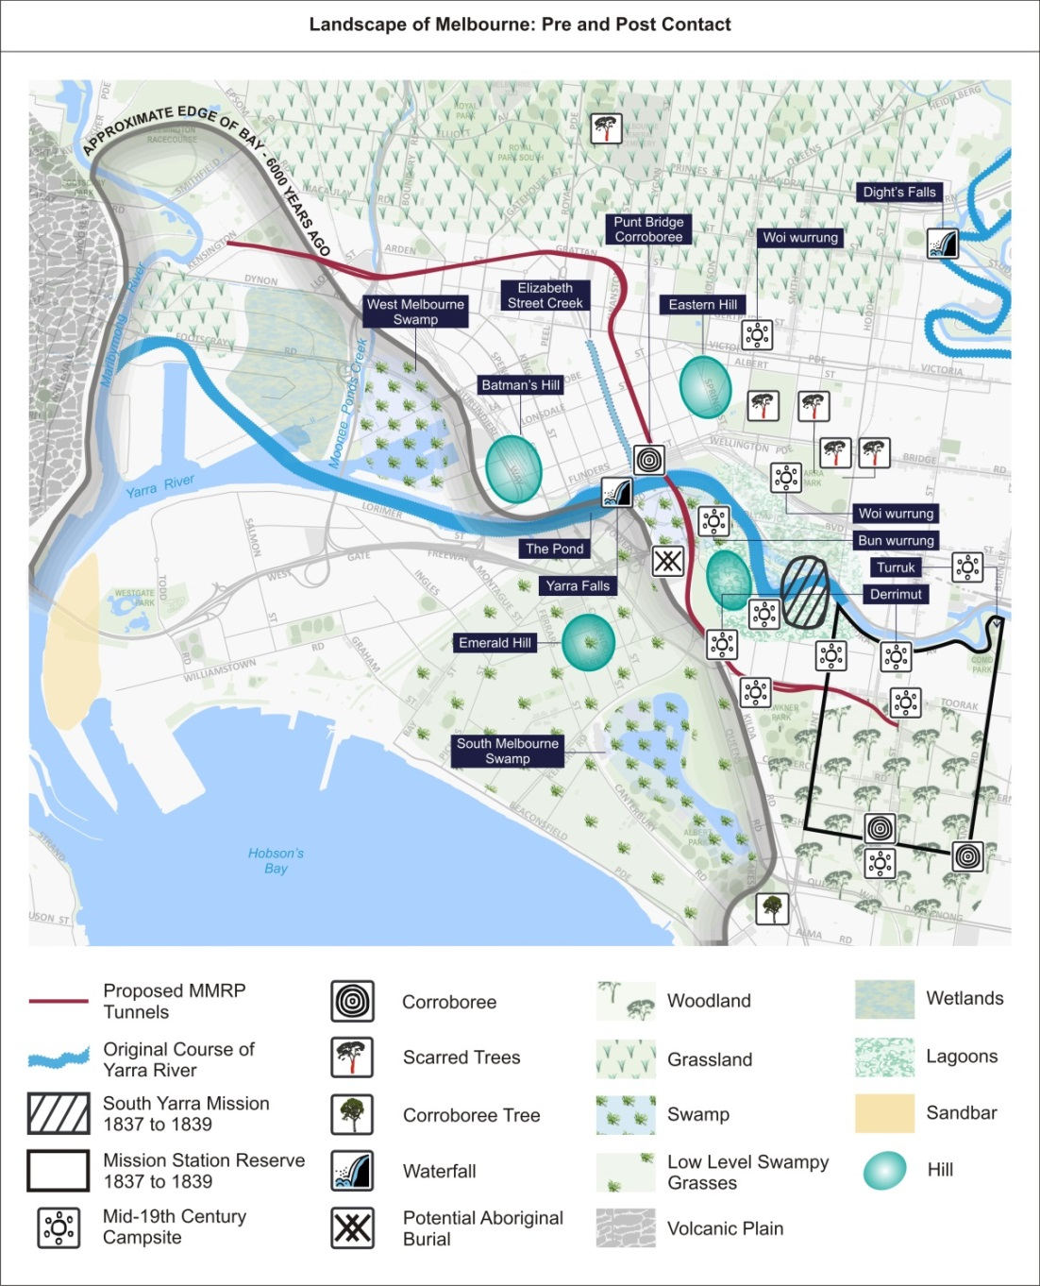

Non-Aboriginal settlement of the Melbourne area led to the severe disruption of Aboriginal traditional life. Little information is known regarding the lives of those living in the area prior to colonisation. At the time of first non-Aboriginal contact, the Melbourne area was located near the border between the Bun wurrung (the ‘Coastal Tribe’) and Woi wurrung (the ‘Yarra Tribe’) language groups or tribes. Tribes were comprised of clans, which were composed of bands or ‘foraging’ groups, made up of family members and, potentially, visitors. It is impossible to know the exact boundaries of the tribes or language groups, as these were drawn as the non-Aboriginal settlers understood them.
Urban development of Melbourne resulted in the loss of traditional lands and resources, the spread of disease, social breakdown and the removal of groups and individuals to reserves and mission stations. In the 1830s, Aboriginal people continued to camp in the vicinity of the township of Melbourne, with many camp locations in places such as the Royal Botanic Gardens, Fawkner Park and the Melbourne and Richmond Cricket Grounds. Through the influence of the government, missionary societies and the new ‘landowners’, the number of Aboriginal people in the area dwindled as a result of high mortality rates and forced movement out of the township.

Aboriginal Sites and Archaeological Sensitivity
Archaeological sensitivity relates to the probability of the occurrence of physical evidence of past human occupation or activity. It does not imply that the ‘cultural’ heritage values of particular land systems are more or less significant. An indicative map of zones of archaeological sensitivity is provided in Figure ‎15-2. The map was developed to assist in understanding areas of archaeological sensitivity and, as such, includes some areas outside the study area.
The map does not account for any significant ground disturbance that has taken place since the non-Aboriginal settlement of Melbourne. Significant ground disturbance has the ability to destroy, reduce or intrude upon Aboriginal cultural heritage objects, artefacts, sites and values. As such, the level of previous ground disturbance is a determinant of the likelihood of recording intact Aboriginal Places.
An evaluation of the nature and extent of significant ground disturbance for each Melbourne Metro precinct is provided in Sections ‎15.8 to ‎15.17. Adjusted levels of potential archaeological sensitivity are presented in these sections. Section 5.12 of Technical Appendix K provides further details of the assessment criteria for archaeological sensitivity and predictive statements used to identify where Aboriginal Places would most likely be found within the study area.

Figure ‎15-2 Indicative map of archaeological zones of sensitivity across the proposed Melbourne Metro alignment (Note: this map does not account for significant ground disturbance that has taken place since the non-Aboriginal settlement of Melbourne)
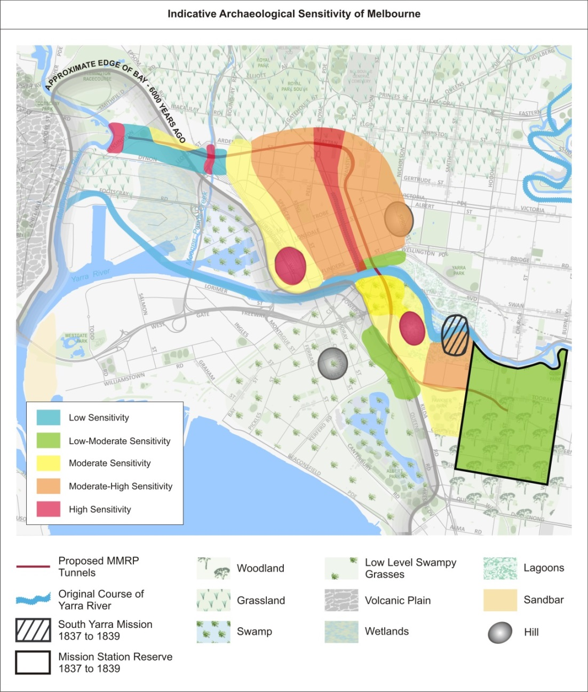

Risk Assessment
An Environmental Risk Assessment has been completed to assess the potential impacts of Melbourne Metro in relation to Aboriginal cultural heritage. Further information about the risk assessment approach adopted for Melbourne Metro is included in Chapter 4 EES Assessment Framework and Approach.
Impact assessment must be informed by risk assessment so that the level of mitigation action relates to the likelihood of an adverse impact occurring.
All Aboriginal cultural heritage risks associated with the proposed Melbourne Metro relate to disturbance or removal of Aboriginal archaeological sites, objects or remains, or damage to intangible cultural heritage values. A number of these risks were assigned medium initial risk ratings. The impact assessment focused on these risks.
As a result of the impact assessment, one Environmental Performance Requirement (which would require compliance with the approved Cultural Heritage Management Plan) has been recommended to reduce the identified impacts. Achieving these requirements would be expected to reduce the residual risk ratings of all risks to low or very low.
A full list of Aboriginal cultural heritage risks associated with Melbourne Metro, showing the initial and residual consequence rating of each risk, is provided in Technical Appendix B Environmental Risk Assessment Report and Technical Appendix K Aboriginal Heritage.
The recommended Environmental Performance Requirement is listed in Section ‎15.18.

Impact Assessment
Throughout the construction phase of Melbourne Metro, the main Aboriginal cultural heritage impact expected would be disturbance or removal of unknown Aboriginal cultural heritage within sub-surface construction works (all precincts). Where construction activities occur within natural soil deposits, there would be the potential to adversely impact on unknown Aboriginal cultural heritage values.
The CHMP would provide management measures and contingences in the event that previously unknown items of Aboriginal cultural heritage are uncovered during project works. If historical archaeological excavations occur, contingency plans within the CHMP would also be developed for the discovery of Aboriginal cultural heritage material.
Following the initial disturbance undertaken to facilitate the construction of Melbourne Metro, no impacts to Aboriginal cultural heritage would be envisaged as a consequence of the operation of Melbourne Metro.

Key Benefits and Opportunities
The key benefits and opportunities arising from Melbourne Metro would include undertaking sub-surface test excavation outside areas of cultural heritage sensitivity, but within areas of potential archaeological sensitivity. The sub-surface test excavation would establish whether Aboriginal cultural heritage is present or absent, which would build on current knowledge of Aboriginal occupation and use of the landscape, both post-contact and pre-contact. It would also check the accuracy of the predictive model developed during the CHMP.

Precinct 1: Tunnels
The tunnels would largely be constructed below ground, at depths below potential Aboriginal archaeological deposits. However, ground disturbance would take place close to the ground surface at:
- Queen Victoria Gardens as a result of the construction of the Linlithgow Avenue emergency access shaft
- The north-east section of Fawkner Park due to the construction of an emergency access shaft
- Potential TBM southern launch site at and surrounding the current Fawkner Park Tennis Centre (along with Domain as discussed in Section ‎15.14).

Queen Victoria Gardens
The Queen Victoria Gardens have been subject to ground disturbance including the construction of the former Immigrants’ Home, built in the 1850s and demolished in 1913. Further disturbances resulted from construction of the toilet block, monument and the floral clock, which still exist.
As these areas have been previously subject to earth moving works, and contain fill up to 5.4 m (within Alexandra Gardens), they have been assessed as being of very low Aboriginal archaeological potential and no further assessment is required.

Fawkner Park
Fawkner Park was reserved in 1862, with the pathways and avenues laid out in 1875. The park has remained relatively unchanged since then, with land to the south of the park comprising former swamp. Fawkner Park was a known camping ground for Aboriginal people, with Aboriginal people camping in the north-west corner of the park as late as 1849.
Sections of Fawkner Park have since been excised from the parklands; this includes the Child Welfare Centre, adjacent to the study area. Various sporting facilities were constructed in Fawkner Park during the early part of the 20th century, including tennis courts and a putting green. During World War II, trenches were excavated along the Toorak Road frontage of the park.
No Aboriginal Places are recorded within Fawkner Park. However, the area is assessed as being of low-moderate and moderate archaeological sensitivity, with some archaeological potential where natural soil deposits remain. As such, works would have the potential to adversely impact on unknown Aboriginal cultural heritage values.
The CHMP would provide management measures and contingences in the event that previously unknown items of Aboriginal cultural heritage are uncovered during project works. If historical archaeological excavations occur, contingency plans within the CHMP would also be developed for the discovery of Aboriginal cultural heritage material..

Alternative Design Options
Ground disturbance would take place close to the ground surface at:
- Fawkner Park open space and tennis courts as a result of the construction of the emergency access shaft (noting that this is an option for the TBM launch site)
- Tom’s Block as a result of construction of the emergency access shaft.

Fawkner Park
See the discussion above.

Tom’s Block, between Linlithgow Avenue and St Kilda Road
Historical land use information indicates that Tom’s Block has not been subject to historical occupation or activities apart from those related to the construction of the park structures, memorials and features. Geotechnical testing results indicate that this area contains fill to 1.4 m, followed by sands, clays and siltstone.
This area is assessed as being of moderate archaeological sensitivity, with archaeological potential where natural soil deposits remain. As such, works would have the potential to adversely impact on the unknown Aboriginal cultural heritage values. Cultural heritage monitoring would occur during construction to ensure that if Aboriginal cultural material is present, it is identified and recorded according to proper archaeological practice.

Precinct 2: Western Portal (Kensington)
The proposed western portal would largely be constructed within the existing rail corridor, with works outside the corridor located at:
- The east end of Childers Street as a result of cut and cover tunnel construction
- 50 Lloyd Street Business Estate as a result of construction of the TBM retrieval box and as a potential location for a substation
- 1-39 Hobsons Road as a result of the establishment of a construction work site.
The alternative design option for the location of the TBM retrieval box would also involve ground disturbance close to ground surface at the site on the corner of Childers Street and Ormond Street.
No Aboriginal Places are recorded within the western portal precinct. Overall, this precinct was assessed as being of low archaeological sensitivity. Since non-Aboriginal settlement, the western portal precinct has undergone industrial development, with railway infrastructure dominating the landscape.
As the rail reserve, road reserve and 50 Lloyd Street Business Estate have been subject previously to earth moving works, these areas have been assessed as having very low Aboriginal archaeological potential and no further assessment is required. In addition, no ground penetration would be required for the construction work site at 1-39 Hobsons Road and therefore no further assessment is required.
If ground penetration does occur within this precinct, contingency plans within the CHMP would be developed for the discovery of Aboriginal cultural heritage material.

Precinct 3: Arden Station
Construction of Arden station would result in ground disturbance close to the ground surface at the publicly owned land managed by VicTrack as a result of the construction of the station box and construction work site.
Ground disturbance would also take place as a result of the construction of a substation, with four options being considered for the location of the substation. Three of these locations are within Precinct 3:
- Option 1 – north of Arden Street between CityLink to the west and Langford Street to the east
- Option 2 – co-location at the Melbourne Metro Trains traction substation
- Option 3 – southern section of the Arden station precinct, between the rail lines to the west and Laurens Street to the east
- Option 4 – within the 50 Lloyd Street Business Estate to the east of Tennyson Street, located within the western portal precinct.
No Aboriginal Places are recorded within the Arden station precinct or the substation locations, although the areas are within an area of cultural heritage sensitivity associated with Moonee Ponds Creek. The precinct and the substation locations are located within an area of moderate-high Aboriginal archaeological sensitivity; however, the archaeological potential is low due to the previous ground disturbing activities associated with the extensive development that has occurred over the last century and no further assessment is required.
If historical archaeological excavations occur within this area, contingency plans within the CHMP would be developed for the discovery of Aboriginal cultural heritage material.

Precinct 4: Parkville Station
Parkville station would largely be constructed within a road reserve. Ground disturbance would take place close to the ground surface at:
- Grattan Street, Barry Street and Royal Parade as a result of construction of the station box and station entrances
- University Square as a result of the establishment of a construction work site
- City Ford car yard (bounded by Pelham Street, Berkeley Street and Haymarket roundabout, Elizabeth Street) as a result of the establishment of a construction work site.
No Aboriginal Places are recorded within the Parkville station precinct. The area would have been located on a rise above two natural creeklines and, as such, the area as a whole is assessed as being of high archaeological sensitivity, with some archaeological potential where natural soil deposits remain.
The land included in the Parkville station precinct (excluding the road reserves and City Ford car yard) has been extensively developed for large buildings including the Royal Melbourne Hospital, Dental Hospital (now demolished), Victorian Comprehensive Cancer Centre and the University of Melbourne’s Medical Building, amongst others. Consequently, Grattan Street, Barry Street and Royal Parade have been subject to earth moving works and have therefore been assessed as having a low Aboriginal archaeological potential.
University Square is the site of an underground car park and has been assessed as having no Aboriginal archaeological potential as extensive excavation works have occurred previously.
Works would have the potential to adversely impact on unknown Aboriginal cultural heritage values within the City Ford car yard. This would only occur if excavation works are within natural soil deposits.
If historical archaeological excavations occur within this precinct, contingency plans within the CHMP would be developed for the discovery of Aboriginal cultural heritage material.

Precinct 5: CBD North Station
CBD North station would largely be constructed below ground, at depths below potential Aboriginal archaeological deposits. However, ground disturbance would take place close to the ground surface at:
- Franklin Street as a result of construction of station entrance and establishment of a construction site (site compounds/laydown area)
- The north-west corner of Swanston Street and La Trobe Street as a result of construction of a station entrance
- A’Beckett Street as a result of construction of a ventilation shaft and maintenance access.
Franklin Street and A’Beckett Street have been assessed as having no historical archaeological potential by the Melbourne central activities district archaeological management plan (an archaeological survey conducted in 1993). Accordingly, no further investigations are required for this area.
Construction activities would have the potential to adversely impact on unknown Aboriginal cultural heritage values on the north-west corner of Swanston Street and La Trobe Street and at the A’Beckett Street construction work site. This would only occur if excavation works are within natural soil deposits. Since non-Aboriginal settlement, the area has undergone commercial, industrial and residential development. However, no basement levels were associated with the developments, indicating that there is potential for intact soil deposits.
Additionally, the area was historically located on a rise above the Yarra River and its associated swamps and lagoons. One Aboriginal Place has previously been recorded within the area: Little La Trobe St 1 (VAHR 7822-0013). The Aboriginal Place comprises a single silcrete artefact recovered during historical excavations at 22-32 Little La Trobe Street, Melbourne. It was found in a pocket of intact sediment. As such, this area is assessed as being of moderate-high archaeological sensitivity, with some archaeological potential.
If historical archaeological excavations occur within this precinct, contingency plans within the CHMP would be developed for the discovery of Aboriginal cultural heritage material.

Precinct 6: CBD South Station
CBD South station would largely be constructed below ground, at depths below culturally (Aboriginal heritage) bearing layers. However, ground disturbance would take place close to the ground surface at:
- Federation Square as a result of construction of the underground connection to the proposed CBD South station
- City Square as a result of construction of a station entrance and establishment of a construction work site
- 9-29 Swanston Street and 228-236 Flinders Street, as a result of construction of a station entrance and cut and cover construction of an underground connection with Flinders Street Station.
No Aboriginal Places are recorded within this precinct. However, the underground entrance connection to Federation Square is within an area of cultural heritage sensitivity associated with the Yarra River. Federation Square is located above railway lines and as such, there is no natural ground surface remaining. This has resulted in the underground entrance connection to Federation Square having no Aboriginal archaeological potential and no further investigations are required.
City Square has also been assessed as having no historical archaeological potential due to a carpark being located below City Square. As such, no further investigations are required for this area.
Within the station entrance and construction work site located near the corner of Swanston Street and Flinders Street, works would have the potential to adversely impact on unknown Aboriginal cultural heritage values. This would only occur if excavation works are within natural soil deposits. Some of the buildings within the station footprint do not appear to have incorporated a basement, indicating potential for natural soil deposits to occur. If historical archaeological excavations occur within this precinct, contingency plans within the CHMP would be developed for the discovery of Aboriginal cultural heritage material.

Precinct 7: Domain Station
Construction of Domain station would result in ground disturbance close to the ground surface at:
- Albert Road Reserve as a result of construction of a station entrance
- The south-west corner of the Shrine of Remembrance grounds as a result of construction of a station entrance
- St Kilda Road as a result of construction of the station box and the southern TBM launch site
- Edmund Herring Oval as a result of establishment of a construction work site.
A TBM southern launch site would be located on St Kilda Road near Domain Road, on the boundary of the Shrine of Remembrance Reserve. The area has been subject to significant ground disturbance, including the construction of a large residence in 1866 on the corner of Domain Road and St Kilda Road. The mansion was demolished after 1912 and the site graded, with 1,200 loads of clay and soil removed. Additional disturbances include the construction of the Shrine of Remembrance’s base, which required thousands of tonnes of earth to be moved to create an artificial gradual rise from St Kilda Road to the Shrine. Accordingly, this area has been assessed as being of very low Aboriginal archaeological potential and no further assessment is required.
Since non-Aboriginal settlement, the St Kilda Road area has undergone residential, commercial, tram, road and parkland development. While there is potential for historical archaeological remains to be present, it is uncertain if Aboriginal cultural material would have survived the previous construction activities.
Edmund Herring Oval appears to have remained largely undeveloped since non-Aboriginal occupation of Melbourne and, as such, the area has been assessed as having some archaeological potential. However, research suggests the oval may have undergone laser-levelling, so it is unknown what areas, if any, remain intact.
Consequently, works would have the potential to adversely impact on unknown Aboriginal cultural heritage values within the construction site located at Edmund Herring Oval and within the St Kilda Road area. This would only occur if excavation works are within natural soil deposits.
The CHMP would provide management measures and contingences in the event that previously unknown items of Aboriginal cultural heritage are uncovered during project works. If historical archaeological excavations occur, contingency plans within the CHMP would also be developed for the discovery of Aboriginal cultural heritage material.

Precinct 8: Eastern Portal (South Yarra)
The eastern portal would largely be constructed within the railway reserve, which has been previously subject to significant ground disturbance. Ground disturbance would take place close to the ground surface at:
- Osborne Street Reserve as a result of construction of the tunnel entrance, the TBM retrieval site and ventilation shaft
- South Yarra Siding Reserve as a result of the establishment of a construction work site.
The Osborne Street Reserve has been subject to heavy disturbance in the past due to construction of the adjacent road, rail corridor and urban development. The area has been assessed as having no Aboriginal archaeological potential and therefore, no further investigations would be required for this area.
Despite historical construction and demolition activities, intact sub-surface sediments are still present at the South Yarra Siding Reserve. Preliminary results from the CHMP complex testing program have identified one previously unknown Aboriginal Place within the South Yarra Siding Reserve. Further investigation during the CHMP process would be required to assist in identifying the potential nature and extent of the new Aboriginal Place within this area. If historical archaeological excavations occur, contingency plans within the CHMP would be developed for the discovery of Aboriginal cultural heritage material.

Precinct 9: Western Turnback (West Footscray)
Since non-Aboriginal settlement, the western turnback precinct has been dominated by urban and railway development resulting in significant ground disturbance. Accordingly, there is no Aboriginal archaeological potential and no further assessment is required.

Early Works
In general, early works seek to modify existing services relating to water, sewerage, drainage, power, telecommunications and tramways. Activities associated with the early works component are located in previously developed areas, therefore limiting potential impact to areas of unknown Aboriginal cultural heritage potential.
It is considered unlikely that these early works would impact Aboriginal cultural heritage. Further, the CHMP would contain contingency plans that outline the required process for the discovery of Aboriginal cultural material during early works.

Environmental Performance Requirements
Table ‎15–2 shows the recommended Environmental Performance Requirement for Melbourne Metro and proposed mitigation measures in relation to Aboriginal cultural heritage.
The risk numbers listed in the final column align with the list of Aboriginal cultural heritage risks provided in Technical Appendix B Environmental Risk Assessment Report.

Table ‎15–2 Environmental Performance Requirements for Aboriginal cultural heritage
Draft EES evaluation objective | Environmental Performance Requirement | Proposed mitigation measures | Precinct | Timing | Risk No.
Cultural Heritage  – To avoid or minimise adverse effects on Aboriginal and historical heritage values | Comply with a CHMP approved under the Aboriginal Heritage Act 2006 and prepared in accordance with the Aboriginal Heritage Regulations 2007 | Specific management recommendations and contingencies within the CHMP | All | Construction | AH001 to AH007

Conclusion
The Aboriginal cultural heritage impact assessment has established that the potential adverse impacts of Melbourne Metro on Aboriginal cultural heritage would be minimal within all precincts.
The majority of works would be constructed below ground, at depths below potential Aboriginal archaeological deposits, which eliminates the potential to disturb or remove unknown Aboriginal cultural heritage within these areas. In addition, the majority of areas where ground disturbance would take place at or close to the ground surface have been subject to historic disturbance, which reduces the potential to disturb or remove unknown Aboriginal cultural heritage.
The recommended Environmental Performance Requirement for Aboriginal cultural heritage further protects unknown Aboriginal cultural heritage by requiring the completion of a CHMP, in accordance with the provisions of the Aboriginal Heritage Act 2006.
For those areas in which there is potential to disturb or remove unknown Aboriginal cultural heritage within sub-surface context, the completion of the CHMP – and the specific management recommendations and contingency plans within the CHMP – would ensure that impacts would be minimised or avoided.
Following the initial disturbance undertaken to facilitate construction, no impacts to Aboriginal cultural heritage are envisaged throughout Melbourne Metro’s operation. Accordingly, the impact assessment found that Melbourne Metro would be consistent with the draft EES evaluation objectives as it would avoid or minimise adverse effects on Aboriginal cultural heritage values.

