Land Use and Planning

Overview
This chapter provides an assessment of the land use and planning impacts associated with the construction and operation of Melbourne Metro. The chapter is based on the impact assessment presented in Technical Appendix E Land Use and Planning. All relevant references are provided in Technical Appendix E.
The study area for the purposes of the land use and planning impact assessment follows the proposed project boundary, extending from Kensington in the north-west, through the Melbourne CBD to South Yarra in the south-east.
There is a broad diversity of land uses along the Melbourne Metro alignment, including retail, office, residential and education uses in the CBD, industrial uses to the north around the western portal and Arden station precincts, mixed use residential and commercial uses in North Melbourne and South Yarra, high density commercial, office and residential uses along St Kilda Road and education, health and research uses in Parkville. There are also a number of parkland areas of varying sizes, including JJ Holland Park, University Square, City Square, Federation Square, Domain Parklands, Albert Road Reserve, Fawkner Park and South Yarra Siding Reserve. Land uses in urban areas change over time, with a subsequent impact on the urban context of Melbourne.
The most significant potential land use and planning impacts arising from the construction and operation of Melbourne Metro are as follows:
- Disruption to existing surface land uses during construction
- Changes to the built environment within the study area, including constraints to access to properties within the proposed project boundary
- Extent of land acquisition and occupation across each precinct and the study area as a whole, and the impact this may have on land use change.
Despite these potential impacts, the land use and planning impact assessment has determined that the impact within the study area is acceptable. This is due to the majority of land use and built form impacts being temporary, with recommended Environmental Performance Requirements (which specify the outcomes to be achieved) and proposed mitigation measures capable of reducing all residual risks to ‘low’ or ‘medium’. The land use changes associated with Melbourne Metro generally have the potential to be reinstated post-construction, would provide benefits to existing land uses or would not inhibit these uses.
Melbourne Metro would bring a number of benefits to Melbourne’s transport network. There would also be a number of potential benefits to land use and built form in central Melbourne as a result of improved access to the transport network. The majority of the project is proposed to be located underground, which is seen as a benefit in itself, as it delivers infrastructure and transport benefits while avoiding many land use and built form conflicts. The majority of opportunities from the project would result from the potential redevelopment within and surrounding station precincts and the reinstatement and enhancement of public open space after works are completed.

EES Objectives
The EES Scoping Requirements set the following draft evaluation objectives for the EES:
- Built environment – To protect and enhance the character, form and function of the public realm and buildings within and adjacent to the project alignment, and particularly in the vicinity of project surface structures, having regard to the existing and evolving urban context
- Social, community, land use and business – To manage the effects on the social fabric of the community in the area of the project, including with regard to land use changes, community cohesion, business functionality and access to services and facilities, especially during the construction phase.
To meet these objectives, a baseline land use and built form survey documented existing conditions along the Melbourne Metro alignment. This baseline assessment provided the foundation for the impact assessment, which identified potential risks and impacts associated with the construction and operation of Melbourne Metro. Using this information, recommended Environmental Performance Requirements and proposed mitigation measures have been identified to avoid or minimise adverse impacts to land use and built form.
The issues discussed in this chapter relate to the impacts on land use and the built environment, including land acquisition, access and existing planning controls and developments. Other aspects closely related to land use and the built environment include transport connectivity, social, business, amenity, historic cultural heritage and landscape and visual impacts. These are addressed in the following Technical Appendices:
- Technical Appendix D Transport
- Technical Appendix F Social and Community
- Technical Appendix G Business
- Technical Appendix H Air Quality
- Technical Appendix I Noise and Vibration
- Technical Appendix J Historical Cultural Heritage
- Technical Appendix L Landscape and Visual.

Legislation and Policy
As discussed in Chapter 4 EES Assessment Framework and Approach, the land use and planning aspects of Melbourne Metro would be managed and assessed in accordance with relevant Commonwealth and Victorian legislation, policies and guidelines. Melbourne Metro is supported by all relevant transport and land use planning strategies that have been published or adopted by the Australian and Victorian governments, and has been designed with regard to the transport system objectives and decision-making principles of Victoria’s Transport Integration Act 2010.
The main laws and policies relevant to Melbourne Metro are set out in Table 9–1. Full details are provided in Section 3 of Technical Appendix E Land Use and Planning.
Table 9–1 Land use and planning legislation and policy relevant to Melbourne Metro
Legislation | Policy/guideline | Comment
Commonwealth
Environment Protection and Biodiversity Conservation Act 1999 | - | The Act states that ‘controlled’ actions – actions that are likely to have a significant impact on a Matter of National Environmental Significance – are subject to a Commonwealth Government assessment and approval process.  On 22 September 2015, the Commonwealth Minister for the Environment determined that Melbourne Metro is ‘not a controlled action if undertaken in a particular manner’ to avoid significant vibrational impacts to the Commonwealth Heritage listed structures within the Victoria Barracks site in St Kilda Road.
State
Environment Effects Act 1978 | - | The Environment Effects Act 1978 provides for the assessment of actions that are capable of having a significant environmental effect. As the Victorian Minister for Planning has declared the project as ‘public works’ that are capable of having a significant impact on the environment under Section 3 of the Environment Effects Act 1978, an EES is required. This Act triggers a substantial assessment process to be followed as per the applicable Ministerial direction.
Major Transport Projects Facilitation Act 2009 | - | The purpose of the Major Transport Projects Facilitation Act 2009 is ‘to facilitate the development of major transport projects’.  Pursuant to the Premier’s declaration (gazetted 4 September 2015) Melbourne Metro would use the Major Transport Projects Facilitation Act 2009 suite of project delivery powers.  The project was declared under s10(1)(b) of the Act, with the Minister for Public Transport declared the Project Minister under s14 of the same Act. Following approval of the proposed planning scheme amendments, a Project Area would be designated to enable the project to use the delivery powers of the Act.
Transport Integration Act 2010 | - | The Act requires transport planning to ‘provide for the effective integration of transport and land use and facilitate access to social and economic opportunities’ (refer to Section 11.1).  The ‘transport system and land use should be aligned, complementary and supportive and ensure that:  - Transport decisions are made having regard to the current and future impact on land use  Land use decisions are made having regard for the current and future development and operation of the transport system (refer to Section 11.3).  Transport planning decisions relating to Melbourne Metro must have regard to current and future impact on land use and include a triple bottom line assessment including costs, benefits and sustainability.  Section 63 requires that the department responsible for administering the Act undertakes integrated transport planning to guide the development of the transport network in Victoria. The Department is developing a network development strategy, which will align with both a refresh of Plan Melbourne (anticipated to be finalised in mid-2016) and the Regional Statement, to provide integrated guidance on land use and transport planning for Victoria.
Planning and Environment Act 1987 | Melbourne, Stonnington, Port Phillip and Maribyrnong Planning Schemes | The Act provides a planning framework that establishes planning schemes as the principal way of setting out objectives, policies and controls for the use, development and protection of land within each municipality.  The area within which Melbourne Metro would be constructed and operated traverses a range of planning controls and approval would be required under this Act.  A planning scheme amendment would be the preferred approval mechanism for Melbourne Metro. Further detail is provided in Chapter 3 Legislative Framework and Approvals Requirements and Technical Appendix A Draft Planning Scheme Amendment and Associated Documentation of the EES.  Planning schemes are given effect by the Planning and Environment Act 1987 and set out objectives, policies and particular provisions for the use, development and protection of land in the area to which they apply.  Planning schemes contain State and Local Planning Policy, which must be considered in assessing the appropriateness of any project.  Plan Melbourne, along with many other strategic documents including the permitted clearing guidelines, is given effect by planning schemes.  Planning schemes trigger the requirement for planning approval for Melbourne Metro. The assessment under the Environment Effects Act 1978 would inform decision-making on any planning approval requirement for the project under the relevant planning scheme.  A planning scheme amendment to facilitate the use and development of Melbourne Metro via an Incorporated Document is proposed. A control is considered desirable to protect the tunnels, stations and other infrastructure during the construction and operation of Melbourne Metro from inconsistent developments. A Design and Development Overlay has been included in a draft planning scheme amendment in Technical Appendix A Draft Planning Scheme Amendment and Associated Documents.
Crown Land (Reserves) Act 1978 | - | This Act enables reservation of land for a range of public purposes, stipulates how reserved land must be dealt with and prescribes some governance arrangements for committees of management appointed to manage reserved land.  Melbourne Metro affects a range of reserved Crown land such as the Domain Parklands and Shrine of Remembrance Reserve.  Land managers are appointed as a committee of management or trustees under the Crown Land (Reserves) Act 1978.  Reserved Crown land supports a wide range of uses such as sports grounds and parks within the study area, which are managed by a range of land managers including Councils, Shrine Trustees and Parks Victoria.  The Major Transport Projects Facilitation Act 2009 provides the ability to reserve Crown land for the purposes of major transport projects.
Land Act 1958 | - | This Act deals with sale, grants and occupation of unreserved Crown land in Victoria.  Melbourne Metro affects a range of unreserved Crown land.  A lease or licence may be required to occupy Crown land. The Major Transport Projects Facilitation Act 2009 provides the ability to reserve Crown land for the purposes of major transport projects.
Environment Protection Act 1970 | The Act provides for the preparation of State Environment Protection Policies (SEPPs), which are used to implement the policies outlined in the primary legislation to protect the environment. The SEPPs relate to emissions to air, water and land in Victoria (including through noise and waste). | Melbourne Metro must consider impacts to the environment, as outlined by the relevant SEPPs.
Heritage Act 1995 | - | The Heritage Act 1995 establishes two registers, the Victorian Heritage Register and the Victorian Heritage Inventory and the Act requires consent to carry out works or activities to a Victorian Heritage Inventory site or a permit to carry out works or activities to a heritage place or heritage object on the Victorian Heritage Register.  The Heritage Act 1995 is relevant to Melbourne Metro as numerous places within the study area are included on the Victorian Heritage Register or the Victorian Heritage Inventory. Two classes of approvals are required from Heritage Victoria:  - Victorian Heritage Register – Permits under s74 of the Act except where works are minor and Heritage Victoria is able to issue an exemption from a permit under s66 of the Act  - Consents to damage or remove archaeological artefacts under s129 of the Act for places on the Victorian Heritage Inventory.  Where approval is required under the Heritage Act 1995, no planning approval is required under the Heritage Overlays of the relevant planning schemes.
Aboriginal Heritage Act 2006 | This Act provides for the protection of Aboriginal cultural heritage in Victoria. The Act states that a Cultural Heritage Management Plan is required for any project requiring an EES. | A CHMP for Melbourne Metro is being prepared concurrent to the EES. However, it would not be submitted for approval until after the Minister’s assessment of the EES is released to enable any changes to the Concept Design to be accommodated.
Other documents of relevance
 | Plan Melbourne  Plan Melbourne is the metropolitan planning strategy that would guide Melbourne's growth to 2050. It is currently being revised.  Plan Melbourne was released in May 2014 and is currently referenced in the State Planning Policy Framework. | Plan Melbourne contains policies and strategies that address transport, housing, economic development, and the environment across Melbourne. Plan Melbourne refers to the ‘Melbourne Rail Link project’ rather than ‘Melbourne Metro’.  Currently, Plan Melbourne is being refreshed and a discussion paper regarding the ‘refresh’ was released in October 2015. This paper refers to ‘the Melbourne Metro Project, which returns to the vision of the draft Plan Melbourne 2014 alignment and includes new stations to generate new land use and interchange opportunities, particularly around Arden and Parkville’.  Consideration must be given to the strategies contained in Plan Melbourne in the approval for the use and development of the project.

Methodology

Assessment Approach
For the purposes of the EES, the land use and planning impact assessment focused on the relevant draft evaluation objectives concerning land use and built form. Accordingly, the assessment focused on the following issues in each of the Melbourne Metro precincts:
- Potential impact of Melbourne Metro on land uses, including changes to existing land uses and built form
- Planning scheme requirements and strategy
- Impacts on land use created by changes in access
- Land acquisition (and potential for land use change)
- Existing and proposed planning approvals.
In addition, this assessment has been independently peer reviewed.
Other issues relevant to land use and planning are discussed in Chapter 8 Transport, Chapter 10 Social and Community, Chapter 11 Business, Chapter 12 Air Quality, Chapter 13 Noise and Vibration, Chapter 14 Historical Cultural Heritage and Chapter 16 Landscape and Visual.

Baseline and Background Data
The following tasks were undertaken to identify and provide an understanding of baseline conditions within the proposed project boundary:
- A review of the legislative framework for the study area, including the Melbourne, Port Phillip, Stonnington and Maribyrnong Planning Schemes, the State and Local Planning Policy Frameworks, zones, overlays and other provisions, any recent planning scheme amendments and current strategic planning work. Planning schemes are discussed further in Section 9.5.1 with commentary on recent planning scheme amendments and relevant strategic planning policies provided in each precinct section (sections 9.9 – 9.17)
- A review of strategic planning policy to identify where the proposed works would impact on strategic plans and land use plans identified by the Government or the relevant municipality. This included a review of relevant Ministerial directions and planning practice notes
- A review of current planning permit applications and recently approved permits (since November 2011 and up until 15 December 2015) within the Melbourne Metro area that may impact on the construction of the project
- A baseline land use survey to identify existing and proposed land uses and development along and adjacent to the Melbourne Metro area (including tunnels alignment, stations, portals, emergency access shafts and construction work sites)
- Identification of the land that may be required permanently or temporarily for the delivery of the project, including its current uses and sensitivities. This task included noting relevant infrastructure, networks and other elements that provide for connectivity within and between communities, to the extent that such features may be disrupted or additionally loaded due to proposed project works or activities
- A review of all Certificates of Title identified for acquisition
- Consultation with relevant State and local government agencies.
As planning schemes and strategic planning studies are constantly evolving, this impact assessment is based on the relevant planning schemes as at 7 December 2015.

Existing Conditions
Melbourne Metro would have works and infrastructure within four local government areas. Most of the works would be located in the City of Melbourne, with some works also proposed to be located within the Cities of Port Phillip, Stonnington and Maribyrnong. The alignment would traverse eight suburbs: West Footscray, Kensington, North Melbourne, Parkville, Carlton, Melbourne, South Melbourne and South Yarra. As at the 2011 Census, these suburbs were home to 102,028 people and contained 58,427 dwellings.
Figure 9-1 maps the land use categories surrounding the Melbourne Metro alignment. The figure shows how the land uses change across the study area and the large diversity of land uses outside the CBD, including industrial uses to the north of the city around the western portal and Arden precincts, residential uses in North Melbourne and South Yarra, an education, health and research precinct in Parkville, and public open space around the Yarra River, the Domain Parklands and Fawkner Park. An even greater diversity of land uses exist in the areas shown as Melbourne CBD, including retail, office, commercial, residential, educational and civic uses.

Planning Schemes
As stated, the proposed Melbourne Metro works are located across the four planning schemes described below and shown in Figure 9-1:
- Melbourne Planning Scheme, including almost all the tunnels alignment (Precinct 1) between the western portal in Kensington and Punt Road in South Yarra, Precinct 2 (western portal), Precinct 3 (Arden station), Precinct 4 (Parkville station), Precinct 5 (CBD North station), Precinct 6 (CBD South station) and that part of Precinct 7 (Domain station) on the east side of St Kilda Road
- Port Phillip Planning Scheme for the west side of St Kilda Road (south of Dorcas Street, South Melbourne), including part of Precinct 7 (Domain station) and the adjoining tunnel alignments (Precinct 1)
- Stonnington Planning Scheme for the tunnels alignment east of Punt Road and Precinct 8 (eastern portal) in South Yarra
- Maribyrnong Planning Scheme for Precinct 9 (turnback at West Footscray).
Planning schemes control the use and development of land within each municipality. A breakdown of planning scheme controls including all affected zones, overlays and particular provisions, is provided in Section 3 of Technical Appendix E.

Figure 9-1 Regional land use context for Melbourne Metro
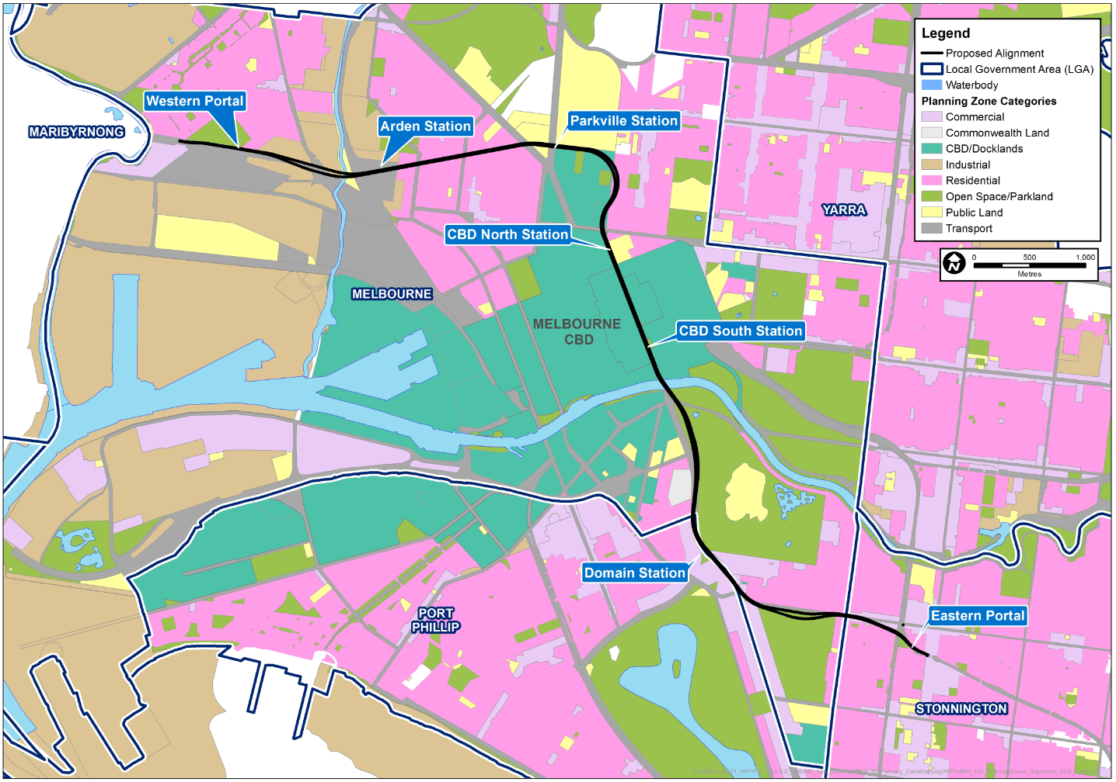

Planning Approval Mechanism

Use and Development
The development and use of Melbourne Metro would be enabled via a planning scheme amendment to the Melbourne, Port Phillip, Stonnington and Maribyrnong Planning Schemes, to be considered and approved by the Minister for Planning. Facilitation of the planning scheme amendment by the Minister for Planning recognises the state significance of the project, as well as its existence in current planning policy.
The planning scheme amendment would seek to insert an Incorporated Document into the four relevant planning schemes. The purpose of the Incorporated Document is to regulate the use and development of land for Melbourne Metro under the relevant planning schemes.
The Incorporated Document would exempt the need for a planning permit for Melbourne Metro (and ancillary activities) under any other provision of the four relevant planning schemes. Development would be undertaken in accordance with the specific conditions contained within the Incorporated Document without further planning approval being required.

Proposed Protection for Melbourne Metro Infrastructure
Melbourne Metro is a major infrastructure project within the inner region of Melbourne and there would be a need to identify and protect the tunnels, stations and associated infrastructure from future development that may impact its structural integrity and capacity to operate safety and efficiently. The project also has the potential to impact on future developments.
Three options to protect the tunnels have been considered. These options are not mutually exclusive:
- A legislative approach. This could include an amendment to the scope of Section 54 of the Transport (Compliance and Miscellaneous) Act 1983 to require persons who propose to develop land along or in the immediate proximity of Melbourne Metro to obtain approval from VicTrack (the authority owning and managing railway land and assets in Victoria) as was the approach for the Melbourne Underground Rail Link (City Loop). Alternatively, project-specific legislation could be enacted
- Amending the planning scheme to introduce a schedule to the Design and Development Overlay (DDO)
- Amending the Victoria Planning Provisions by including:
  - A new particular provision in Clause 52 of the relevant planning schemes to describe the type and location of permit applications that need to be referred to a referral authority
  - Introducing a project-specific overlay
  - Amending Clause 66.02 to describe the type and location of permit applications that need to be referred to a referral authority.
When developing the draft planning scheme amendment within the current statutory regime and using existing planning controls, MMRA was concerned to balance the need to protect Melbourne Metro from inappropriate development, while also achieving visibility in the planning system and integration with the planning permit process. Early consideration of the project infrastructure by future developments would assist design and decision-making for those developments.
The options to protect Melbourne Metro are outlined in detail in Technical Appendix E.
The preferred mechanism is to amend the relevant planning schemes to apply a Design and Development Overlay to land in the vicinity of the Melbourne Metro tunnels, stations and other infrastructure. The overlay would clearly identify the land to which it applies in the accompanying planning scheme maps. A Design and Development Overlay can be used to trigger planning approval for buildings and works within the Design and Development Overlay area and can require referrals of applications to either the Secretary of DEDJTR or VicTrack to ensure they have an opportunity to assess and advise on how a proposed development could impact on Melbourne Metro. The Cities of Melbourne, Port Phillip and Stonnington have all used this tool to manage design and built form within their municipalities and are familiar with Design and Development Overlays and their implementation.
A draft Design and Development Overlay forms part of the suite of potential planning controls in the draft planning scheme amendment for Melbourne Metro. The Design and Development Overlay is proposed to work in conjunction with the establishment of easements, title acquisition and strata acquisition.

Risk Assessment
An Environmental Risk Assessment has been completed for impacts of Melbourne Metro in relation to land use and planning. Further information about the risk assessment approach adopted for Melbourne Metro is included in Chapter 4 EES Assessment Framework and Approach and in Technical Appendix B Environmental Risk Assessment Report.
Impact assessment must be informed by risk assessment so that the level of mitigation action relates to the likelihood of an adverse impact occurring.
High and medium initial risk ratings were assigned to a range of land use and planning risks. The impact assessment focused on those risks that were assessed as having an initial risk level of medium or above. As a result of the impact assessment, project-specific and location-specific Environmental Performance Requirements, combined with proposed mitigation measures, have been recommended to reduce the identified impacts.
Achievement of the recommended Environmental Performance Requirements and implementing the proposed mitigation measures would be expected to reduce the residual risk ratings of all potential events to medium or low. The only land use and planning risk associated with Melbourne Metro with a residual risk of medium or above is shown in Table 9–2. A full list of land use and planning risks, showing the initial and residual risk rating of each risk, is provided in Technical Appendix B Environmental Risk Assessment Report and in Technical Appendix E.
The recommended Environmental Performance Requirements are listed in Section 9.19.
Table 9–2 Land use and planning risks
Impact pathway |  | Project phase | Precincts | Residual risk rating
Category | Potential event
Acquisition of properties | Acquisition of residential, commercial and retail titles, resulting in some changes in land use. | Design | 5 - CBD North station | Medium

Impact Assessment
As noted in Section 9.4.1, impacts resulting from Melbourne Metro have been divided into land use and built form impacts and conformity with strategic policy. Key impacts are summarised in the following sections. Specific impacts relating to each precinct are discussed in Sections 9.9 to 9.17.

Land Use
The main impacts associated with land use are related to the acquisition or occupation of properties and public open space.
In most cases, where land would be temporarily occupied during the construction phase, the primary land use would not change in the longer term and, therefore, the impact to land uses would be minimal. Land temporarily occupied during construction would generally be reinstated following the completion of works (where possible).
However, there are a few scenarios where there is potential for permanent land use change as a result of Melbourne Metro, particularly in the Arden and CBD North station precincts and in relation to a number of public open spaces within the proposed project boundary.
In the CBD North station precinct, the project would acquire 60 titles, 49 of which are residential titles. The land use would change from predominantly residential to transport purposes, although residential land uses may be reinstated as part of future over-site development at the station. Landowners and tenants would be compensated in accordance with the requirements of the Land Acquisition and Compensation Act 1986.
All public open space that is temporarily occupied for the purpose of the project would be reinstated following construction of the project. Small areas of public open space, located generally on the edge of public open spaces, would be permanently acquired for a station entrance or other infrastructure. Examples include City Square, Federation Square and the Shrine of Remembrance Reserve. In each of these cases, the use of land for a station entrance would not compromise the overall use of land for public open space in the long term.

Built Form
The built form impact of Melbourne Metro is generally considered acceptable as the majority of works would be located underground within road reserves or – where possible – in locations that have avoided acquisition of private land and impacts to places of heritage significance.
Where titles would need to be acquired permanently, the built form has the potential to change. However, the future use of the land would still need to be consistent with the provisions of the relevant planning schemes as they apply to each site. This would be particularly the case for titles acquired in the CBD in the Capital City Zone, where Melbourne Metro would support the function of the city centre. Any surplus land remaining upon completion of the project’s construction phase would be managed in accordance with relevant Victorian Government guidelines.
There would be some impact on the existing built form, particularly at CBD North and South stations. The required acquisition and demolition of buildings along Swanston, La Trobe and Flinders Streets for station entrances would alter the existing built form of the relevant precincts. However, there would be potential for replacement built form across these precincts as a result of future over-site development. Planning approval would be required for any future over-site development separate to Melbourne Metro.

Strategic Policy
The development of Melbourne Metro has been undertaken within the context of existing Commonwealth, State and local legislation and policy. Melbourne Metro is supported by government transport and land use planning strategies and studies, and has been designed with regard to the transport system objectives and decision-making principles of Victoria’s Transport Integration Act 2010, Plan Melbourne (the metropolitan planning strategy) and the relevant planning schemes. The selection of the design options for Melbourne Metro has been shown to best align with these relevant planning policies.
MMRA has had regard to the principles of the Transport Integration Act 2010 in developing the Concept Design. Melbourne Metro would deliver a range of benefits that align with the transport system objectives of Transport Integration Act 2010, including:
- Social and economic inclusion as more people are able to use the public transport system to access jobs and services
- Greater accessibility to jobs, improved freight efficiency and employment growth in the CBD, leading to economic prosperity
- Promotion of environmental sustainability by accommodating growing public transport use and alleviating vehicle traffic
- Integrated transport and land use, particularly at stations where there are station oversite and other development opportunities
- Improved transport efficiency and reliability.
Plan Melbourne is the Victorian Government's metropolitan planning strategy that will guide the city's growth to 2050. It seeks to integrate long-term land use, infrastructure and transport planning to meet Melbourne’s future population, housing and employment needs – and to identify the infrastructure, services and major projects needed to meet these needs. Plan Melbourne is being refreshed to reflect community and expert priorities.
The Plan Melbourne Refresh discussion paper (released in October 2015) acknowledges the ‘big challenges’ facing Melbourne as a result of projected population growth and the need to upgrade the city’s transport system to respond to growth pressures. The discussion paper notes that ‘as the city grows, Melbourne’s transport network will be under increasing pressure which will impact on productivity and the city’s liveability. Building new transport infrastructure will be a key part of responding to increased demand, particularly in the fast growing parts of the city’. Melbourne Metro is clearly aligned with the directions outlined in the discussion paper.
Plan Melbourne is currently referenced in the State Planning Policy Framework and, while the current plan does not reference the proposed alignment of Melbourne Metro, the idea of a ‘metro-style rail system’ accommodating Melbourne’s future travel needs is acknowledged.
Melbourne Metro is consistent with the State Planning Policy Framework, particularly the objective of Clause 11.04-3 (A more connected Melbourne) ’to provide an integrated transport system connecting people to jobs and services, and goods to market’. Melbourne Metro also supports the aim of Clause 18 (Transport) as it would act to ‘ensure an integrated and sustainable transport system that provides access to social and economic opportunities, facilitates economic prosperity, contributes to environmental sustainability, coordinates reliable movements of people and goods, and is safe’.
The project is also consistent with local planning policy as the Melbourne, Port Phillip, Stonnington and Maribyrnong Planning Schemes include directions to provide opportunities for development in locations with accessibility to public transport and identify the importance of integrated land use planning, infrastructure planning and sustainable transport to ensure growth and economic prosperity for their municipalities.
Further discussion about relevant legislation and policy is included in Section 3 of Technical Appendix E.

Precinct 1: Tunnels
Key issues related to land use and planning associated with Melbourne Metro in this precinct are:
- The vertical alignment would require the acquisition of underground strata of up to 3,500 Certificates of Title
- The CityLink tunnels cross the study area beneath Alexandra Gardens, Queen Victoria Gardens, Kings Domain and part of the Domain Parklands. At this location, impacts at ground level would require permanent reservation of Crown land
- Restrictions on access to public open space and community facilities such as the Fawkner Park Tennis Centre and child care facilities due to temporary occupation for construction purposes and permanent occupation by the emergency access shafts in Fawkner Park and Queen Victoria Gardens
- Potential temporary restricted access to existing dwellings and commercial/office uses due to construction activities and construction truck movements
- Future developments within the proposed project boundary may have similar construction timeframes, compounding potential amenity impacts.

Land Use
The potential land use impact in Precinct 1 is considered acceptable as the Melbourne Metro tunnels would be located primarily beneath existing road reserves and public open space with surface structures limited to station entrances, vents and emergency access shafts. The amount of surface land acquisition required would be limited and located on the fringes of open spaces and on titles where existing land use could be replaced post-construction. The impact of the project and the resulting land acquisition on land use would be minimal and has a residual risk rating of low.
The Melbourne Metro tunnels would require the underground strata acquisition from up to 3,500 titles that do not have specified depth limitations. Strata acquisition would be required to construct and operate the underground components of the project. To date, no existing or proposed basements have been identified that would be impacted directly by the tunnels; however, this would be continually monitored by MMRA throughout the design and construction phases of the project. Initially this is being carried out in conjunction with planning authorities to identify relevant planning permit applications. In addition, the tunnels and stations are proposed to be protected in the planning scheme through the application of a project-specific Design and Development Overlay (see Section 9.6.2).
Locations in Precinct 1 where there would be potential surface acquisition are the emergency access shaft locations in either Queen Victoria Gardens or Tom’s Block and the potential southern TBM launch site and/or emergency access shaft at Fawkner Park, or the southern TBM launch site at the Domain station construction work site. The southern TBM launch site would involve either Domain or Domain and Fawkner Park. The impact of the southern TBM launch site at Domain station is discussed in Section 9.15.
As the proposed emergency access shaft sites at Fawkner Park, Queen Victoria Gardens or Tom’s Block are located on Crown land, this would require the revocation of the existing Crown land reserves and temporary (and in some cases, permanent) reservation for the purpose of Melbourne Metro. The southern TBM launch site would only require temporary occupation.
The proposed construction work site at Fawkner Park would have an area of approximately 19,800 m², which would be a relatively small proportion of the total area of the park (approximately 410,000 m²). This equates to approximately 5 percent of the overall Fawkner Park area. Despite this, it is anticipated that Melbourne Metro would impact on the use of a broader area of the park due to noise, dust, vibration and access restrictions. The impact of the emergency access shaft options in either Queen Victoria Gardens or Tom’s Block would be acceptable as they would be small in scale and profile.
The majority of construction for the Tunnels precinct would be undertaken via a TBM or through mined excavation, which would limit impacts on access to existing land uses throughout this precinct. However, the proposed construction work sites to support the tunnelling would potentially create access issues for existing land uses as a consequence of road closures, land occupation and vehicle traffic, primarily associated with spoil removal activities.
Construction traffic associated with the project, in particular vehicles servicing the Fawkner Park construction work site, would directly impact on access to existing land uses, including the childcare centre and kindergarten for parents dropping off and picking up children. However, there may be potential to limit impacts through scheduling of truck movements to avoid conflict.

Built Form
Existing planning applications and relevant planning permits along the tunnels alignment have been reviewed (up until 15 December 2015) and there are no potential issues in relation to the use or development of land within, above or adjacent to the rail tunnels, apart from the desirability of protecting the Melbourne Metro infrastructure from new development.
The intent of the proposed Design and Development Overlay to protect Melbourne Metro structures would be ‘To identify areas which are affected by specific requirements relating to the design and built form of new development’. The Design and Development Overlay can be introduced as part of the planning scheme amendment for Melbourne Metro as discussed in Section 9.6.2.
This planning overlay is proposed to work in conjunction with the establishment of easements, title acquisition and strata acquisition. A discussion about the need for the Design and Development Overlay, as well as a discussion about the other available mechanisms, is provided in Technical Appendix A.
There are no planning permit applications or recent planning permits that would impact on the proposed TBM access shaft and construction work site at Fawkner Park or the proposed locations for the emergency access shafts. As a result, the impact on built form of Melbourne Metro is considered acceptable.

Strategic Policy
Proposed activities in Precinct 1 are generally consistent with the strategic planning policies and municipal planning controls relative to the precinct. Strategic planning policies generally relate to surface development and, as such, the proposed Fawkner Park TBM launch site and emergency access shafts have been considered against the existing strategic policy that applies for this precinct.
If the southern TBM launch site and emergency access shaft options were located in Fawkner Park, they would be subject to the City of Melbourne’s Open Space Strategy 2012 and relevant Master Plans. Discussion on compliance with planning policy related to the Domain station construction work site is included in Section 9.15. The Open Space Strategy identifies Fawkner Park as a regionally significant open space encouraging the community ‘outdoors to participate in organised sport, unstructured recreational activities and informal uses that promote social connectedness and community health and wellbeing’. The Fawkner Park Master Plan emphasises the significance of Fawkner Park’s historical layout as ‘a place for promenading and watching sporting activities’. The Fawkner Park Master Plan is still in the process of being implemented.
The proposed works would impact on the tennis courts, a path, a portion of a cricket oval (also used for softball and soccer) and an area used for informal recreation. The use of the park for promenading (or walking) and watching or partaking in sporting activities would be maintained in the majority of the park and the overall purpose of the land would be maintained. Many of the works in Fawkner Park would be contained within the area occupied by the tennis courts (which would be removed for construction). Post-construction, the land would be returned to public use as required by the City of Melbourne (except for a small portion that would be occupied by an emergency access shaft).
The proposed emergency access shaft site in Queen Victoria Gardens (Linlithgow Avenue) and the alternative design option in Tom’s Block would be located in the Domain Parklands, which is subject to the Domain Parklands Master Plan 1997 (the plan is currently in the early stages of being reviewed). The Master Plan describes the tenure and administration of the Parklands, identifying the Queen Victoria Gardens as Crown land reserved for memorial statues and public gardens and Tom’s Block as being reserved for public park and gardens. The Domain Parklands are also subject to Heritage Overlays and are listed on the Victorian Heritage Register.
The proposed emergency access shaft within Queen Victoria Gardens (Linlithgow Avenue) and alternative design option in Tom’s Block would not significantly impact on the use of the Parklands and therefore are considered to be generally consistent with the provisions of the Domain Parklands Master Plan. After construction, land would be returned to public use as required by the City of Melbourne (except for a small portion that would be used for the selected emergency access shaft).
The Moonee Ponds Creek Strategic Plan 2011 provides guidance for the development and protection of the entire length of Moonee Ponds Creek. Melbourne Metro would pass beneath Moonee Ponds Creek within this precinct and would not impact on the implementation of this Plan. A potential electrical substation location has been identified adjacent to the Moonee Ponds Creek and is discussed in Section 9.11.1.

Precinct 2: Western Portal (Kensington)
Key issues related to land use and planning associated with Melbourne Metro in this precinct would be:
- Loss of on-street car parking and street trees along Childers Street
- Loss of the shared path adjacent to Childers Street
- Acquisition of 25 private titles including nine residential properties within a Heritage Overlay (HO9 Kensington Precinct).

Land Use
The impacts to land use in this location are considered acceptable as the majority of permanent works would be undertaken within the existing rail corridor, with relatively limited impact on land outside the corridor. Consequently, the residual risk rating for impacts to land use and built form in this precinct is low.
This precinct requires the acquisition or temporary occupation of 26 titles for construction purposes and operation of Melbourne Metro. This includes 13 full titles and one part title (common area) within the 50 Lloyd Street Business Estate, nine residential properties, part of one property in the Hobsons Road Industrial Estate and one Council owned property (comprising two parcels) used for a shared pedestrian/bike path south of Childers Street.
The Hobsons Road Industrial Estate (comprising of two titles) would be occupied for a construction work site. The existing buildings on land identified for acquisition would be demolished. Land within the 50 Lloyd Street Business Estate required for acquisition would be reinstated post construction.
Occupation by the project would result in the temporary removal of commercial land uses from this precinct; however, it is likely that after construction is complete, this land (except for the proposed relief shaft and associated infrastructure) could be reinstated to industrial and business-related uses. Land acquired that is currently used for the shared path would not be reinstated following completion of the project.
The land immediately adjacent to the Maribyrnong River, which is identified for use as a project construction work site, is at the rear of 1-39 Hobsons Road in Kensington and is within the Hobsons Road Industrial Estate. The Mixed Use Zone, Incorporated Plan Overlay (Schedule 2 -Hobsons Road Mixed Use Area) and Heritage Overlay (HO239 -1-39 Hobsons Road) applies to this estate.
The Incorporated Plan Overlay (Schedule 2) supports the change of use of the land from industrial use to residential and commercial uses and gives guidance to any future development. Any buildings and works within land covered by the Incorporated Plan Overlay (Schedule 2) would require planning approval and should meet the requirements as set out in the Hobsons Road Incorporated Plan March 2008 and Incorporated Plan Overlay (Schedule 2). The Heritage Overlay (HO239) also includes requirements for proposed developments.
Land within the Hobsons Road Industrial Estate at 71-89 Hobsons Road (which is outside the proposed project boundary) is currently vacant and is used for storage of industrial materials. However, this land has been identified for redevelopment and is currently in the early stages of being developed for 182 dwellings, plus commercial use, in a building with a maximum height of six storeys.
The project impacts would be temporary and, at the completion of works, opportunities for redevelopment could be provided in accordance with the City of Melbourne’s strategic direction for the area and in line with the goals and objectives of the Incorporated Plan Overlay (Schedule 2).
The alternative design option at the western portal includes the relocation of the TBM retrieval box further west. This would limit private land acquisition to one residential property.

Built Form
As the majority of permanent works in this precinct would be located within the existing rail corridor, there would be a limited impact on built form. While the existing buildings and houses on the properties identified for acquisition would be removed, post-construction there would be potential for the reinstatement of built form of similar scale and form on most sites. Figure 9-2 shows the existing built form in this precinct.
The Heritage Overlay which applies to the residential properties identified for acquisition is a precinct-wide overlay that would not be significantly impacted by the removal of these properties (see Chapter 14 Historical Cultural Heritage).
The multi-unit, mixed use development at 71-89 Hobsons Road is outside the proposed project boundary but should be considered as an example of the type of development that could occur at 1-39 Hobsons Road in Kensington.

Strategic Policy
Precinct 2 adjoins JJ Holland Park, which is subject to the JJ Holland Park Concept Plan 2008. The plan identifies car parking as an issue in the area, but considers the provision of car parking along Childers Street as sufficient for the ongoing use of the park. The temporary removal of this car parking during construction would be likely to exacerbate parking issues in the area; however, much of the lost car parking in the area would be replaced at the completion of construction. Other than the added pressure on car parking in the area, Melbourne Metro would not impact on the implementation of the JJ Holland Park Concept Plan 2008.
Figure 9-2 Built form in the western portal precinct
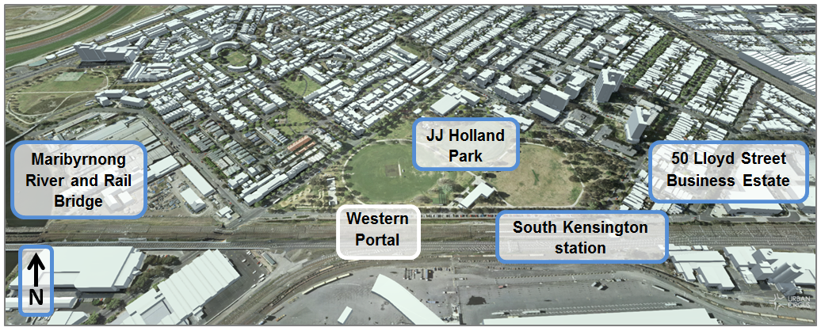
Source: DELWP, November 2015

Precinct 3: Arden Station
Key issues related to land use and planning associated with Melbourne Metro in this precinct would be:
- The buffer distances required around the proposed concrete batching plant
- Close proximity to sensitive residential uses in Munster Terrace and Laurens Street.

Land Use
As a whole, the impacts to land use in the Arden station precinct are acceptable from a land use perspective. The majority of land impacted is within the Public Use Zone 4 (Transport) and would be temporarily used to support the construction of Melbourne Metro. Other zones impacted include the Industrial 1 Zone (including substation options 1 and 3) and the Public Use Zone 1 (Service and Utility) (substation option 2). Substation option 4 is also within the Industrial 1 Zone, but is located within the western portal precinct.
As the majority of land is publicly owned, no land would need to be acquired (with the exception of the electrical substation option 4, which would require some private land acquisition and would prevent the return of the land to commercial uses after construction). The project would require the displacement of existing industrial uses through the discontinuance of existing leases on the public land.
The use of the land for a railway station is consistent with the draft Arden-Macaulay Structure Plan (City of Melbourne 2012). The Victorian Government and the City of Melbourne are developing a framework plan to guide the renewal of the area around the new Arden station over the next three decades. Further information on the Arden-Macaulay Structure Plan is provided in Chapter 2 Project Rationale and Benefits and in Section 10 of Technical Appendix E.
Associated works including the electrical substation and concrete batching plant may be required for the construction and ongoing use of Melbourne Metro and as the works are associated with railway uses, the existing Public Use Zone 4 (Transport) would be acceptable. As a result, the residual risk rating for this precinct is low.
Consideration does need to be given to the location of the potential concrete batching plant, particularly in relation to existing sensitive uses and the staging of future sensitive developments. Any development would need to be consistent with the master plan prepared in accordance with the Arden-Macaulay Structure Plan and any EPA requirements. The presence of two existing concrete batching plants on the site could provide opportunities for utilising existing use rights, should the contractor wish to pursue this.
The site is affected by a Land Subject to Inundation Overlay. The station entrances and vents are designed to address potential flooding issues with any future development of the site would be required to include flood mitigation measures. Further discussion regarding the management of surface water flows in the area is provided in Chapter 17 Surface Water. Figure 9-3 shows the extent of the Land Subject to Inundation Overlay across the Arden station precinct.
Figure 9-3 Land Subject to Inundation Overlay affecting the Arden station precinct
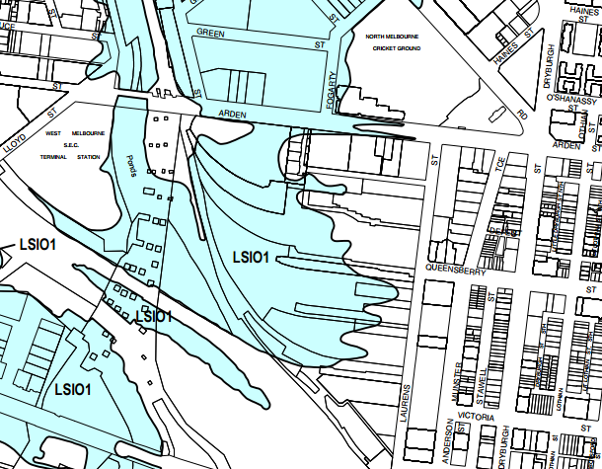
Source: Melbourne Planning Scheme, 2015
As stated, no property acquisition would be required for the station precinct as the land is publicly owned. However, of the four options associated with the proposed electrical substation, one title would be required for acquisition for option 4, as they are not located on publicly-owned land.
Potential impacts related to reduced amenity from the removal of spoil and construction activity are included in Chapter 8 Transport and Chapter 10 Social and Community.

Built Form
No current planning applications or recently approved developments in this precinct have the potential to impact on Melbourne Metro (as of 15 December 2015). Figure 9-4 shows the low scale built form in the area and identifies (in blue) the recently approved developments in the surrounding area that are yet to be completed.

Strategic Policy
Arden station is located within the Arden-Macaulay Structure Plan 2012 area, which identifies the Arden station and construction work site for future urban renewal and development. The City of Melbourne’s Open Space Strategy 2012 also identifies land within the precinct as incorporating potential future Capital City Open Space. Capital City Open Space is classified in the strategy due to its value to the City either as large parks and gardens for events and informal use, venues for major sporting events or public gathering spaces and squares focused around the Hoddle Grid and the Yarra River. These parks are identified as iconic and have appeal for visitors.
The provision of public open space would need to be incorporated into any master plan for the area, with the provision of such space being delayed until completion of Melbourne Metro works at Arden station in 2023.
Melbourne Metro would support the revitalisation of the precinct and change in intensity of land use, which is consistent with the Arden-Macaulay Structure Plan 2012. As such, consideration needs to be given to the staging of development and the potential buffer requirements of the temporary concrete batching plant to limit any existing and future impacts to residential uses. The preparation of the Master Plan should have regard to Technical Appendix M Urban Design Strategy.
Figure 9-4 Image of recently approved developments within the surrounding area (Arden station precinct)
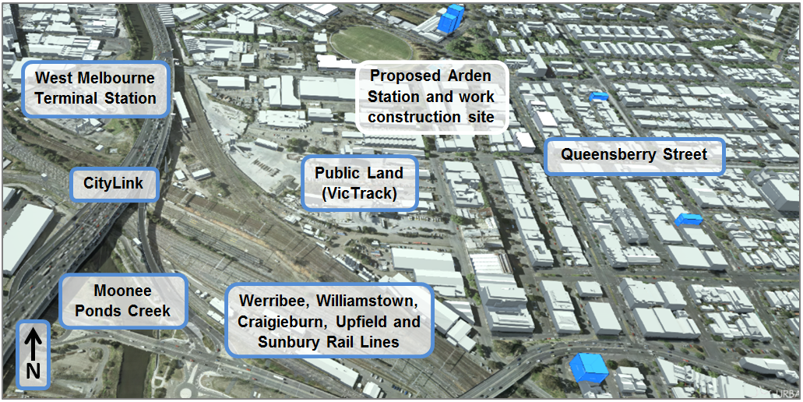
Source: DELWP, November 2015

Precinct 4: Parkville Station
Key issues related to land use and planning associated with Melbourne Metro in this precinct would be:
- The acquisition of two titles and one part title, as well as occupation of the City Ford site and part of University Square for a period of three years. One strata acquisition of a portion of land owned by the University of Melbourne would be required
- The temporary closure of Grattan Street between Royal Parade and Leicester Street and part of Barry Street between Grattan and Pelham Street, limiting vehicle access to the medical precinct and the University of Melbourne
- The maintenance of pedestrian access to properties surrounding the construction work site
- The heritage significance of street trees in Royal Parade and the overall loss of trees within the precinct with potential for reinstatement of street trees
- Reduction in public open space through the temporary occupation of part of University Square
- The presence of technology and sensitive equipment associated with the hospital and university within this precinct should be taken into consideration during construction to limit impacts on the use of sensitive equipment.

Land Use
Impacts to the Parkville station precinct are acceptable as the siting of the station would contribute to the ongoing development of the broader Parkville precinct. The proposed station is identified in the City North Structure Plan 2012 and acted as a catalyst for the rezoning of land in the precinct to the Capital City Zone as it would connect the Parkville National Employment Cluster to the Melbourne CBD. The new Parkville station would support continued growth in the Parkville area, enabling it to accommodate more people and jobs.
Land acquisition, occupation and strata acquisition would be required for construction in this precinct. Land within the University of Melbourne required for acquisition includes land along the northern side of Grattan Street for two proposed station entrances. Two further titles are identified for acquisition in Berkeley Street. Two titles, one of which has been leased to City Ford by the University of Melbourne and part of University Square (public open space managed by the City of Melbourne), would be temporarily occupied for approximately three years. It is anticipated that following construction, land within the University of Melbourne disturbed by construction activities but not required for station entrances would be reinstated to its previous use or could be integrated into future redevelopments by the University of Melbourne.
While the permanent acquisition and temporary occupation of land in the Parkville precinct would not result in a change of land use or the loss of dwellings, construction would impact temporarily on existing land uses in the area through:
- Increased noise, vibration and dust from construction and haulage
- Impacts on three sites listed on the Victorian Heritage Register in the University of Melbourne
- Reduction in amenity and public open space arising from the temporary occupation of the northern portion of University Square
- Increased congestion across the precinct from the temporary occupation of University Square
- Closure of part of Grattan Street and Barry Street during construction impacting on connectivity within the precinct and public accessibility of the Royal Melbourne Hospital, Royal Women’s Hospital, Victorian Comprehensive Cancer Centre and the University of Melbourne.
These impacts would be managed and or mitigated through various management measures as discussed in Chapter 8 Transport, Chapter 10 Social and Community, Chapter 11 Business, Chapter 12 Air Quality, Chapter 13 Noise and Vibration and Chapter 14 Historical Cultural Heritage.
As Melbourne Metro would not impact on the existing land uses on a permanent basis, the residual risk rating on land use and built form in this precinct is low.

Built Form
Within this precinct, there are no recent planning applications that would significantly impact the built form of the precinct or the Melbourne Metro development. The University of Melbourne has advised of plans to undertake redevelopment works, including but not limited to the following:
- Redevelopment of the City Ford site
- Underground connectivity across Royal Parade between station entries at the University of Melbourne and the Victorian Comprehensive Cancer Centre
- Creation of a direct pedestrian connection between the main campus and University Square through the closure of Grattan Street between Royal Parade and Swanston Street.
The timing of Melbourne Metro’s construction would allow for the integration of these future projects with the station entrances and station ventilation shafts. The project would increase the redevelopment potential of nearby land within the Parkville station precinct by delivering heavy rail to the precinct, acting as a catalyst for these projects and others. Figure 9-5 shows the general built form of the Parkville precinct and surrounds and identifies the recently approved developments.
Figure 9-5 Image of recently approved developments within the surrounding area (Parkville station precinct)
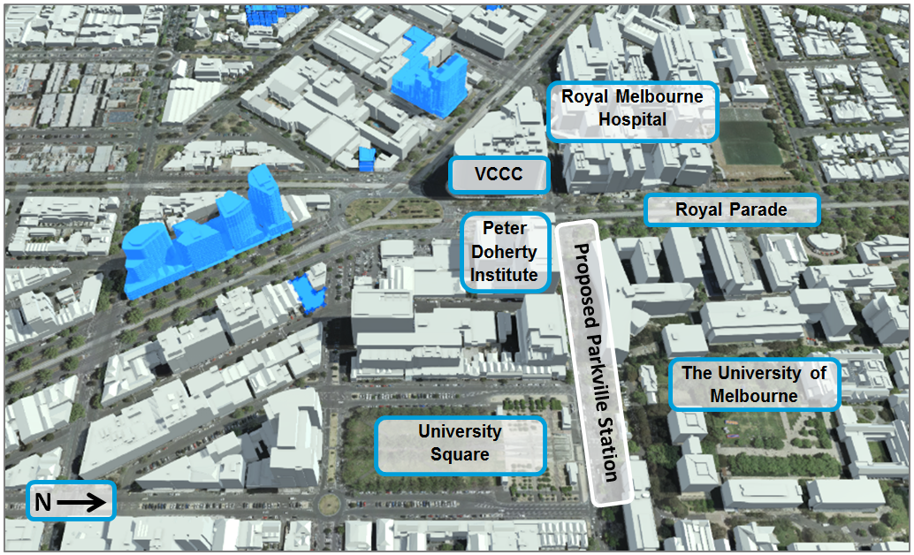
Source: DELWP, November 2015

Strategic Policy
A number of strategic policies are relevant to the development of Melbourne Metro near Parkville station. These include Plan Melbourne, City North Structure Plan 2012 and the University of Melbourne Parkville Master Plan.
Melbourne Metro is generally consistent with the objectives of Plan Melbourne, the metropolitan planning strategy guiding Melbourne’s growth to 2050. While currently under review, there are a number of objectives of Plan Melbourne relevant to Melbourne Metro such as supporting the development of Parkville as a National Employment Cluster (Initiative 1.5.1) and the development of a ‘Metro-style rail system’ (Initiative 3.1.2).
The City North Structure Plan 2012 and the associated recent rezoning of land to the south of Grattan Street to Capital City Zone (Schedule 5 – City North) is intended to support more intensive development of the area, essentially becoming an extension of the central city area. Melbourne Metro would support this aspect of the City North Structure Plan 2012 and would help to support the desired increase in density within the Parkville precinct.
The Structure Plan identifies the station location in this precinct and provides a framework to guide the development of the area as an extension of the Central City. As per the provisions of the structure plan, it would be unlikely that the future expansion of University Square (foreshadowed in the City North Structure Plan 2012) would be able to occur until Melbourne Metro is constructed. Further information on the City North Structure Plan 2012 is included in Section 11 of Technical Appendix E.
Melbourne Metro would contribute to the implementation of the University of Melbourne Parkville Master Plan, with MMRA working together with the University of Melbourne to develop this precinct in line with the aims of the Master Plan and the Melbourne Metro Urban Design Strategy (provided in Technical Appendix M).

Precinct 5: CBD North Station
Key issues related to land use and planning associated with Melbourne Metro in this precinct would be:
- A variety of buildings, including a residential apartment building, require acquisition
- A number of buildings that would be acquired currently have planning permits for redevelopment
- Limiting access to public institutions and services, such as RMIT and City Baths, during construction
- Loss of on-street car parking along parts of Franklin and A’Beckett Streets.

Land Use
The land use impacts within the CBD North station precinct are considered acceptable as the majority of works would be within the Swanston, A’Beckett and Franklin Street road reserves. However, the works would require the acquisition of 60 titles in this precinct, across nine buildings.
While some changes in land use would be temporary, there would be potential for permanent land use change resulting from potential future development over the station site. There would be potential for land uses, outside of the impacted road reserves, to be reinstated and any land redeveloped after construction would be subject to the provisions of the planning scheme.
Given the potential for land use change and the extent of acquisition in the precinct arising from Melbourne Metro’s development, the residual risk rating is medium.
In one building on La Trobe Street, 49 residential titles would be acquired. The loss of 49 residential properties within the Melbourne CBD is considered to be acceptable when viewed in the context of the CBD as a whole. There are a large number of residential vacancies within the CBD and it is likely existing tenants and landowners would be able to find alternate accommodation/assets within a similar budget.
The other sites proposed for acquisition are a mix of commercial, retail and office uses that would be easily accommodated within the CBD. The loss of existing residential and commercial uses may be supplemented at the completion of works through potential for over-site development above the station entrance at the corner of Swanston and La Trobe Streets. Future development will be guided by the relevant planning scheme requirements at the time the development is proposed. The availability of relatively similar alternative accommodation within close proximity and the creation of future development options reduce the impact of acquisition on residential and commercial land uses within the CBD North station precinct.
The heritage significance of buildings and places such as the City Baths and State Library forecourt would be respected, as the works would not directly impact on these sites. The impact on the heritage values of the precinct are discussed in Chapter 14 Historical Cultural Heritage.
The construction of surface infrastructure, such as the station entrance in the Franklin Street road reserve east of Swanston Street and the vent shaft in the A’Beckett Street road reserve west of Swanston Street, would require the closure of part of the road. The vent shaft in Franklin Street west of Swanston Street would require the narrowing or closure of a portion of the road.
The tunnels and station platforms in this location would be mined, with the construction work sites used to enable construction of the station cavern from underground. This technique would eliminate the need for the excavation of Swanston Street and reduce the surface impacts to existing land uses on Swanston Street and surrounding streets. However, there is likely to be some vibration and ground-borne noise impacts on nearby residences as a result of the use of roadheaders to construct the station cavern. This is discussed further in Chapter 13 Noise and Vibration.
One of the proposed construction work sites for this precinct would be on Franklin Street, between the main RMIT City Campus and the City Baths. While the works would not directly impact on RMIT owned buildings or the City Baths, and while access to Bowen Street would be maintained, there would be some impacts to access due to the closure of Franklin Street.
The siting of a station entrance in this location would result in the permanent loss of on-street car parking on the east side of Franklin Street. The benefit of siting a station entrance at this location outweighs the impact of the loss of car spaces.
The works in A’Beckett Street would result in its closure at Swanston Street, preventing access to and from Swanston Street during the construction phase. There is also potential for this section of road to remain closed post-construction for use as public open space. Alternative access to properties on A’Beckett Street would be available from the north via Franklin and Stewart Streets and west via A’Beckett Street. The potential impacts of the project on parking, transport and local traffic are described in Chapter 8 Transport.

Built Form
Four multi-storey developments have been permitted recently in the northwest corner block between Swanston, La Trobe, Elizabeth and Little La Trobe Streets:
- 377-391 Swanston Street
- 212-222 La Trobe Street
- Deakin House, 393 Swanston Street
- 224-252 La Trobe Street.
Of these approvals, two are on land identified for acquisition for the project. It is unlikely any of these developments would have been designed with any consideration of Melbourne Metro as they were permitted prior to the current design of the project.
The development potential of existing permits has the potential to be replaced by future over-site development at the station entrance site (as guided by planning controls at the time it is proposed). While over-site development is not part of the EES, facilitating future opportunities for redevelopment on properties that require acquisition would reduce the potential impact of Melbourne Metro.
Neighbouring developments at the former brewery site (Swanston Square) include a variety of large, multi-storey apartment and education buildings. Further development of Swanston Square is anticipated in the next two years, with approval granted for construction of a 77-storey residential tower. These large developments would greatly increase the population density of the area, as well as potentially increasing cumulative construction impacts should the site continue to be built on when Melbourne Metro is being constructed.
Figure 9-6 and Figure 9-7 show the existing built form (buildings shown in white and grey) and approved buildings in the CBD North station precinct, and surroundings, that are yet to be constructed (buildings shown in blue). These figures show the large scale of development likely to be undertaken within the immediate area of the precinct. These images have been provided by DELWP with input from the City of Melbourne and are based on information correct as of 30 November 2015. These images do not show any potential future over-site development above the Melbourne Metro station entry.
Figure 9-6 CBD North station precinct showing approved developments
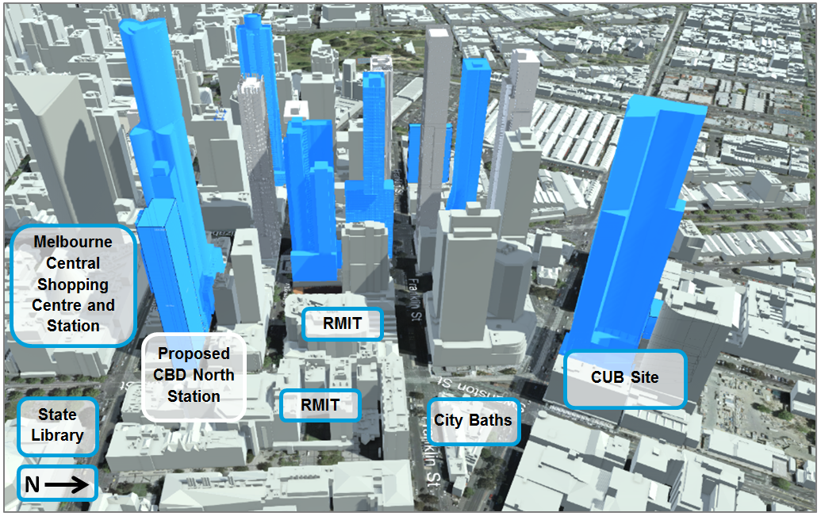
Source: DELWP, November 2015
The timing for construction for some of these developments is unknown and it is not certain that they would actually be built in accordance with the current endorsed plans or at all.
The completion of Melbourne Metro would support the redevelopment and revitalisation of this area of Melbourne’s CBD.

Strategic Policy
The City North Structure Plan 2012 includes the CBD North station precinct and seeks to guide the development of the city north area as an extension of the Central City. The Structure Plan identifies a number of sites adjacent to the CBD North station precinct, such as the former brewery site as redevelopment sites and community hubs. CBD North station would facilitate the implementation of this Structure Plan, as public transport provision in this part of the city would be enhanced, encouraging revitalisation of the area.
The Design and Development Overlay (Schedule 10 – Built Form Controls) provides interim built form and height controls impacting land in the CBD North station precinct. This 12-month interim control, which expires on 4 September 2016, provides DELWP and the City of Melbourne with the opportunity to review the existing controls and prepare permanent controls (via Amendment C270). Further information regarding the planning controls associated with this interim Design and Development Overlay, including the land affected by it, is provided in Section 12 of Technical Appendix E.
Any permanent controls would influence any potential over-site development at the CBD North station precinct.
Figure 9-7 CBD North station precinct showing approved developments
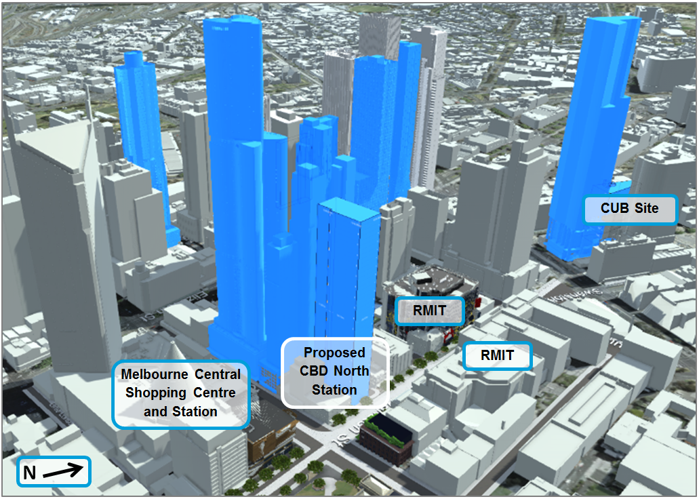
Source: DELWP, November 2015

Precinct 6: CBD South Station
Key issues related to land use and planning associated with Melbourne Metro in this precinct would be:
- Acquisition of land within the CBD retail core across 13 titles, including leases within Flinders Street Station and the Port Phillip Arcade building (including 29 tenancies), resulting in loss of retail and commercial uses
- Temporary occupation of City Square and part of Federation Square during construction and the ongoing use of part of both City Square and Federation Square as station entrances
- Constrained access to businesses for pedestrians adjacent to construction sites in the CBD and disruption to access due to the partial closure of Flinders Street during construction
- Potential impacts on the State heritage values of Young and Jackson Hotel, St Paul’s Cathedral, Flinders Street Station, Nicholas Building and Ross House during and post construction. The whole area is also covered by a precinct wide Heritage Overlay (HO505 Flinders Gate Precinct).

Land Use
The land use impacts in the CBD South station precinct are acceptable as there would be minimal land use change resulting from the development of Melbourne Metro.
The proposed station would require the acquisition of 13 property titles, including a number of car park spaces beneath City Square, permanent acquisition of part of City Square and Federation Square, and the temporary occupation of the whole of City Square. The majority of acquisitions are commercial buildings on the west side of Swanston Street between Flinders Street and Flinders Lane.
The acquisition of these properties would not impact on the land use character of the area, as there are many retail stores along Swanston Street and in the retail core. There are multiple outlets for each fast food chain within the CBD.
The productivity of businesses in the Westin Hotel building fronting City Square is expected to be either lost entirely or significantly reduced during the temporary occupation of the Square. Business impacts associated with the project are discussed further in Chapter 11 Business.
Construction in this location would result in the loss of retail properties. There are opportunities for the re-establishment of businesses within the new development, reducing the impact of land use change. This is consistent with Clause 21.12 Hoddle Grid of the Melbourne Planning Scheme, which requires developments along Swanston Street to ‘ensure the ground level design of shop fronts… contribute to its role as a pre-eminent retail and lifestyle avenue and entry axis to the Retail Core’. The station building design includes retail shop fronts on Swanston Street, which would contribute to the continued use of the ground level of Swanston Street as part of the retail core of the CBD.
Construction activity in City Square would result in a temporary loss of public open space. While a railway station is a prohibited use in the Public Park and Recreation Zone of the Melbourne Planning Scheme which applies to City Square, public open space would remain the predominant use of the space upon project completion. The planning scheme amendment proposes to provide for a project-specific control that would allow for uses that would otherwise be prohibited.
Federation Square is located in the Capital City Zone and provides public open space within the central city area. While the permanent acquisition of a small part of Federation Square for a station entrance would result in a small loss of public open space, station entrances in Federation Square and City Square are considered to be an appropriate use of this land as they would support the ongoing function of the central city.
While there would be constrained access for pedestrians and vehicles adjacent to the station entrances during construction, the mined cavern construction methodology adopted for the station means that access would be maintained along Swanston Street, as well as to Young and Jackson Hotel. There is however, a risk that construction activity would impact on the economic success of businesses in this locality due to access and amenity impacts in the broader precinct. This is discussed further in Chapter 11 Business.

Built Form
The built form in the precinct would be impacted during construction as a number of buildings would be demolished. Despite this, as the buildings removed are generally low rise and not of significant architectural value, the impact on built form in the CBD South station precinct is acceptable.
City Square is a landmark open space area that would be unavailable during construction. However, as noted above, the long-term use of the majority of the site would revert back to public open space upon the completion of construction and its primary use and built form would remain as public open space. Consequently, the residual risk rating for built form in this precinct is low.
CBD South station would act as a catalyst for change and reinvigorate a block of the CBD that is currently tenanted by lower value retail tenancies. The increased connectivity of the CBD South station precinct provided by Melbourne Metro, as well as increased pedestrian traffic and future over-site development, would provide retail opportunities in the area and act as a lure for quality retail and food tenancies. There would be potential for future invigoration of the station connections below ground level through commercial and retail opportunities at sub-surface level.
Figure 9-8 illustrates the low scale built form within this precinct.

Strategic Policy
The interim Design and Development Overlay (Schedule 10 – Built Form Controls) discussed in Section 9.13.3, also applies to CBD South station precinct. Melbourne Metro would support the implementation of the interim Design and Development Overlay by providing enhanced public transport in this part of the city and encouraging revitalisation of the area.
Figure 9-8 Built form in the CBD South station precinct
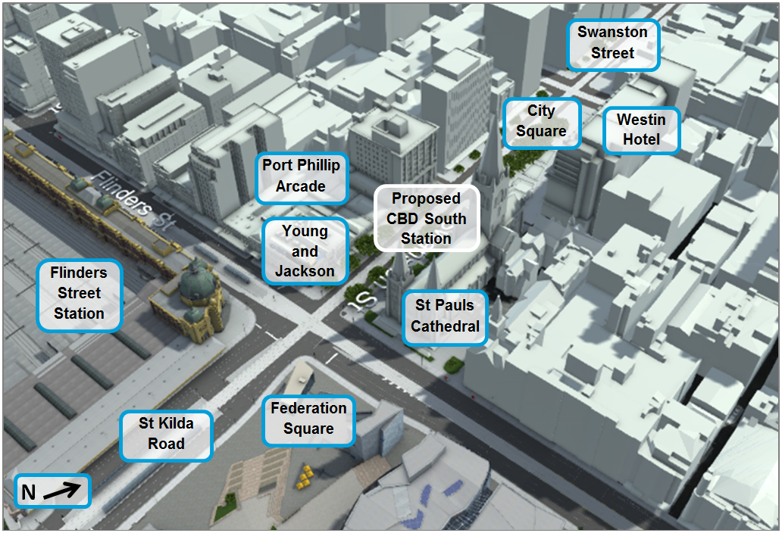
Source: DELWP, November 2015

Precinct 7: Domain Station
Key issues related to land use and planning associated with Melbourne Metro in this precinct would be:
- Permanent loss of a small part of public open space within the Shrine of Remembrance Reserve and a large portion of the Albert Road Reserve
- The temporary loss of public open space at the Edmund Herring Oval
- Loss of trees along St Kilda Road, Albert Road and in the Albert Road Reserve
- Temporary closure of Domain Road between St Kilda Road and Dallas Brooks Drive and the partial closure of lanes on St Kilda Road in stages during construction
- Restricted access to existing buildings around construction sites and movement through the precinct.

Land Use
The impact on land use within this precinct is acceptable as there would be no private land acquisition. While Crown land within the Shrine of Remembrance Reserve and the Albert Road Reserve would be used as temporary construction work sites and station entries, the dominant use of these spaces would be returned to public use post-construction.
Edmund Herring Oval in the Domain Parklands would be temporarily occupied for use as a construction work site and reinstated as public open space post-construction. Consequently, the residual risk rating within Domain station precinct is low.
The Shrine of Remembrance Reserve and the Albert Road Reserve are within the Public Park and Recreation Zone of the Melbourne and Port Phillip Planning Schemes respectively. Within this zone, a railway station is a prohibited use. However, post-construction, the public open space acquired for the station entries or construction work areas would be returned to their dominant use of public open space, with the station encouraging visitors to this area.
The planning scheme amendment proposes to provide for a project-specific control that would allow for uses that would otherwise be prohibited. The station would support the ongoing commercial and recreational activity in this area, including the provision of an underground walkway between the east and west sides of St Kilda Road. This link would improve safety for pedestrians and eliminate the need to cross busy St Kilda Road at ground level at this point in the road.
Post-construction, there would be opportunities to provide an improved open space area in the Albert Road Reserve for the community and surrounding office workers. See Section 14 of Technical Appendix E for a more detailed discussion of this aspect of the project.
The Domain tram interchange would be relocated but would remain within the existing road reserve of St Kilda Road, so there would be no significant change in land use. The proposed location of the tram interchange is unlikely to have a significant impact on surrounding land uses, with the detailed design of the infrastructure to be confirmed at a later stage of the project. The proposed pedestrian underpass beneath St Kilda Road, associated with the Domain station, would provide a safer and more direct option for getting to and from the interchange, the Shrine of Remembrance Reserve and Melbourne Grammar School. More details regarding the transport impacts within Precinct 7 are provided in Chapter 8 Transport.
The proposed works would result in the loss of a number of trees across the precinct, including street trees along St Kilda Road and Albert Road and within the Albert Road Reserve and Shrine of Remembrance Reserve. Tree removal would impact on the valued landscape character of St Kilda Road. It is proposed to replace trees along St Kilda Road in consultation with Councils and VicRoads. Further information regarding trees and visual amenity impacts is included in Chapter 16 Landscape and Visual.
The closure of Domain Road during construction would restrict access around the station precinct, particularly when trying to access Melbourne Grammar School and the Shrine of Remembrance Reserve. The impact of this road closure would be minimised as there are alternative access routes available to both these land uses and around the construction work site, and through access would be retained along St Kilda Road during works. Traffic alterations required along St Kilda Road during construction are discussed in Chapter 8 Transport.
There would be constrained access for pedestrians adjacent to the construction work sites, and restricted access to part of the public open space (Albert Road Reserve and a small part of the Shrine of Remembrance Reserve) during construction; however, access would be maintained to businesses and residents surrounding the proposed construction work sites.
Domain station would have limited long-term impact on the land use surrounding the precinct. Post-construction, the only change in land use in this precinct resulting from Melbourne Metro would be at the station entrances. During construction, there would be a number of disruptions to surrounding land uses within the area, mostly due to the impact of construction activities on the local traffic network, access and amenity in the area. These impacts are discussed further in Chapter 8 Transport and Chapter 10 Social and Community.

Built Form
The impact on built form of the Domain station entrances would be acceptable as their scale and layout would be minimal. The residual risk rating of the project’s impact on built form is low.
While there are a number of recent and current planning permit applications within the Domain station precinct, these would not impact on or be impacted by the construction or operation of Melbourne Metro.

Strategic Policy
The new Domain station would impact upon land within the Domain Parklands Master Plan (City of Melbourne) and St Kilda Road North Precinct Plan 2013 (and associated Planning Scheme Amendment C107) (City of Port Phillip).
The Domain Parklands Master Plan provides a broad strategic direction for the Domain Parklands as a whole and was prepared by the City Melbourne in 1997. The Master Plan is currently being updated. Melbourne Metro does not impact on the implementation of the current Domain Parklands Master Plan and any precinct plans prepared for this area of the Parklands would have regard to Technical Appendix M Urban Design Strategy. Melbourne Metro would support the continued use of the Domain Parklands by increasing accessibility to the location.
The City of Port Phillip has submitted Planning Scheme Amendment C107 to the Minister for Planning for approval. The Amendment seeks to implement a series of built form and height controls that are derived from the St Kilda Road North Precinct Plan 2013. The Precinct Plan responds to the changing character of the area, with a shift away from commercial uses to an increased demand for residential apartments. While Domain station is within the area affected by the new Design and Development Overlay (Schedule 26 – St Kilda Road North Precinct), which requires the consideration of the development on the views to and from the Shrine of Remembrance and the St Kilda Road boulevard, only station entrance structures and minor other station infrastructure would be affected. The station would not impact on Planning Scheme Amendment C107 or the new Design and Development Overlay.
Amendments to the Melbourne, Port Phillip and Stonnington Planning Schemes were approved in 2014 to implement the findings of ‘The Shrine of Remembrance, Managing the significance of the Shrine, July 2013’ planning study. The amendments strengthened the planning polices and controls applicable to land that forms the setting and background of the Shrine of Remembrance. The concept design of the proposed station takes these views into consideration, and further detailed design would have regard to this Precinct Plan and Technical Appendix M Urban Design Strategy.
Further strategic policies are discussed in more detail in Section 14 of Technical Appendix E.
Figure 9-9 illustrates the existing built form in the precinct. Proposed development is not identified in this image.
Figure 9-9 Existing built form surrounding the Domain station precinct
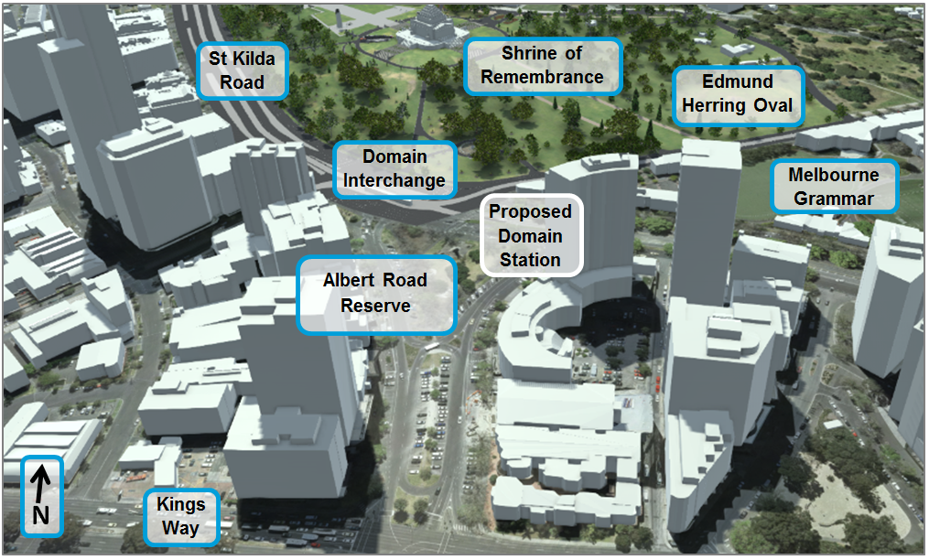
Source: DELWP, November 2015

Precinct 8: Eastern Portal (South Yarra)
Key issues related to land use and planning associated with Melbourne Metro in this precinct would be:
- Temporary reduction of public open space of the South Yarra Siding Reserve and Osborne Street Reserve and pedestrian access via Lovers Walk
- Acquisition of seven residential properties
- Impacts on access through the precinct due to the high volumes of construction traffic and road closures
- Construction of a vent shaft and other surface structures adjacent existing residential properties on Osborne Street.

Land Use
This precinct includes a highly urbanised area within South Yarra. However, Melbourne Metro in this location is considered acceptable from a land use impact perspective, as the majority of works would be located within the existing rail corridor and on surrounding public open space, with nine private titles required for full land acquisition plus one for partial strata acquisition. Thirteen titles would be acquired, including private residences and publicly owned (VicTrack) land on Arthur Street and Osborne Street (including the car park on Arthur Street), to support construction activities. South Yarra Siding Reserve would be temporarily occupied during the construction phase.
The private titles identified for acquisition would be acquired in accordance with the Land Acquisition and Compensation Act 1986. The land use impact on the eastern portal precinct is considered to have a low residual risk rating.
The acquisition of private residences would not impact on the long-term land use character of the precinct. The area would remain as a mix of residential and commercial uses and the character of the area would be maintained. Post-construction, some of the acquired sites would be available for redevelopment in accordance with the Stonnington Planning Scheme and any relevant Structure Plans.
The occupation of South Yarra Siding Reserve, Osborne Street Reserve and Lovers Walk for up to five years would result in a temporary loss of public open space. While this would be inconsistent with the purpose of the zone, there would be the opportunity to redevelop the sites to provide a more functional and enhanced public open space post-construction. The Chapel reVision Structure Plan 2013–2031 identifies the opportunity to develop a ‘Village Square’ on the south side of Toorak Road above the existing railway line. While the decking to construct the ‘Village Square’ is not part of the EES, the design of the portal in this precinct would not preclude potential over-site development at a later stage.
Due to the constrained nature of the proposed construction area, and the current single entry point to the South Yarra Siding Reserve, there would likely be access restrictions in parts of the precinct. The surrounding streets are narrow and busy and would be required to support construction traffic for approximately five years. The William Street bridge would need to be removed for the duration of construction and reinstated post construction. This would impact on local traffic and access would no longer be possible to one property. A bridge would be built to provide construction access from Osborne Street to the South Yarra Siding Reserve. This bridge would be retained post-construction for pedestrian access to the reserve. Impacts from construction traffic are discussed in Chapter 8 Transport.

Built Form
The acquisition of a number of private titles and use of public open space during construction would be an acceptable impact on the built form of the eastern portal precinct.
There are a number of recent planning permit applications within the precinct, some directly affected by Melbourne Metro. Where approvals have been granted on acquired sites, compensation would take this into consideration.
The former South Yarra Post Office (VHR H210), which has a modern extension to the rear, and the former South Yarra station (VHR H1068) are listed on the Victorian Heritage Register. Melbourne Metro would not impact on these buildings and their heritage significance would be protected, including view lines to the buildings along Toorak Road.
Figure 9-10 illustrates the existing built form in the precinct.

Strategic Policy
Within Precinct 8, the Forrest Hill Structure Plan and the Chapel reVision Structure Plan 2013–2031 are intended to guide development of much of the area directly adjacent and within the study area at the proposed eastern portal. Melbourne Metro would support the implementation of these policies.
Figure 9-10 Built form surrounding the eastern portal precinct
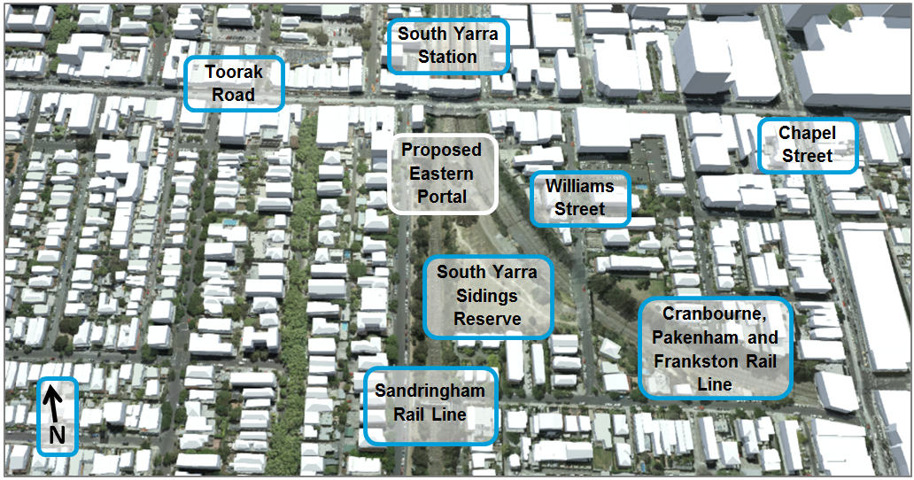
Source: DELWP, November 2015

Precinct 9: Western Turnback (West Footscray)
Key issues related to land use and planning associated with Melbourne Metro in this precinct would be:
- Alterations required to the concourse at West Footscray station
- The proximity of residential land uses to some of the proposed rail corridor works
- The temporary loss of 26 car spaces within the station car park during construction.

Land Use
The proposed works would be wholly contained within the rail corridor and would be consistent with the purpose of the zone. In terms of land use and built form, the residual risk rating for the western turnback precinct is considered low and, therefore, the impacts of Melbourne Metro to the precinct are considered acceptable.
Other than potential amenity impacts during construction, such as construction noise and an increase in construction traffic, there would be limited impacts on surrounding land uses. The turnback at West Footscray station would not inhibit future use of the site as part of any future Melbourne Airport Rail Link project. As such, the project is consistent with the requirements of Development Plan Overlay (Schedule 11 – Melbourne Airport Rail Link Development Plan), which requires that proposed works do not prejudice the future construction of the Melbourne Airport Rail Link.
No land acquisition would be required as the works would be confined to the existing rail corridor.
Access to surrounding land would not be impacted except through the increase in construction traffic on surrounding roads.

Built Form
The proposed works would not impact on the built form of the precinct. Figure 9-11 shows the current built form in the precinct.
Figure 9-11 Built form surrounding the eastern portal precinct
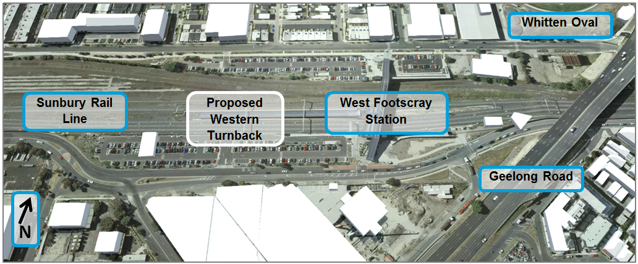
Source: DELWP, November 2015

Strategic Policy
As the works would be wholly retained within the rail corridor, there are no strategic policies that require consideration, with the exception of the Design and Development Overlay and Development Plan Overlay under the Maribyrnong Planning Scheme that relate to the development of an Airport Rail Link. Melbourne Metro would not inhibit the construction of an airport rail link as per these planning policy controls. Furthermore, Clause 21.09 (Transport) of the Maribyrnong Planning Scheme identifies Melbourne Metro as a high priority as it would provide linkages ‘connecting Footscray to Parkville and the Melbourne CBD’. As such, the Maribyrnong Planning Scheme supports the development of Melbourne Metro.

Early Works
Key issues related to land use and planning associated with Melbourne Metro in regard to early works would be:
- Temporary road closures or altered access arrangements due to construction works and tram works
- Potential for temporary disruption to utility services during construction
- Potential amenity impacts (noise, dust) for land uses surrounding the construction work sites, particularly the re-routing of the route 8 tram.

Land Use
Early works would be required prior to the commencement of the main construction works. These works are related to existing utility services and comprise modifications and relocations of electrical and telecommunication conduits, gas, water, stormwater and sewage pipeline infrastructure and tram works.
All early works are located within the proposed project boundary and are subject to assessment as part of the EES. Most works would involve underground protection or relocation of utilities within road reserves or rail reserves, with no impact on adjacent land uses.
The following key components have been identified as potentially impacting on existing land uses:
- The relocation of two high voltage transmission towers within the western portal precinct, with each relocated high voltage tower potentially requiring land of approximately 100 m² (10 m x 10 m) and an easement 37 m wide (13 m either side of the tower). The towers would be relocated to publicly-owned (VicTrack) land, with the exception of a temporary tower to be constructed within the Hobsons Road Industrial Estate (which would be subject to temporary occupation)
- The realignment of the South Yarra Main Sewer to avoid the new Domain station. The majority of works would be below ground and would not impact on land use and built form
- Construction of tram infrastructure on Toorak Road West between St Kilda Road and Domain Road to divert the route 8 tram from Domain Road and Park Street and remove tram infrastructure along Park Street and Domain Road. The tram works along Toorak Road West and the removal of the tram tracks on Domain Road would have an impact on land uses in the area as these would be major road works. Amenity and traffic impacts would be likely for residents and public transport access to the existing retail businesses on Domain Road would be likely to be reduced. Further discussion on these issues is included in Chapter 8 Transport
- Other works, such as construction of new water mains and stormwater drains and pipes, new sewerage pipes and associated manholes, and relocation of existing telecommunication cables and conduits.
No property acquisition would be required for these early works and it is unlikely they would impact on any current or proposed developments. Any impacts to private land would only be where utility service connections to the private land need to be maintained.

Built Form
There would be no impact on built form as a result of early works, due to their low impact nature.

Environmental Performance Requirements
As noted in Section 9.8, measures are available to avoid or minimise land use and planning impacts during construction and operation. Table 9–3 shows the recommended Environmental Performance Requirements and proposed mitigation measures for Melbourne Metro in relation to land use and planning.
The risk numbers listed in the final column align with the list of land use and planning risks provided in Technical Appendix B Environmental Risk Assessment Report.

Table 9–3 Environmental Performance Requirements for Land Use and Planning
Draft EES evaluation objectives | Environmental Performance Requirements | Proposed mitigation measures | Precinct | Timing | Risk No.
Built environment  – To protect and enhance the character, form and function of the public realm and buildings within and adjacent to the project alignment, and particularly in the vicinity of project surface structures, having regard to the existing and evolving urban context | Develop and implement measures for construction and operation of Melbourne Metro that aim to minimise impacts to the development and/or operation of existing land uses, including:  - Limiting the permanent change of use within existing public open space  - Minimising footprints of construction sites and permanent infrastructure on public land  - Minimising impacts to existing public open spaces and recreational facilities and the users of these facilities, including but not limited, to JJ Holland Park, University Square, City Baths, City Square, Federation Square, the Shrine of Remembrance and the Shrine Reserve, Domain Parklands, Edmund Herring Oval, Fawkner Park and Albert Road Reserve  Such measures must be developed in consultation with affected land managers for public land. | Ensure proposed works are appropriately located to limit impacts on the site  Undertake strata and, where required, full acquisition of titles where conflict exists  Minimise the construction footprint where possible  Use the proposed DDO to protect Melbourne Metro infrastructure and trigger discussions with third party developers regarding future development  Demonstrate that construction work sites have been optimised to reduce their footprint on the parklands and/or landmarks  Avoid the use of the Shrine of Remembrance Reserve for construction activities unrelated to the station entrance  Ensure that open space and associated facilities are reinstated post construction  Incorporate proposed works with the planned future development of the University of Melbourne  Provide for temporary relocation of households in proximity to construction zones with restricted access and/or amenity impacts  Use hotels/motels or other temporary accommodation for short term disruptions  Where relocation is longer term, make use of service apartments or provide for alternative rental properties  Communicate construction timeframes with potential developers  Selection of construction equipment/construction methodology  Consultation with affected institutes  Potential redevelopment of the CBD North station precinct to have regard to the City North Structure Plan, Plan Melbourne and the Capital City Zone (Schedule 5 - City North Area)  Compliance with the Melbourne Planning Scheme and implementation of the DDO to identify and protect Melbourne Metro from future development impacts  Consultation with affected landowners and tenants | All | Construction/ Operation | LU001 to LU008
 | Development of the project is to have regard to the relevant Open Space Master Plans (including but not limited to, the Domain Parklands and Fawkner Park Master Plans) in designing and constructing above-ground infrastructure for the tunnels.  Consultation must occur with land managers and/or agencies responsible for the implementation of the relevant Open Space Master Plans. | Refer to above Environmental Performance Requirements in relation to public open space | All | Construction/ Operation | LU002  LU005  LU006
 | Design and construction of Arden station must consider the ongoing strategic planning of the Arden-Macaulay Urban Renewal Area and include consultation with the Metropolitan Planning Authority, City of Melbourne and any other relevant agencies | Prepare a Master Plan having regard to the Melbourne Metro Urban Design Strategy to guide future development in Arden-Macaulay | 3 - Arden station | Construction | LU003  LU007  LU008
 | Prior to the development of the detailed design of all permanent structures, prepare and implement strategies in accordance with the Urban Design Strategy and relevant planning schemes that cover:  - Public arts and cultural strategy  - Wayfinding, signage and advertising  The strategies must be developed in consultation with relevant local Councils and land managers. | No mitigation measures | All | Design | LU008
Refer also to the recommended Environmental Performance Requirements in relation to social and community, business and landscape and visual impacts. These requirements and proposed mitigation measures are provided in Chapters 10, 11 and 16 respectively.

Conclusion
The land use and planning impact assessment found that the following land use impacts would need to be addressed to ensure consistency with the relevant draft evaluation objectives:
- Land acquisition within a precinct and the resulting potential for some land use change – Future land use and built form would need to be undertaken in accordance with the relevant planning policy and strategic planning guidance, as well as with consideration of the Melbourne Metro Urban Design Strategy. Underground strata acquisition would not result in any land use change; however, the development potential of the site would be determined by the provisions of the relevant planning scheme
- Potential constraints on future development potential of land due to the presence of the underground infrastructure – A Design and Development Overlay is proposed to be applied along the alignment to protect Melbourne Metro’s underground infrastructure and to trigger referral of particular types of planning permit applications with the potential to impact on the infrastructure and existing and future structures in the vicinity
- Potential for access issues to impact on existing land uses – These are generally considered temporary issues during construction
- Potential land use change within the CBD North station precinct as a result of the acquisition of land for the station development
- The loss of public open space for use as a temporary construction site or station entrance in several precincts. It is considered that Melbourne Metro would generally contribute to the main function of the land for public purposes and would not change the ultimate use of the land in the future.
Each impact has been considered and found to be acceptable.
Overall, the project provides a land use and built form benefit as it would act as a catalyst for change at station locations, improving accessibility and providing the potential for revitalisation of land use within the study area and to some extent across Melbourne. Other key benefits include:
- Delivery of a significant project that has relatively limited impact on above ground land uses, especially given the scale of the project, as the tunnels limit the permanent impact to land use and the built environment
- Opportunities for improving public open space at the completion of the project through legacy works at City Square, Federation Square, University Square, Fawkner Park, Albert Road Reserve and South Yarra Siding Reserve
- The use of publicly owned land at Arden for a station and a major construction site limits private land acquisition and would invigorate extensive urban renewal in the area
- Opportunities to incorporate the proposed works with future planned development of land including at Arden, Parkville, CBD North and CBD South
- Enhanced connections through precincts and opportunities for improved train, tram, and bus interchanges at Parkville, CBD North, CBD South and Domain stations
- Enabling opportunities for over-site development, particularly in the CBD, as appropriate, to allow for future replacement of land uses removed as part of the project, therefore lessening the impact on existing land use and built form.
Impacts would be managed by achieving the recommended Environmental Performance Requirements and implementing the proposed mitigation measures. This would ensure that Melbourne Metro would meet the draft evaluation objectives set by the EES Scoping Requirements.

