Executive Summary
The Victorian Government is proposing to build the Melbourne Metro Rail Project (Melbourne Metro) to connect the Cranbourne/Pakenham Line to the Sunbury Line through the construction of new twin nine-kilometre rail tunnels and five new underground stations.
Melbourne Metro would facilitate the transformation of Melbourne’s rail network into an international-style metro system, boosting the capacity of the rail network to keep pace with Melbourne’s growing and changing travel needs as the city’s population grows to 6 million by 2031 and nearly 8 million by 2051 (DTPLI, Victoria in Future 2015).
Melbourne Metro would provide the foundation for expanding Melbourne’s public transport network, helping to ensure Melbourne remains one of the world’s most liveable cities now and into the future. Melbourne Metro would also catalyse significant urban renewal, opening up opportunities for new housing, commercial development and jobs close to the city centre. With accessibility and connectivity the hallmarks of a successful city, there is a clear need to upgrade Melbourne’s metropolitan rail network to provide viable public transport options for the city’s growing population.
As Melbourne continues to grow, its economy is shifting away from a traditional reliance on manufacturing to one based around knowledge-based services. The distribution of employment across the metropolitan area is also changing, with growth in service-based jobs increasingly concentrated in the CBD and manufacturing-based industries moving to the city’s outer growth areas. These changes in the pattern of population and jobs growth are already straining Melbourne’s infrastructure and services, with a growing demand for travel putting the city’s transport networks under pressure.
The rail network is carrying more passengers than ever before, the fastest growing train lines are rapidly approaching capacity and many peak period services suffer from chronic overcrowding and unreliability. By 2031, average weekday boardings on metropolitan trains are forecast to double from 750,000 to 1,500,000. This unprecedented patronage demand would exceed the capacity of the city’s metropolitan rail services during peak times and exacerbate overcrowding and delays.
Melbourne Metro would deliver a substantial uplift in capacity across the rail network, allowing more people to travel by train in the morning and evening peak periods.
In September 2015, the Minister for Planning determined that Melbourne Metro required assessment under the Environment Effects Act 1978. The Environment Effects Statement (EES) for Melbourne Metro provides an integrated assessment of the potential environmental, social and business impacts associated with the construction and operation of Melbourne Metro.
The EES evaluates the potential effects of the project on a local and project-wide basis and recommends Environmental Performance Requirements that define the project-wide environmental outcomes that must be achieved during the design, construction and operation of Melbourne Metro to avoid, manage or mitigate these impacts. The recommended Environmental Performance Requirements – which have been informed by possible mitigation measures –define the outcomes to be achieved to avoid, manage or mitigate the identified impacts.
Achieving these Environmental Performance Requirements would result in a manageable number of adverse impacts occurring during the construction and operation phases of Melbourne Metro. Most of these impacts would be temporary and would occur during construction.

Melbourne Metro Rail Project
The infrastructure proposed for construction as part of Melbourne Metro and assessed in this EES includes:
- Twin nine-kilometre rail tunnels from Kensington to South Yarra, travelling beneath Swanston Street in the Melbourne CBD and connecting the Sunbury and Cranbourne/Pakenham railway lines to create a new Sunshine to Dandenong line
- Five new underground stations at Arden, Parkville, CBD North, CBD South and Domain, with CBD North and CBD South stations featuring direct interchanges with the existing Melbourne Central Station and Flinders Street Station respectively
- A new transport interchange at Domain
- Rail tunnel portals (entrances) at Kensington and South Yarra.
The project would also require track work (a turnback) at West Footscray to enable trains using the Sunbury Line to turn around before reaching Sunbury and head back through the Melbourne Metro tunnels.

Reconfigured rail network
The new Melbourne Metro rail corridor would create a dedicated line from Sunbury in the city’s west to Cranbourne/Pakenham in the east (the Sunshine − Dandenong Line). This line would be operated using the latest generation of High Capacity Metro Trains (HCMTs). Creating a dedicated pathway through inner Melbourne for the Cranbourne/Pakenham and Sunbury lines would provide capacity to increase services on five other lines: Werribee, Craigieburn, Upfield, Sandringham and Frankston.
Melbourne Metro would also create the opportunity to reconfigure the metropolitan rail network into a coordinated network of simple metro lines, with separate facilities and dedicated tracks for each line − removing unnecessary interactions between train services on different lines and enabling higher levels of reliability and greater capacity
The project would help to enable the reconfiguration of the current Northern Loop and Caulfield Loop Lines into four independent groups:
- Sunshine – Dandenong Line via Melbourne Metro – a new pathway through the inner core of the network for the Sunbury and Cranbourne/Pakenham Lines, connecting to new stations at Arden, Parkville, CBD North, CBD South and Domain and creating more capacity for new services
- Northern Loop Line – removes Sunbury services from the Northern Loop, freeing up capacity on the Northern Loop to operate additional services on the Upfield and Craigieburn lines
- Frankston Loop Line – provides a dedicated pathway through the City Loop for Frankston services, providing additional capacity for growth and new services on the Frankston line
- Cross-City Line – connects the Werribee Line with the Sandringham Line via North Melbourne, Southern Cross, Flinders Street, Richmond and South Yarra, enabling more service to run on this line.
Melbourne Metro would also release a track pair between South Yarra and Flinders Street (currently used by Cranbourne/Pakenham Line services) for use by V/Line and freight services, providing a staging area for these services to operate independently of suburban trains.
While other lines would remain unchanged by the project, Melbourne Metro would give passengers the opportunity to interchange easily in the CBD (via Melbourne Central Station or Flinders Street Station) to the Sunshine – Dandenong Line for access to the new stations at Parkville, Domain and Arden.
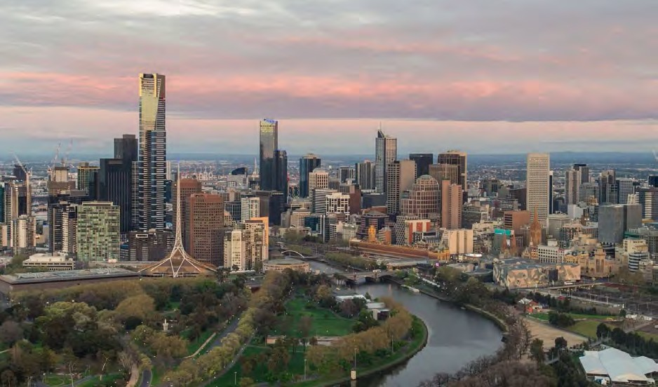

Melbourne Metro Rail Project
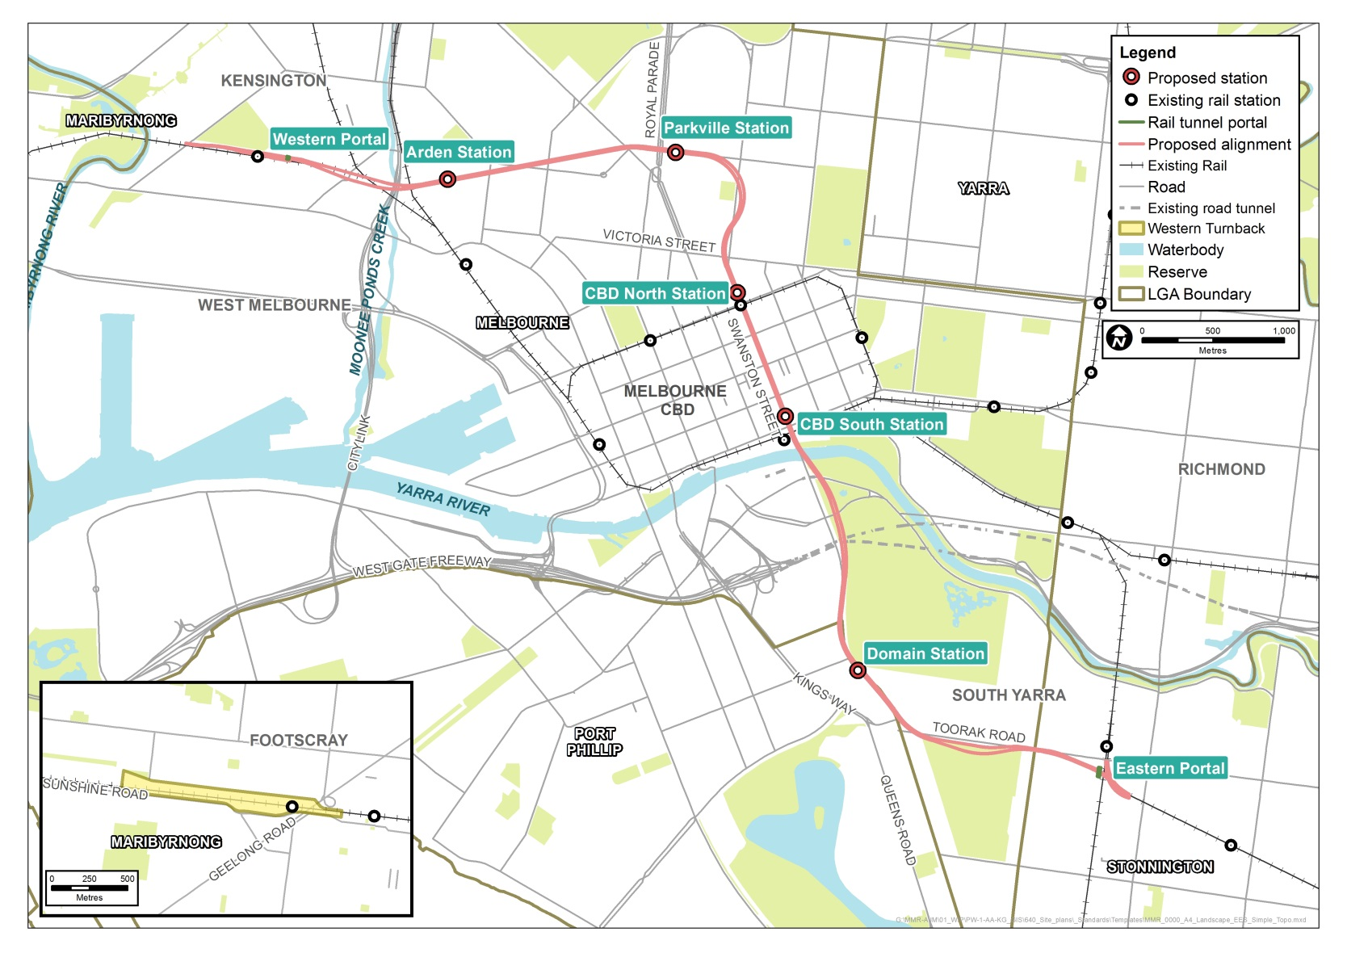
A metro-style system for Melbourne
Metro-style systems are characterised by:
- Simple timetables with ‘turn up and go’ frequency and consistent stopping patterns
- Frequent services that interact seamlessly with other train lines, trams and buses, enabling convenient interchange
- Stand-alone, end-to-end lines where service disruptions on one line do not affect other lines
- Separate train fleets, maintenance and stabling facilities for each line
- Modern high capacity signalling technology to maximise the number of trains that can operate on each line
- High Capacity Metro Trains that can carry more passengers and are designed to minimise boarding and alighting times
- Grade separations of level crossings for an integrated and more efficient transport network.
Reconfigured rail network with Melbourne Metro
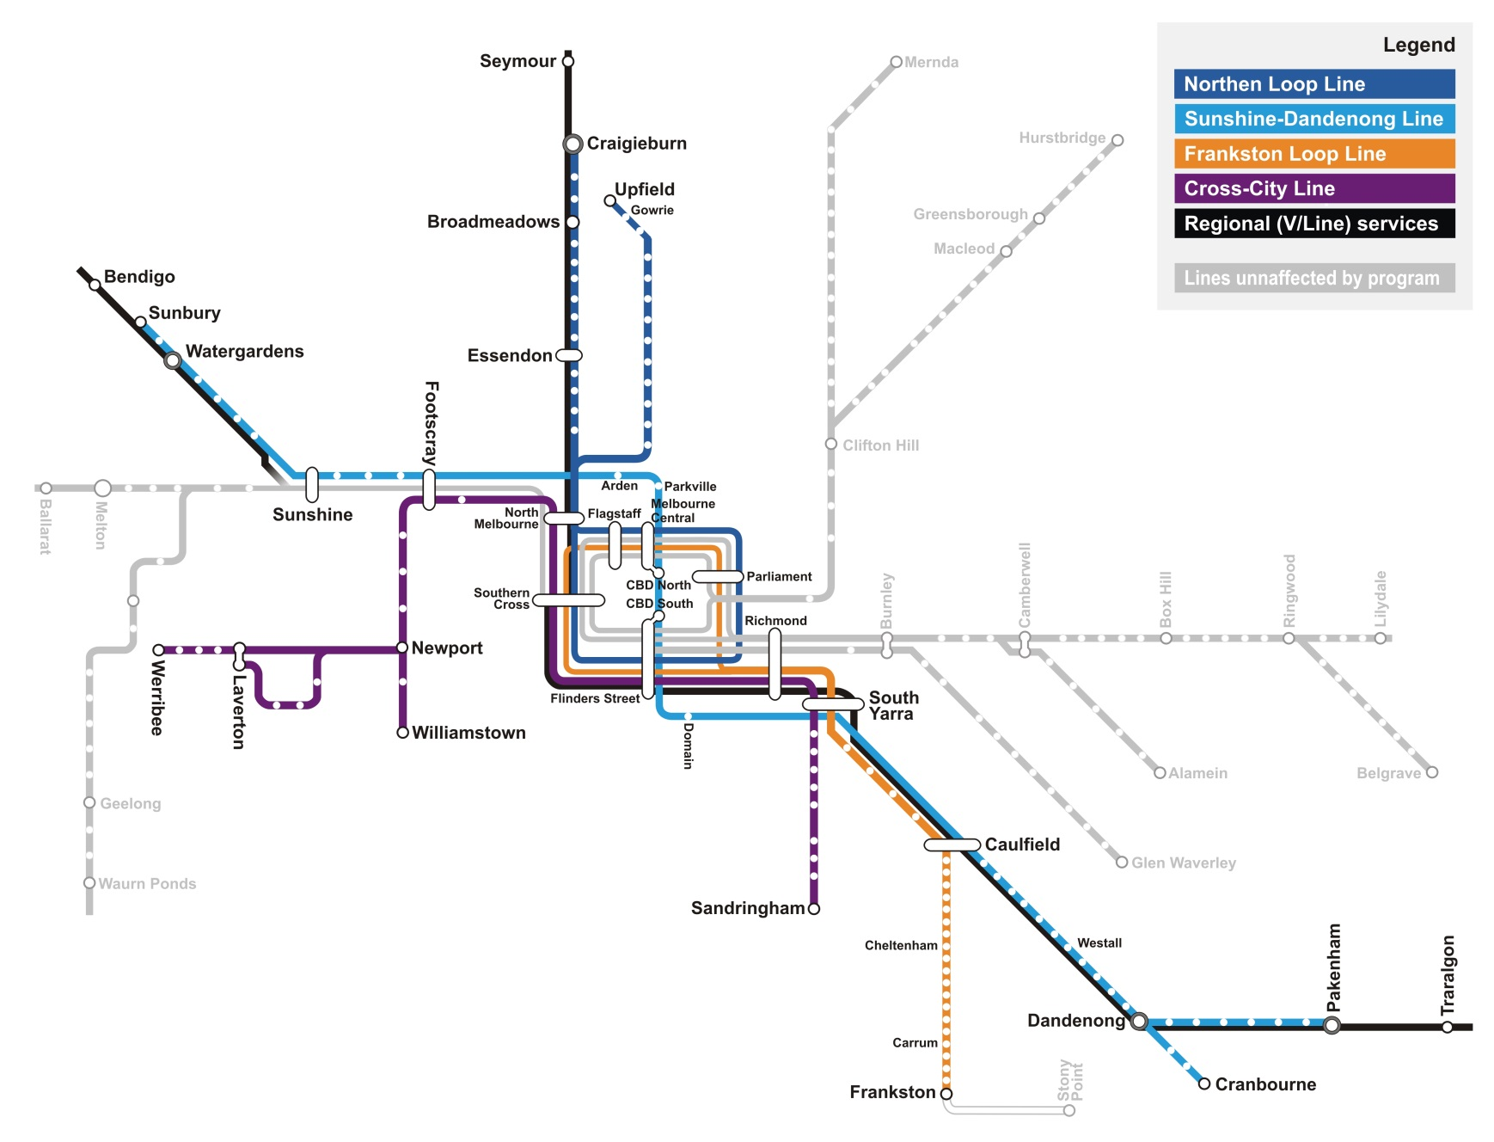

Why is Melbourne Metro needed?
As Melbourne’s population grows, the city’s public transport system is feeling the strain.
The City Loop is already at capacity on three of the four lines (the Northern, Caulfield and Burnley Groups) and the fourth line (the Clifton Hill Group) is approaching capacity. By 2031, average weekday boardings on metropolitan trains are forecast to more than double from 750,000 to 1,500,000. This unprecedented patronage demand is exceeding the capacity of the city’s metropolitan rail services during peak times and capacity constraints will intensify within the next five to ten years, exacerbating overcrowding and delays.
By 2031, over 40 per cent of Melbourne’s population growth is expected to occur in greenfield residential developments in the north, west and south-eastern growth corridors. However, the highest levels of employment growth will continue to be recorded in central Melbourne. Existing inner city train stations and associated transport infrastructure will be incapable of managing the shifts in travel patterns generated by these changes.
If the rail network cannot keep up with the growing and changing demand for travel, this will affect Melbourne in a number of ways:
- Access to jobs, services and important economic centres will be reduced, undermining Melbourne’s reputation for liveability and making it harder to attract new businesses, investors and skilled workers.
- The misalignment between the city’s public transport networks and growing job catchments will constrain the mobility of the labour force, reducing Melbourne’s economic prosperity and productivity
- Insufficient public transport will limit access to central Melbourne, which is Victoria’s strongest jobs and economic hub and potentially Australia’s largest commercial and residential centre by 2040. Constrained access will limit jobs and business growth and restrict the potential for urban renewal in areas such as the Arden-Macaulay precinct.

Developing Melbourne Metro
Options to increase Melbourne’s rail capacity have been under development for several years. Following extensive transport planning and a comprehensive assessment process, substantial new investment in rail infrastructure – delivered through Melbourne Metro – has been assessed as the best solution to providing the uplift in public transport capacity needed to support Melbourne’s needs over the coming decades. Melbourne Metro was also assessed as being the most cost-effective way to expand the core of the rail network while also providing for further capacity uplifts in the future.
Once Melbourne Metro was identified as the preferred solution, vertical and horizontal alignment options and potential train station locations were identified, developed and assessed. The criteria used for this assessment included customer experience (such as ease of interchange between transport modes), transport system outcomes (such as the reliability and frequency of services), disruption (such as the impacts during construction on the transport network, open spaces, residences and businesses) and cost (such as construction, operation and property costs and value for money).
These assessments − carried out in collaboration with Public Transport Victoria (PTV) and other stakeholders − have progressively refined and improved the design of Melbourne Metro to avoid major adverse impacts and achieve the greatest potential benefits from the project. Particular attention has been given to reducing disruption in central Melbourne and to moving construction activities in and out of the CBD as quickly as possible.

Planning for Melbourne Metro
Melbourne Metro is being assessed under the Environment Effects Act 1978, which provides for the assessment of projects that the Minister for Planning has determined could have a significant effect on the environment.

The EES
On 2 September 2015, the Minister for Planning determined that the Melbourne Metro Rail Authority (MMRA), as the project proponent, must prepare an EES to allow the Minister to assess the environmental effects of the works proposed to be carried out for the project. The Minister’s reasons for the determination included the potential impacts of a large scale infrastructure construction project in an intensely developed urban area and the importance of subjecting the project to a robust and transparent assessment of the potential environmental effects and the effectiveness of measures to manage and mitigate these effects.
The Minister published Scoping Requirements to guide the preparation of the EES. These requirements identify specific issues that must be addressed, the approach to be adopted in assessing the project’s risks and impacts, the content and style of the EES and draft evaluation objectives to focus the impact assessment.
Technical Reference Group
MMRA was assisted in preparing the EES by a Technical Reference Group convened by the Department of Environment, Land, Water and Planning.
The group comprised representatives of the Cities of Melbourne, Port Phillip and Stonnington, EPA Victoria, VicRoads, Heritage Victoria, Office of Aboriginal Affairs Victoria and Melbourne Water.
As well as participating in briefings and workshops, the group reviewed all the technical impact assessment reports and the EES main document.
The Scoping Requirements also require MMRA to inform the public and engage with stakeholders to identify and respond to their concerns about the project.
The EES for Melbourne Metro identifies the proposed alignment for the project and the proposed locations of new train stations and above ground structures. It describes the proposed construction methods that would be used. It includes detailed assessments of the potential impacts of the project and possible measures to avoid, minimise, manage or offset impacts. It identifies the potential benefits delivered by Melbourne Metro and opportunities that could be leveraged from the project. The recommended Environmental Performance Requirements would also guide the project’s detailed design, construction and operation.
Overall, the EES has concluded that achieving the outcomes set by the recommended Environmental Performance Requirements would ensure Melbourne Metro achieves acceptable environmental, social and economic outcomes. This EES provides the basis for determining whether the project can meet the approvals required under Victorian and Commonwealth laws.
The Project Proponent, MMRA, on behalf of the Secretary of the Department of Economic Development, Jobs, Transport and Resources (DEDJTR), is the agency proponent responsible for delivering Melbourne Metro.
MMRA is an administrative office established within DEDJTR and is one of several agencies assisting the State Government to achieve its integrated transport policy. The Chief Executive Officer of MMRA is accountable to the Minister for Public Transport, reporting to the Minister through the Secretary of DEDJTR.
MMRA is responsible for all aspects of Melbourne Metro, including developing a Concept Design, conducting site investigations, engaging with stakeholders and the community, obtaining planning and other approvals and procuring the project – through to construction delivery and project commissioning.

Subject Matter of the EES
Melbourne Metro incorporates four key components that are evaluated in this EES:
- The Concept Design and alternative design options
- Proposed construction methodology
- Environmental impact assessments underpinned by a risk assessment
- Recommended Environmental Performance Requirements.
These components have been assessed within a proposed project boundary (see overleaf).
Each of these components has evolved as baseline investigations and impact assessments undertaken for the project have identified issues that required further refinement of the Concept Design, the proposed construction methodology or the recommended Environmental Performance Requirements.

Concept Design
The Concept Design and alternative design options are assessed in the Melbourne Metro EES. The components of the Concept Design are shown in the figures above and displayed in the EES Map Book.
As is typical for an EES, the Concept Design is not the final design for Melbourne Metro. Further refinements could be made by the companies contracted to develop and deliver the project as detailed design is developed and finalised. These design refinements are anticipated to occur primarily within the proposed project boundary. Consequently, the potential effects of these refinements have been contemplated by the EES and would be managed through complying with the Environmental Performance Requirements (see overleaf).
The EES also assesses a number of alternative design options to the Concept Design. These options demonstrate different ways that the recommended Environmental Performance Requirements could be achieved. Inclusion of these options provides an opportunity for the community to be consulted during the EES process on the impacts of each option.

Proposed construction methodology
Constructing Melbourne Metro would take a number of years and potentially have significant environmental effects. For the purpose of assessing these effects and developing recommended Environmental Performance Requirements, a proposed construction methodology was developed by MMRA.
Some aspects of the construction methodology would be prescribed: for example, the use of tunnel boring machines (TBMs) to construct the rail tunnel outside the Melbourne CBD and for crossing under the Yarra River. Other aspects may be optimised or altered by the companies contracted by the Victorian Government to undertake the detailed design and construction of Melbourne Metro. However, irrespective of the methodology adopted, the construction of Melbourne Metro must comply with the final Environmental Performance Requirements.

Environmental Impact Assessment
To ensure this EES addresses the Scoping Requirements, 18 specialist technical assessments have evaluated the environmental effects of the Concept Design, alternative design options and proposed construction methodology. The specialists have also provided an assessment of how the environmental effects of Melbourne Metro could be mitigated and the matters that MMRA should consider for inclusion in the Environmental Performance Requirements.
The technical assessments applied a systems and risk based approach to identifying and assessing potential environmental effects across interrelated specialist studies, and also considered potential cumulative effects.

Environmental Performance Requirements
Melbourne Metro would be delivered in accordance with Environmental Performance Requirements that set the environmental outcomes the project must achieve during its design, construction and operation (regardless of any particular design solutions that are adopted).
These requirements are designed to ensure that the project’s contractors adopt measures to avoid, manage or reduce the project’s environmental impacts by defining the outcomes to be achieved rather than specifying the approach to be taken. The Environmental Performance Requirements are based on the recommendations of the specialists who have undertaken the impact assessments for the EES.
The final Environmental Performance Requirements approved by the Minister for Planning are expected to be based on the requirements recommended in the EES. The contractor would have to meet these requirements in designing, constructing and operating the project. This approach would ensure Melbourne Metro achieves acceptable and required environmental outcomes, while still allowing flexibility for the contractor to determine how best to achieve the Environmental Performance Requirements.

Proposed project boundary
The proposed project boundary encompasses all the key locations that would be used for permanent structures and temporary construction work sites (above and below ground). This area provides the basis for the technical impact assessments undertaken for the EES. For assessment purposes, the proposed project boundary has been divided into nine precincts to assess the potential impacts on local areas and surrounding communities.
Some of the assessments undertaken for the EES have adopted larger study areas than the proposed project boundary in order to fully understand the relevant effects, collect sufficiently detailed baseline information and investigate any broader implications.
The proposed project boundary and assessments undertaken for the EES have informed the ‘draft Project Land’ being exhibited with this EES, which is contained in the draft Planning Scheme Amendment and associated documentation provided in Technical Appendix A.

Project precincts
For assessment purposes, the proposed project boundary for Melbourne Metro has been divided into nine precincts based on the location of project components and construction works, the potential impacts on local areas and the characteristics of surrounding communities:
- Precinct 1 – Tunnels (the underground alignment of the two tunnels between the western portal at Kensington and the eastern portal at South Yarra, with the exception of the station and portal precincts)
- Precinct 2 – Western portal (Kensington)
- Precinct 3 – Arden station
- Precinct 4 – Parkville station
- Precinct 5 – CBD North station
- Precinct 6 – CBD South station
- Precinct 7 – Domain station
- Precinct 8 – Eastern portal (South Yarra)
- Precinct 9 – Western turnback (West Footscray).

Concept Design key project components and precincts adopted for the Melbourne Metro EES
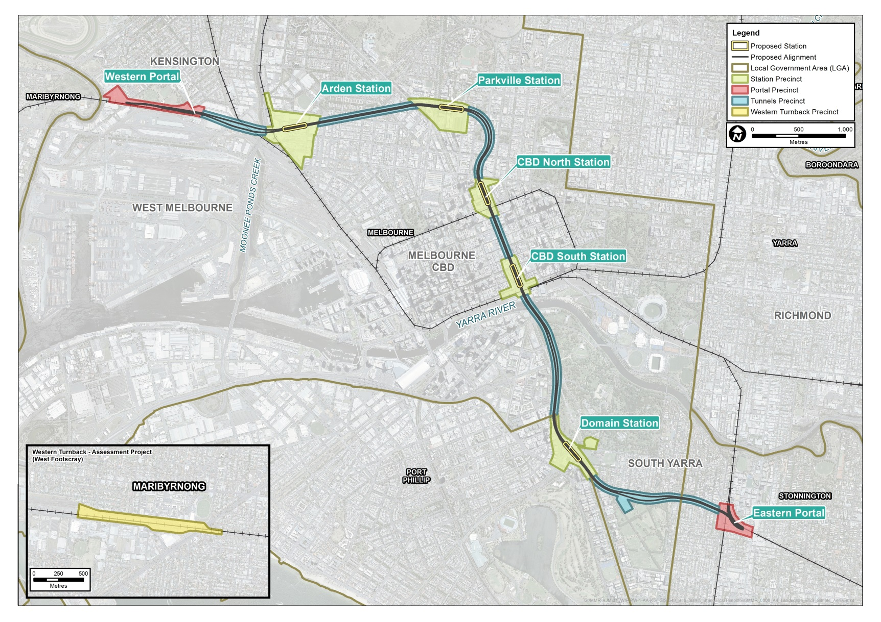

Benefits and opportunities
Melbourne Metro would directly deliver substantial benefits to Melbourne and Victoria. Melbourne Metro would also create opportunities for further benefits to be realised through actions taken indirectly as a result of the project.

Transport benefits
As the first major upgrade of the core of the Melbourne metropolitan rail network in 30 years, Melbourne Metro would result in a major reconfiguration of the network, which would allow for the independent operation of all lines and support the transformation of the rail network into a metro style service.
On its first day of operations, Melbourne Metro would expand the capacity of the network by over 39,000 additional passengers in each of the morning and afternoon peak periods. Approximately one third of this increased peak period capacity would be delivered on the new Sunshine – Dandenong Line. The remaining capacity uplift would benefit lines operating via the existing network, using capacity released by moving Sunshine – Dandenong Line services into the new Melbourne Metro tunnels.
Over the longer term (after making a number of wider network enhancements), Melbourne Metro would free-up capacity to move an additional 41,000 passengers in each peak period to and from the Melbourne CBD each day. By the mid-2030s, this would mean that Melbourne Metro would have provided the foundation for moving around 80,000 additional passengers in each peak period.
Other transport benefits as a result of Melbourne Metro would include:
- More reliable and more frequent train services as Melbourne Metro reduces the need to manage complex interactions between services operating across multiple lines
- Less crowded services and shorter waiting times, especially on the Sunbury, Upfield, Craigieburn, Werribee and Williamstown Lines
- Enabling more people to travel from the suburbs to central Melbourne and other activity centres such as Sunshine, Footscray, Monash and Parkville
- Taking pressure off existing congested CBD stations, especially Flinders Street and Melbourne Central
- Reducing crowding at the key inner city interchange stations of North Melbourne, Richmond and South Yarra
- Relieving the busy Swanston Street tram corridor and easing crowding on trams along Swanston Street, St Kilda Road and Elizabeth Street
- Providing the opportunity to move tram services to better align with jobs growth in the western end of the CBD
- Encouraging more people to shift from car travel to public transport, improving operating conditions on the road network and easing congestion around Melbourne.
Melbourne Metro is expected to enhance connectivity across metropolitan Melbourne. By 2046, a significant convergence of population and jobs is anticipated in areas with an improved ability to access economic activity across the city as a result of the project − with the west and north of Melbourne expected to see the biggest uplift.
By reshaping accessibility throughout the metropolitan area, Melbourne Metro is expected to generate an additional $317.3 million Gross Value Added (the measure of goods and services produced in an area) across the metropolitan economy by 2031.
The greatest impacts would occur in the Arden, Parkville and Domain station precincts, as commercial and residential development is redirected to these areas due to their increased connectivity and accessibility. Together, these three precincts are expected to generate an additional 6,500 jobs and an additional $1.7 billion Gross Value Added by 2041 as a result of the operation of Melbourne Metro (compared to conditions in 2041 if the project does not proceed).

Active transport connections
The construction of Melbourne Metro would provide opportunities to encourage walking and cycling. Improvements that would occur directly as a result of the project include:
- Station designs that accommodate high levels of pedestrian activity with a high degree of safety, comfort and amenity
- Landscaping and tree re-planting to improve Grattan Street in Parkville as a pedestrian-friendly zone and on-road bicycle lanes on Grattan Street and the Royal Parade-Elizabeth Street corridor
- A re-design of Franklin Street in the CBD to maximise pedestrian space and amenity
- New pedestrian underpass under St Kilda Road, aligned with the new Domain station
- An upgrade to Lovers Walk in South Yarra to improve amenity for pedestrians
- New pedestrian bridge from Osborne Street to the South Yarra Siding Reserve.
All Melbourne Metro stations would be fully compliant with the Disability Discrimination Act 1992, with specific consideration being given to disability access for Parkville station, including high capacity lifts at each station entrance. DDA-compliant tram superstops would be provided in Royal Parade and St Kilda Road.
Once operational, the new stations would also provide opportunities for the relevant Councils to invest in pedestrian and bicycle infrastructure to encourage people to walk or ride to the stations as part of their journeys.

Social benefits
Melbourne Metro would deliver a large social benefit to the wider community as it would increase the capacity of the metropolitan transport network to cater for the anticipated growth in travel demand. This would enable people to continue to access jobs, education, services and valued places across Melbourne as the city grows.
Other potential social benefits provided by the project include:
- Improved access to wider Melbourne for the communities hosting new train stations
- Increased residential development opportunities and greater housing options in established inner urban areas
Opportunities for urban renewal and development
The improvements in connectivity and accessibility provided by Melbourne Metro would potentially lead to a shift to higher value land uses in a number of places, which would attract new residents and businesses and create renewal and redevelopment opportunities.
Generating renewal and development in the Arden-Macaulay precinct – The Arden-Macaulay precinct is a major urban renewal area with the potential to accommodate many more residents, businesses and jobs over the next 30 years. The new Arden station would support and facilitate this renewal.
Supporting the Parkville research, medical and education precinct – Melbourne Metro would connect the Parkville research, medical and education precinct to the metropolitan rail network for the first time. Improving access to this area would make it an even more attractive location for businesses, potentially boosting the already substantial benefits this precinct delivers to Melbourne and Victoria.
Partnering with the University of Melbourne − Melbourne Metro would provide an opportunity to integrate the new Parkville station with future projects being planned by the university, such as the redevelopment of the Faculty of Medicine building and the redevelopment of the City Ford site on Elizabeth Street.
Strengthening the development potential of the northern part of the CBD − The new CBD North station would support efforts to encourage more intensive development in the northern part of the CBD and make the area a more attractive destination for residents, businesses and visitors.
Creating new development opportunities around and over the new stations – The Melbourne Metro stations offer opportunities to develop new urban landmarks and precincts, and attract new residential and commercial development. Three of the stations – Arden, CBD North and CBD South – would be designed to enable over-site development above the stations.
- Opportunities to reinvigorate areas adjacent to the new stations
- Better access to growing employment areas, such as the CBD, Parkville, Monash, Sunshine and Footscray
- Improved access to facilities such as hospitals and universities and valued places such as the Shrine of Remembrance and the Domain Parklands.

Business benefits
The accessibility improvements delivered by Melbourne Metro would have significant implications for business activity in the expanded central Melbourne and surrounds. Businesses would be able to locate outside the CBD, but still have ready access to the benefits it provides. They would have better access to customers, suppliers and professional services.
Businesses would benefit from new retail and commercial development opportunities that would be created through higher density residential development in and around train stations and well-connected activity centres.
Improved accessibility for workers to central Melbourne would reduce commute times and travel time costs, impacting positively on labour output. This could widen the employee pool available to businesses in central Melbourne, enabling better matching of worker skills to jobs and increasing productivity. These improvements would lift business profitability and attract greater levels of investment into the city − driving further business and jobs growth.
Melbourne Metro would also be likely to transform the business mix of some areas, as improvements in accessibility spark shifts in the locational preferences of firms – particularly knowledge-intensive and creative firms.

A sustainable project
MMRA is committed to achieving excellent environmental outcomes across all phases of Melbourne Metro and sustainable design and construction methods would be strong features of the project. Specific opportunities would include:
- Embedding sustainability across all phases of the project to ensure sustainability is integrated throughout the project life cycle. MMRA has developed a sustainability policy and quantifiable sustainability targets that focus on climate resilience, resource efficiency, waste, water, sustainable procurement and workforce strategies
- Actively monitoring and driving sustainability performance. MMRA will require the use of two key sustainability rating tools to benchmark and monitor performance against the sustainability policy and sustainability targets. These tools include the Infrastructure Sustainability Council of Australia’s Infrastructure Sustainability rating scheme and Green Building Council of Australia’s rating scheme, which has been adapted for application to the 5 underground stations. MMRA aims to achieve a minimum ‘Excellent’ certified rating for ‘Design’ and ‘As-built’ with the IS rating scheme and a minimum 5 star ‘Design’ and ‘As-built’ rating for the stations
- MMRA will maintain a Sustainability Management System that will be integrated into all project deliverables and activities.
While the construction of the project would require trees to be removed in a number of locations, as many mature trees as possible would be reinstated post-construction. In the Parkville station and Domain station precincts, tree reinstatement and new plantings would be undertaken in accordance with the City of Melbourne’s and City of Port Phillip’s Urban Forest Strategies.
All parkland impacted by construction activities would be returned to a condition that is equal to or better than its existing condition. There would be opportunities to significantly improve the landscape quality, amenity and tree canopy cover of a number of parks and reserves. This would include improvements to the Albert Road Reserve and the South Yarra Siding Reserve.
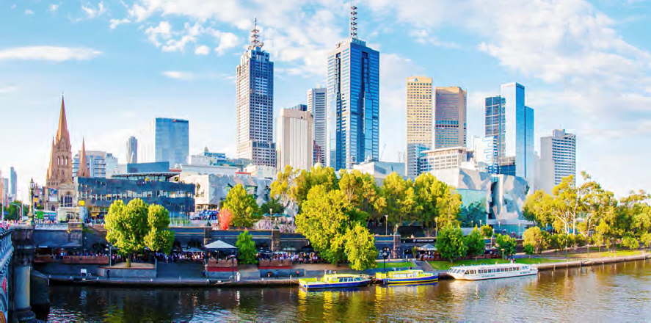

Assessing Melbourne Metro’s Impacts
The progressive design and development of Melbourne Metro has resulted in a Concept Design that largely avoids major adverse impacts and provides significant benefits to Melbourne during the project’s operation. The key impacts arising from Melbourne Metro would occur during construction and have been the focus of the EES.
Specialist investigations were conducted for the EES to assess the project’s potential risks and the likelihood of adverse events occurring. In each specialist area, risks were identified and assigned initial ratings, ranging from very low to very high.
Environmental Performance Requirements – which have been informed by possible mitigation measures – define the outcomes to be achieved to avoid, manage or mitigate the identified impacts. Achieving these recommended Environmental Performance Requirements would result in a manageable number of adverse impacts occurring during the construction and operation phases of Melbourne Metro. Most of these impacts would be temporary and would occur during construction.
There would be further opportunities to reduce impacts even further during the detailed design phase of the project.
The key impacts associated with the project are summarised below, aligned with the specialist impact assessments conducted for the EES. A full list of all project risks, showing the initial and residual risk rating of each risk, is provided in the Environmental Risk Assessment Report (Technical Appendix B of the EES).

Transport
With most construction and operational activities associated with Melbourne Metro taking place underground, the impacts of the project on traffic operations and transport connectivity would be minimised significantly and largely confined to local roads and networks.
The main construction-related impacts would be:
- Construction activity generating truck movements for removing spoil and delivering materials and equipment, which would add to existing local traffic
- The temporary closure of a number of roads, which would disrupt local traffic patterns, bus and tram operations, and walking and cycling routes
- The presence of a large construction workforce, which would generate additional traffic that could impact the local and wider road network at times.
Managing and minimising these impacts would be a critical component in the delivery of Melbourne Metro. The recommended Environmental Performance Requirements developed for the project would mandate the implementation of detailed traffic management plans that would include measures to direct traffic away from construction work sites to alternative routes and minimise truck movements during peak periods and through residential areas at night.
The plans would also identify construction traffic routes for each precinct with the aim of moving this traffic away from local areas to the arterial road/motorway network as quickly as possible. As a result, any delays and travel time increases associated with construction works are not expected to be substantial.
While these measures would minimise traffic disruption during construction, the closure of Grattan Street (in the Parkville station precinct) and the closure of Domain Road and the reduction in St Kilda Road to one lane in each direction in the Domain station precinct would have a potentially significant impact on traffic operations. Traffic would be encouraged to divert around these road closures and use alternative routes available in these locations.
Construction impacts on public transport operations would vary across the Melbourne Metro alignment. The most significant impacts would be the re-routing of the 401 and 402 bus services along Grattan Street (with associated longer travel times along these routes) and the re-routing of the route 8 tram from Domain Road to Toorak Road West.
The contractor for Melbourne Metro would be required to minimise disruption to the rail, tram and bus networks (in collaboration with PTV and other service providers) and implement a communications strategy to advise road and public transport users of any changes to traffic conditions and public transport services.
Compared to other locations along the alignment, there would be a higher number of truck movements in the three precincts where the major construction work sites would be based: Tunnels (in relation to the potential Fawkner Park construction work site), Arden station and Domain station precincts. While this traffic would cause some disruptions, the key access roads in the vicinity of the work sites in these precincts have sufficient capacity to accommodate the additional traffic, particularly as it would be spread across a number of routes. Truck movements would be minimised during peak periods and at night time in residential areas.
Impacts on walking and cycling routes during construction would vary across the alignment. The contractor would be required to minimise disruption to these routes, provide safe alternative routes around work sites and reinstate routes post-construction. In the two CBD precincts, the very high levels of walking and cycling that occurs means that construction activities would need to be carefully managed to minimise disruption to pedestrians and cyclists, especially during peak periods. All existing cycle lanes in the CBD would remain open. In the Domain station precinct, the high volumes of bicycle traffic along St Kilda Road on weekdays mean that cyclists would be travelling on lower standard facilities (such as temporary paths around work sites) during construction.
The contractor for Melbourne Metro would be required to minimise disruption to car parking, provide alternative car parks where parking is lost due to construction activities, prevent construction vehicles from parking at undesignated locations on local roads and reinstate or offset car parking post-construction.
The operation of Melbourne Metro would require a small number of permanent changes to the road network, with the main changes being:
- Grattan Street reduced to one lane in each direction between Flemington Road and Leicester Street (Precinct 4 – Parkville station)
- Permanent closure of part of Franklin Street between Swanston Street and Bowen Street (Precinct 5 - CBD North station)
- Reconfiguration of St Kilda Road, between Domain Road and Toorak Road to optimise the thoroughfare for all modes of transport (Precinct 7 – Domain station).
Following the adoption of the recommended Environmental Performance Requirements and implementation of the proposed mitigation measures (such as the provision of advisory signs, diversion routes and replacement car parks), the risk of these permanent changes affecting transport connectivity has been assessed as low or very low. While there would be some increases in travel times and delays along parts of the road network in these areas, the overall network would continue to operate to acceptable standards.

Land Use and Planning
The main impacts associated with land use are related to the acquisition or temporary occupation of private property and public open space.
There would be a temporary loss of public space and changes to highly valued parkland as a result of the project’s construction, which would require the occupation of City Square in the CBD, part of University Square in Carlton, the Albert Road Reserve in South Melbourne and the South Yarra Siding Reserve and part of Fawkner Park in South Yarra during construction. This would affect users of these spaces and adjacent properties, although access to and through these spaces would be maintained where possible.
Small areas of land located on the edges of public spaces such as City Square and the Shrine of Remembrance Reserve would be permanently acquired for station entrances, without compromising the overall use of the land for public open space in the longer term.
At the end of construction, all parkland impacted by the project (not required to be permanently occupied) would be returned to a condition that is equal to or better than its existing condition. There would be opportunities to improve the landscape quality, amenity and tree canopy cover of a number of parks and reserves.
Land temporarily occupied during construction would be reinstated and redeveloped in accordance with the Urban Design Strategy developed for Melbourne Metro and the requirements of the relevant local planning schemes.
As most of Melbourne Metro would be underground, there would be limited permanent impacts on the built form within the proposed project boundary. The Urban Design Strategy developed for the project would require that all surface structures are of a high quality design and finish, integrate with their location and settings, and have appropriate footprints. The design of Melbourne Metro would also take into account neighbourhood character and the local community’s aspirations for each precinct as set out in the relevant planning polices and strategies and identified through consultation with Councils and other stakeholders.
The new Arden station would present a significant opportunity to stimulate urban renewal in Arden-Macaulay, supporting the area’s potential for growth as a major employment destination built around a high capacity public transport connection. Melbourne Metro would also provide an opportunity for over-site development at CBD North and CBD South station entrances. While any development proposed by the contractor would be subject to separate planning and approval processes, this would be an opportunity for a high quality built response that is designed and constructed in synergy with the expansion of the transport network.
The land use and planning impact assessment conducted for the EES determined that the impact to the central Melbourne area, within the proposed project boundary, is acceptable. This is due to the majority of impacts to land use and built form being temporary in nature and the land use changes associated with the project generally having the potential to be reinstated post-construction or providing benefits to existing land uses.

Social and Business
While the Melbourne Metro alignment traverses a highly urbanised, densely populated and diverse area, most of the project’s construction and operational activities take place below ground, meaning that a range of social and business impacts can be avoided. However, project activities would still interact with social values and the community in a number of places.
Once Melbourne Metro is operational many of these interactions would result in benefits to, or generate opportunities for, local communities and the broader metropolitan area. Notably, the project would benefit users of the wider transport network and enable the community to continue accessing employment, social infrastructure, valued places and wider social networks. Without Melbourne Metro (and other projects designed to increase the capacity of Melbourne’s transport network), it is likely the community would face a deterioration of social opportunities as projected population growth outstrips road and rail capacity and transport networks find it increasingly difficult to keep pace with rising travel demand.
Temporary adverse social and community impacts associated with the construction of the project relate mainly to amenity impacts (such as traffic disruption, noise and dust) and the temporary loss of access to valued public spaces. Some potential adverse operational impacts (such as the permanent placement of noise walls) would occur in a small number of locations.
While the Concept Design developed for Melbourne Metro has minimised the amount of private land acquisition required for the project, the impacts on individual landowners, households, tenants and businesses would be significant.
In addition to the businesses displaced as a result of commercial property acquisition, the construction of Melbourne Metro would create temporary disruptions to some businesses in close proximity to work sites as result of changed amenity, traffic disruptions, reductions in passing trade and constrained access for customers, deliveries and staff.
The operations of some businesses in the CBD would be disrupted to a significant extent during construction, with those located near the City Square, in Scott Alley and around the Flinders Street and Swanston Street intersection likely to experience the greatest disruption. Depending on the nature and location of the business, disruption could occur as a result of less foot traffic, reduced access to customers or noise and dust impacts.
Businesses in the Parkville station precinct could also experience higher levels of disruption than in other precincts due to the large number of businesses in the area that rely heavily on passing foot traffic for a proportion of their sales and the presence of the University of Melbourne, hospitals and medical research facilities that have particular access needs and operate sensitive equipment.
Private land acquisition
A limited number of residential and commercial buildings would need to be acquired to enable construction of the project.
Across the entire alignment, up to 19 residential buildings (including an apartment block with 49 separate titles) and 32 commercial buildings would need to be acquired permanently.
Residential buildings would only need to be acquired adjacent to the tunnel entrances (Kensington and South Yarra) and in the CBD North station precinct.
Commercial building acquisition would result in up to approximately 90 businesses having to relocate. This would include around 60 businesses in the CBD along Swanston Street, La Trobe Street and Flinders Street, and in the Port Phillip Arcade. No businesses would be displaced in the Domain, South Yarra and West Footscray areas.
While the impacts on these business owners and their employees could be significant, most of these businesses would be likely to relocate within or near to their existing locations and retain their employees.
Across the Melbourne Metro alignment, underground strata (the part of the land that is beneath the surface and buildings) would need to be acquired from up to 3,500 titles where the train tunnels would pass beneath properties. The property at surface level is not required in this type of acquisition.
Landowners and tenants with an interest in buildings and land being acquired (including strata acquisition) would be compensated in accordance with the Land Acquisition and Compensation Act 1986.
MMRA would provide a high level of assistance to displaced businesses, including help with finding new premises and with the logistics of relocating, and assistance with signage, advertising and other requirements arising from a changed business location and address.
Measures would be taken to support businesses in close proximity to construction activity, including providing signage indicating they remain open, maintaining access for customers, deliveries and waste removal, and keeping businesses informed about planned construction activities. In the Parkville precinct, access to hospital emergency departments would be maintained at all times. In some precincts, the large number of workers present on a daily basis during the construction phase would generate demand for goods and services that may benefit local retail, food and beverage businesses. Local businesses may also be able to provide some of the materials and services required for the construction, maintenance and operation of Melbourne Metro.
While a rail project of the scale of the proposed Melbourne Metro has not been undertaken in Melbourne since the City Loop, there have been many recent large construction projects that can be used to help understand the potential business impacts from Melbourne Metro. While projects have generated disruptions (such as noise, dust and changes to traffic and pedestrian movements), surrounding businesses have continued to operate.

Air Quality
The impact assessment undertaken for the EES demonstrates that the project can be constructed and operated in compliance with the applicable air quality regulatory standards and best practice guidelines.
Air quality is a key factor that contributes to the amenity of an area. Melbourne Metro is located in an area with high traffic levels and where major projects are often underway in different stages of development, which contribute to existing air quality impacts. A key requirement for Melbourne Metro is to minimise additional impacts on air quality that could affect the community in which the project is located.
Above ground construction activities would generate dust, with the greatest temporary impacts likely to occur at locations where the largest volumes of spoil would be excavated and transported (the Fawkner Park construction work site and the major construction work sites at Arden station and Domain station) and where highly sensitive receptors would be close to construction work sites (at Parkville station).
The contractor for Melbourne Metro would be required to develop and implement a dust management and monitoring plan, in consultation with the EPA, to minimise and monitor the impact of construction dust. The plan would include the use of well-tested measures across all construction work sites, such as minimising the extent of spoil stockpiles, applying water to unsealed surfaces to suppress dust, minimising double handling of material, re-vegetating areas of disturbed soil as soon as practicable and modifying activities according to weather conditions.
Dust monitoring would also be undertaken at a number of sensitive receptors (such as hospitals, hotels and residences close to the major construction sites) to ensure compliance with the air quality criteria set for the project.
As Melbourne Metro would use electric trains, air emissions associated with the routine operation of the project would be insignificant.
Regional air quality impacts from the operation of the project are also considered to be insignificant.

Noise and Vibration
As a large, busy and dynamic city, Melbourne hosts a range of activities – such as major construction projects, heavy vehicle traffic, train and tram operations and outdoor events – that generate varying types and levels of noise and vibration. The construction and operation of Melbourne Metro would occur within this context.
The extent of noise and vibration impacts associated with Melbourne Metro would depend on a range of factors. Some factors would be influenced by the project (such as the construction methods adopted and the mitigation measures implemented). Others would depend on the sensitivity of the receiver to noise and vibration impacts (such as the structural condition of an affected building or the nature of the activities undertaken on a particular site).
Guideline targets for noise and vibration have been set for Melbourne Metro’s construction and operation to minimise adverse impacts on residents, communities, structures and sensitive equipment and areas, as far as practicable. Well-tested construction methodologies and management processes would be used to meet these targets. Where levels of noise and vibration are predicted to be higher than the targets, additional management actions would be taken to reduce impacts. These actions could include close liaison with potentially affected households, businesses and institutions, additional vibration attenuation and offers for temporary respite accommodation in particular circumstances (a standard mitigation measure on major infrastructure projects).
Levels of vibration during construction are predicted to comply with the structural guideline targets. Accordingly, no structural damage to buildings and structures is anticipated due to vibration arising from the construction of Melbourne Metro. Property condition assessments and ongoing vibration monitoring would provide the basis for managing potential structural damage.
There are anticipated to be relatively short periods during construction when management actions would need to be implemented to address impacts to human comfort and amenity as a result of vibration and ground-borne noise. The progress of the TBM would mean that the most-affected sensitive receivers (locations immediately above or in very close proximity to the tunnel alignment) may experience vibration levels above the guideline targets for approximately 10 days on two occasions as the TBM for each tunnel passes by. As roadheader-mined tunnels progress more slowly than TBM-bored tunnels, sensitive receivers at a limited number of locations within the CBD may experience vibration levels higher than the guideline targets on one occasion of up to 32 days over the course of the construction program.
Roadheader excavation of station caverns has the potential to generate vibration and ground-borne noise that may impact on amenity. Guideline Targets may not be met at several locations in the CBD for periods of up to six weeks, up to three times over the course of the station cavern construction.
Specific guideline targets have been set for construction activities in close proximity to the healthcare and education institutions within the Parkville and CBD North station precincts. These institutions support uses, and contain equipment, that are highly sensitive to the impacts of vibration and ground-borne noise. A comprehensive management response, including consultation with affected stakeholders, would be implemented to ensure that impacts of construction at these locations are managed appropriately.
Airborne noise generated by construction activities would be managed in accordance with the applicable EPA Victoria guidelines, which are based on protecting residential premises from unreasonable noise. Construction is expected to be audible at times but – with appropriate mitigation – is not anticipated to give rise to unreasonable impacts on nearby residents in any of the Melbourne Metro precincts.
Guideline targets have also been specified for Melbourne Metro’s operation. Airborne noise, vibration and ground-borne noise levels would need to meet these targets. Melbourne Metro would be designed so that appropriate track attenuation is applied to achieve compliance with the operational vibration and ground-borne noise targets. Airborne noise during operation would only be experienced as trains enter and exit the tunnel portals and at the western turnback. The effects of this noise would be mitigated where required through treatments such as noise barriers in accordance with the Victorian Passenger Rail Infrastructure Noise Policy (PRINP).
Accordingly, the long-term noise and vibration effects of Melbourne Metro are predicted to be low to negligible.

Historic and Aboriginal Heritage
The Melbourne Metro Concept Design has been developed to avoid impacts on significant historic buildings and places where practicable. There would be no direct impacts on important heritage places such as the City Baths, the State Library of Victoria, St Paul’s Cathedral, Princes Bridge, Young and Jackson Hotel, Melbourne Town Hall or the Shrine of Remembrance.
Interactions with sites of heritage or archaeological significance include:
- Demolition and alteration of heritage places – A number of buildings could be demolished that are locally listed in heritage overlay precincts or on individual listed sites. Construction would also require the removal of some significant trees within heritage places, although these could be replanted. A number of heritage places would be altered as a result of their interface with the new permanent Melbourne Metro infrastructure and this could result in an adverse impact on the heritage values of these places. Multiple historical archaeological sites would be impacted, particularly in the central city.
- Vibration and ground settlement affecting the fabric of heritage buildings – There would be potential impacts on the fabric of heritage places as a result of vibration and/or ground settlement in proximity to construction works. These impacts would be modelled and managed throughout the project’s construction phase.
- Visual impacts as the result of the introduction of permanent infrastructure – Where permanent above-ground structures would be constructed, there would be the potential for adverse impacts on the heritage value of the affected or any nearby heritage place through the juxtaposition of a new built form of contrasting or atypical form. To mitigate these impacts, design refinements would give consideration to the heritage context and values of places in proximity to new Melbourne Metro structures. These impacts would also be managed through compliance with the Melbourne Metro Urban Design Strategy.
Overall, the impact assessment conducted for the EES concluded that the potential historical cultural heritage impacts of the Melbourne Metro are acceptable and would be appropriately managed, especially when considering the scale, location and complexity of the project.
The Melbourne Metro alignment covers an area that historically had a rich and extensive history of Aboriginal occupation. However, there has been significant ground disturbance and development over many decades that has significantly reduced the presence of Aboriginal cultural heritage along the alignment.
Throughout the construction phase of Melbourne Metro, the main Aboriginal heritage impact would be disturbance or removal of unknown Aboriginal cultural heritage values within sub-surface construction works. This could occur where construction is within natural soil deposits that may not have been disturbed.
A Cultural Heritage Management Plan (required under the Aboriginal Heritage Act 2006) has been prepared alongside the EES in consultation with the Office of Aboriginal Affairs Victoria and the Traditional Landowners. This Cultural Heritage Management Plan assesses the potential impact of the project on Aboriginal cultural heritage values and outlines measures to manage and protect Aboriginal cultural heritage discovered during construction. No impacts to Aboriginal cultural heritage are envisaged from the operation of Melbourne Metro.
Opportunities to enhance heritage values would include repair and conservation works (where structures need to be protected or relocated) and the development of a heritage interpretation strategy for Melbourne Metro as a whole that would explore historical and Aboriginal cultural heritage themes and recognise historical and Aboriginal heritage places in the design of the new stations.
Potential physical impacts from ground movement, particularly during construction, would be the subject of ground movement modelling of the project’s final detailed design. If heritage buildings are identified as potentially being affected, pre-construction condition assessments would be carried out, continual monitoring would be undertaken during construction and management and mitigation measures would be implemented as appropriate.

Landscape and Visual
While Melbourne Metro would have a substantial construction footprint, the potential landscape and visual impacts of this footprint would be ameliorated by a large proportion of construction activities being carried out underground. However, a relatively small number of locations within close proximity to above ground construction work sites and activities would experience high level landscape and visual impacts during the project’s construction phase. These temporary impacts would mainly be the result of tree removals, overlooking of construction work sites from elevated viewpoints or where views and sightlines would be obstructed by construction work sites and activities.
An Urban Design Strategy has been developed to manage landscape and visual impacts during construction and to set a high standard and quality of design for the entire project. While aesthetic hoardings and other measures would mitigate construction impacts at ground level, medium to high temporary visual impacts would occur at a number of locations, most notably:
- The University of Melbourne, the Victorian Comprehensive Cancer Centre and University Square in Parkville
- High rise residential apartments and hotels with views over construction sites in the CBD
- City Square in the CBD
- Views to St Paul’s Cathedral, Flinders Street Station and Federation Square in the CBD
- Views along Swanston Street and St Kilda Road to the Shrine of Remembrance
- Residences adjoining the South Yarra Siding Reserve and Lovers Walk in the eastern portal precinct.
Melbourne Metro would involve the removal of trees associated with the construction of the stations, emergency access shafts and the eastern and western tunnel portals. The landscape and visual impacts caused by the removal of trees would be high in some locations – particularly in the Parkville station precinct, where trees would be removed from sections of Grattan Street and Royal Parade, and in the Domain station precinct, where trees would be removed from sections of St Kilda Road and Albert Road.
The restoration of parkland, the integration of Melbourne Metro’s permanent above ground structures and station entrances into their surrounding environments and the remediation of construction work sites would restore these views post-construction and ensure that ongoing landscape and visual impacts would be low. This includes the restoration of views down Swanston Street towards the Shrine of Remembrance.
Post-construction, high quality design in accordance with the Melbourne Metro Urban Design Strategy and compliance with the Melbourne Planning Scheme would ensure that over-site development at CBD North and South stations does not have major adverse impacts on nearby apartments or the heritage buildings in the CBD.
Tree removal and replacement
A broad range of tree species, including native and exotic, would be potentially impacted by the project. There would be a keen focus on protecting trees in construction zones, with a view to minimising the numbers that need to be removed where possible.
Within the eastern portal precinct, the trees that would likely be removed are largely introduced and comprise numerous sucker weeds. In the Arden station precinct, there are numerous native trees within the publicly owned land managed by VicTrack and currently used for light industrial purposes. Around 20 per cent of these trees have been assessed as reaching their Useful Life Expectancy (ULE) within 10 years.
In the remaining precincts, the trees are largely introduced exotic plantings contained in boulevards such as Royal Parade and St Kilda Road, and in parklands such as the Domain Parklands.
Up to around 900 trees could need to be removed during Melbourne Metro’s construction phase - although this number would reduce under some options being considered. Of these trees, nine palm trees could be suitable for relocation. Around half the trees likely to be removed within the public realm are either juvenile trees that do not contribute strongly to the biodiversity of the region, or trees that have been assessed as over-mature or in decline and already likely to be subject to removal within the time of the construction phase of the project.
In recognition of the significant contribution trees make to Melbourne's public realm, measures would be taken to re-establish canopy cover, restore the continuity of tree-lined avenues and reinstate trees in public open spaces as quickly as practicable. In some places, tree re- planting could commence during the construction period.
The Urban Design Strategy would require that all surface structures are of a high quality design and finish, integrate with their location and settings, and have appropriate footprints. The design of Melbourne Metro would also take into account neighbourhood character and the local community’s aspirations for each precinct as set out in the relevant planning policies and strategies, and identified through consultation with local Councils and other stakeholders.
Recreational areas would be affected by the temporary occupation of public open space during construction, including Edmund Herring Oval, possibly Fawkner Park in the Domain station precinct, and the South Yarra Siding Reserve and Lovers Walk adjacent to the eastern portal. The recommended Environmental Performance Requirements require the contractors to explore opportunities to provide alternative public open space during construction, where possible. Recreational areas would be reinstated and enhanced and in accordance with the project’s Urban Design Strategy.
Recreational values would be affected by the loss of public open space during construction, such as Edmund Herring Oval in the Domain station precinct and the South Yarra Siding Reserve and Lovers Walk in the eastern portal precinct. The recommended Environmental Performance Requirements set out a process for identifying alternative areas of public open space for community use during the construction period to mitigate these impacts, and require these public open space areas to be returned and upgraded as improved public open spaces following construction.

Surface Water
There would be no direct impacts on water quality or flows in the three major waterways traversed by the proposed Melbourne Metro alignment. As the crossings of the Yarra River and Moonee Ponds Creek would be via bored tunnels, there would be no direct impacts on these waterways. As the construction footprint does not cross the Maribyrnong River and there would be no construction activity in the immediate vicinity of the riverbank, there would be no direct impacts on this waterway.
During Melbourne Metro’s construction, there would be exposed surface areas at construction work sites. During high volume rainfall events, runoff from these surfaces could potentially impact water quality in waterways, either directly or via stormwater drainage systems. Standard construction site management practices – including minimising the area of exposed ground, isolating site runoff from the existing drainage system and bunding (using retaining walls and similar structures) – would minimise the risk of contaminated runoff entering the stormwater drainage system.
Once Melbourne Metro is operational, drainage runoff from permanent above ground structures (such as the station and tunnel entrances) would be discharged into existing local drainage systems. The rate at which this runoff is discharged would be controlled. The impacts of stormwater runoff from structures across the alignment would be minimised by collecting runoff and treating it to EPA and Melbourne Water standards before discharge to receiving waterways.
Adopting water sensitive design principles and meeting EPA requirements in the design of the project’s stormwater treatment system would also ensure that Melbourne Metro’s operations do not have any adverse effects on water quality.

Groundwater
Groundwater would be encountered across almost the entire Melbourne Metro alignment. Most of the tunnels, stations and other underground structures would be located below the watertable. Excavation below the watertable would provide a pathway for groundwater to seep into the excavations and result in groundwater drawdown during construction and operation unless tanking (sealing to minimise groundwater inflow) of the excavations is undertaken to reduce groundwater inflow to negligible rates. Groundwater drawdown can potentially cause ground settlement or the movement of contaminant plumes or affect groundwater dependent ecosystems.
The groundwater impact assessment found that existing groundwater quality within the proposed project boundary is variable, with high salinity levels in the west and some known groundwater contamination plumes along the alignment. The assessment undertaken for the EES has been informed by detailed groundwater modelling to assess the potential effects of groundwater drawdown and movement.
Protecting the tunnels, portals and stations from flooding
The underground components of Melbourne Metro would potentially be subject to flooding during large flood events or very high rainfall events.
While these events are rare, the tunnels, portals and stations would be designed to provide protection against flooding during construction and operation. Proposed protective measures include:
- Constructing barriers to intercept overland surface water flows and divert them away from excavation sites and cavern entrances
- Using retaining walls or similar barriers to protect the portals from flooding during construction
- Raising station entrances to be well above the expected flood levels during the life of the project
- Developing emergency measures to manage the impacts of larger flood events, including a flood warning system and emergency evacuation procedures.
The key potential impacts of Melbourne Metro on groundwater arise from the tunnels, stations and other sub-surface infrastructure being located below the watertable.
Excavations would be ‘tanked’ prior to completion of construction and the bored tunnels would be tanked as the TBMs progress, so inflows would be negligible. For the mined sections of the tunnels and other excavations, the drawdown would be short-term and groundwater levels would recover after tanking of the structures. As all tunnels and station structures associated with Melbourne Metro would be tanked for operation, drawdown would be insignificant post-construction for all structures.
Temporary impacts to local groundwater quality are expected during the construction of Melbourne Metro from dewatering (the process of moving unwanted water away from a construction site to create dry working areas). Mitigation measures such as tunnel grouting and temporary recharge bores would avoid significant drawdown impacts, especially near to CBD North station where there would be the potential for groundwater contamination plumes to migrate. Compliance with the recommended Environmental Performance Requirements would prevent significant adverse impacts to regional groundwater from the construction or operation of Melbourne Metro.
The removal, storage and transport of groundwater (especially in areas with known groundwater contamination) would be carried out using best practice treatment, management and disposal measures and in accordance with Melbourne Water’s specifications and requirements.

Ground Movement and Land Stability
The Concept Design for Melbourne Metro has been informed by a substantial amount of geotechnical investigation. Detailed modelling of the potential ground movement impacts has demonstrated the project can be constructed and operated with negligible to minor effects to buildings, civil infrastructure, utilities or the natural environment. Negligible to minor impacts on buildings are defined as no damage or at worst, aesthetic damage, comprising hairline or visible small cracks that can be treated during normal decoration or where some external repointing could be required. The impact assessment conducted for the EES concluded that any excavation-induced ground settlements associated with the Melbourne Metro tunnels would be small and unlikely to cause major distress to nearby surface or underground structures.
Ground movement impacts would be minimised by adopting sound engineering practices, including excavation support systems, appropriate controls on TBM operations and ground improvement measures at some locations.
The Environmental Performance Requirements for the project would require the contractor to undertake further modelling based on Melbourne Metro’s final detailed design to demonstrate that predicted ground movements would be minimised to acceptable levels. Detailed condition surveys of potentially affected structures would also be conducted prior to construction commencing. These surveys would confirm that predicted ground movements would be acceptable or identify the need for further mitigation measures to ensure there would be no impacts worse than minor.
In addition, the contractor would be required to undertake comprehensive ground movement and groundwater monitoring programs from the start of construction and to prepare contingency plans to manage any issues that may arise during construction.

Contaminated Land and Spoil Management
Most major tunnelling projects in urban environments have the potential to encounter contaminated soil, rock and groundwater – the legacy of many years of commercial and industrial development combined with poor environmental management and waste disposal practices in the past. Melbourne Metro is no exception, with many known and potentially contaminated sites along or near the proposed project boundary.
Most of the spoil material generated from the construction of Melbourne Metro would be ‘clean fill’. In all precincts where excavation and tunnelling activities would occur, there would be limited opportunities to reuse this excavated clean fill onsite: it would have to be removed off-site as a waste. However, as this waste would be natural and classified as ‘clean fill’, it could be directed for reuse at another site in accordance with EPA guidelines.
The urban and industrial history of the areas through which the alignment would pass – and the prevailing geological conditions − increases the likelihood of the project encountering hazardous waste and asbestos containing materials, as well as potential acid sulfate soils and rock. The excavation, storage, management and disposal of these materials is common in Melbourne and would be undertaken in accordance with EPA and WorkSafe Victoria guidelines and the adoption of best practice construction methods, materials and practices.
Well-tested construction techniques and management processes would be used to mitigate and avoid the potential impacts of encountering gases and vapours during construction and operation and protecting the durability of buildings and structures from sources of contamination.
The recommended Environmental Performance Requirements mandate development and implementation of a Spoil Management Plan prior to construction. MMRA’s draft Spoil Management Plan (provided in this EES) identifies the predicted volumes and categories of spoil from construction in each precinct and outlines potential measures to store, classify, treat and dispose of spoil. Movement of spoil has been taken into account in the air quality and transport impact assessments, as well as through the requirement that construction sites comply with EPA guidelines in managing potential stormwater runoff.
The health and safety of construction workers would be protected in accordance with Commonwealth and Victorian laws and policies, and with EPA and WorkSafe Victoria requirements.

Biodiversity
The highly developed urban area along Melbourne Metro’s alignment means that many areas have a long history of disturbance and have been cleared of native vegetation.
No threatened flora species are present within the proposed project boundary.
The Domain station and eastern portal precincts are the only areas where threatened fauna species are known to be present. In the Domain station precinct, the Grey Goshawk, Powerful Owl and the Grey Headed Flying Fox may forage in some of the larger mature trees in the area. Similarly in the eastern portal precinct, the Grey Goshawk and the Grey Headed Flying Fox may forage in larger trees when they are flowering. However, as all three species are highly mobile and similar habitat is present throughout the Royal Botanic Gardens and in parks and backyards throughout suburban Melbourne, Melbourne Metro would have a negligible to minor impact on these species.
Flora and fauna values would also be protected by the Environmental Performance Requirements that would ensure any water entering stormwater drains or surface water bodies is of acceptable quality, and that contingency measures are in place to address emergency situations.
In the Arden station precinct, a small number of scattered indigenous trees would need to be removed from the station site. These trees are unlikely to be remnant vegetation and their loss is considered to have negligible consequence in relation to biodiversity. However, a suitable offset would have to be provided for the tree removal in accordance with Victoria’s Permitted clearing of native vegetation – Biodiversity assessment guidelines.

Greenhouse Gas
Carbon dioxide (CO₂₎ is considered to be the most important greenhouse gas (GHG) contributing to climate change, being responsible for approximately 77 per cent of total global GHG emissions, primarily from fossil fuel use. CO₂ is the most significant GHG associated with Melbourne Metro, with major sources of CO₂ emissions being purchased electricity used during the project’s construction and operation, and indirect carbon emissions associated with embodied carbon in construction materials.
Best practice GHG avoidance, reduction and mitigation measures would be incorporated into the construction and operation phases of Melbourne Metro, including the use of building products with less embodied carbon and the purchase of accredited GreenPower. With the adoption of these measures, Melbourne Metro would contribute to a slight increase in transport GHG emissions over time (largely due to the relatively high energy requirements to operate the extended 10-car HCMTs that would commence operating after the first several years of the project).
Overall, Melbourne Metro would have a negligible impact on regional GHG emissions and GHG emissions from the project would be likely to reduce further as a result of the ‘greening’ of the electricity grid in Victoria over the next 30 years.
By 2046, Melbourne Metro is expected to remove 281.8 million VKTs (vehicle kilometres travelled) of cars and, as a consequence of more direct routes being made available following removal of those VKTs, nearly 4.4 million VKTs of trucks from Melbourne roads each year. This is due to people opting to travel by train rather than by motor vehicle. This equates to a substantial reduction of road transport GHG emissions (compared to a scenario where Melbourne Metro is not constructed).

Managing impacts
Melbourne Metro would be designed, constructed and operated in accordance with an Environmental Management Framework (EMF), included as Chapter 23 in this EES, which would be endorsed by the Minister for Planning following assessment of this EES. The EMF is a transparent framework that outlines clear accountabilities for managing the environmental aspects of the project and avoiding or minimising potential impacts. The contractors delivering the project would be required to adopt and comply with the EMF.
The EMF would include a project-specific Environmental Management System that would be consistent with relevant Australian and Victorian standards legislation, policy and guidelines, and aligned with MMRA’s Sustainability Policy and Environmental Policy. The Environmental Management System would ensure monitoring, reporting and compliance with the Environmental Performance Requirements, the EMF and relevant Victorian legislation, standards and guidelines.
The contractors delivering the project would be required to comply with the EMF and develop, implement and maintain an Environmental Management System for the design, construction and operation phases of the project. The EMF requires Construction Environmental Management Plans (CEMPs) and Site Environmental Implementation Plans (SEIPs). These plans would set out in detail how the contractors would meet the Environmental Performance Requirements and manage and mitigate environmental risks during design and construction.
MMRA would review, approve and audit compliance with the CEMPs and SEIPs for the early works, rail infrastructure and rail systems elements of Melbourne Metro. Compliance by the Public Private Partnership (PPP) contractor for the tunnels and stations would be audited and approved by an independent reviewer and auditor, with audit reports provided to MMRA, the Minister for Planning and relevant regulators and agencies. All major revisions to the EMF and CEMPs would be approved by MMRA.
Compliance with the final Environmental Performance Requirements approved for the project would be assured through the EMF having regulatory status as a condition of the Incorporated Document proposed under the planning scheme amendment for Melbourne Metro. The EMF would inform all of MMRA’s contractual arrangements for the delivery of Melbourne Metro and the relevant Environmental Performance Requirements would be contractual requirements for all contractors.
The technical impact assessments undertaken for the EES have identified potential mitigation measures to avoid, reduce or offset environmental impacts. These measures are current and commonly adopted mitigation measures, and have been taken into account when developing the recommended Environmental Performance Requirements. The contractors may adopt these measures or may choose to use additional or different measures, provided they achieve the final approved Environmental Performance Requirements.
The EMF and the recommended Environmental Performance Requirements would be updated by MMRA prior to awarding the Melbourne Metro contracts to ensure all requirements specified by the Minister for Planning as a consequence of the EES and the subsequent planning scheme amendments are included.

Finalising the EES process
The EES will be on public exhibition for 30 business days from 25 May 2016 to 6 July 2016. During this time, members of the public can inspect the EES and make written submissions.
At the end of the public exhibition period, the Minister for Planning will appoint an independent inquiry to consider the effects of Melbourne Metro, having regard to the EES, the proposed planning scheme amendment and public submissions. The inquiry is expected to conduct formal public hearings from August to September 2016 at which MMRA and people who have made submissions can make presentations.
Following receipt of the inquiry’s report, the Minister will prepare an assessment of the environmental effects of the proposed project that includes the EES documents, public submissions, MMRA’s response to submissions and the Inquiry report. Once the Minister is satisfied that the project is ready to proceed, MMRA and other relevant statutory decision-makers (such as local councils and public authorities) will consider the Minister’s assessment in deciding whether to approve aspects of the project under Victorian law. The final step in the planning process is the approval of the planning scheme amendments by the Minister for Planning.

Delivering Melbourne Metro
The Victorian Government has announced that Melbourne Metro would be procured through four separate works packages for early works, the tunnels and stations, rail infrastructure works and rail systems.
The main contract – for the tunnels and stations – would be procured using a PPP. A PPP is a long-term service contract between the Government and a private party (usually a consortium) to deliver infrastructure and related services over an agreed period of time and to specified standards.
Rail infrastructure works at the eastern and western portals would be procured via a Competitive Alliance, where the Government would collaborate with one or more parties to share risks and responsibilities during construction.
A Competitive Alliance would also be used to procure the design, installation, integration and commissioning of the rail systems for Melbourne Metro.
MMRA would deliver the project using the delivery powers of the Major Transport Projects Facilitation Act 2009, which include commissioning transport infrastructure that needs to be developed as part of the project, closing roads to traffic and realigning roads, acquiring public and private land (including below ground stratum) and managing the interface with utilities.
At the completion of construction and project commissioning, PTV would become responsible for the ongoing operation and maintenance of the train services and infrastructure delivered by the project. The metropolitan rail franchisee, currently Metro Trains Melbourne, would operate the train services using Melbourne Metro’s infrastructure.
The tunnels and stations contract would be awarded in 2017, with works at the stations, portals and tunnels completed in 2022/23. Station fit-out and the installation of rail systems would be completed in 2024/25, and systems integration and operational readiness finalised in 2025. Passenger services on Melbourne Metro would be expected to commence in 2026.

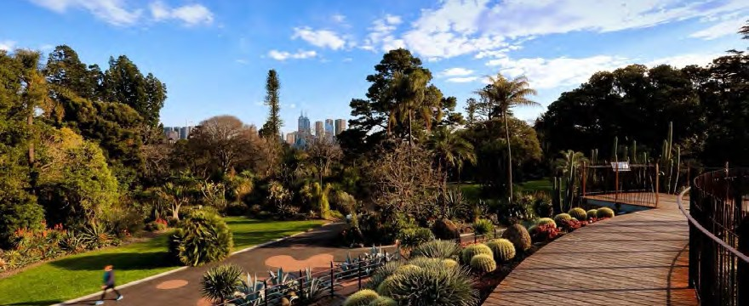
Domain Parklands

